Tracking Link to Use In Both Email and Social Promotion:
http://offers.hubspot.com/blog-post-templates?utm_source=email&utm_campaign=CH-blog-post-templates&partner_portal=INSERT_PORTAL_ID
IMPORTANT: Don’t forget to put your HubSpot portal ID at the end of the tracking link
Recommended Subject Line: 5 Essential Blog Post Templates Every Marketer Needs
Body Copy:
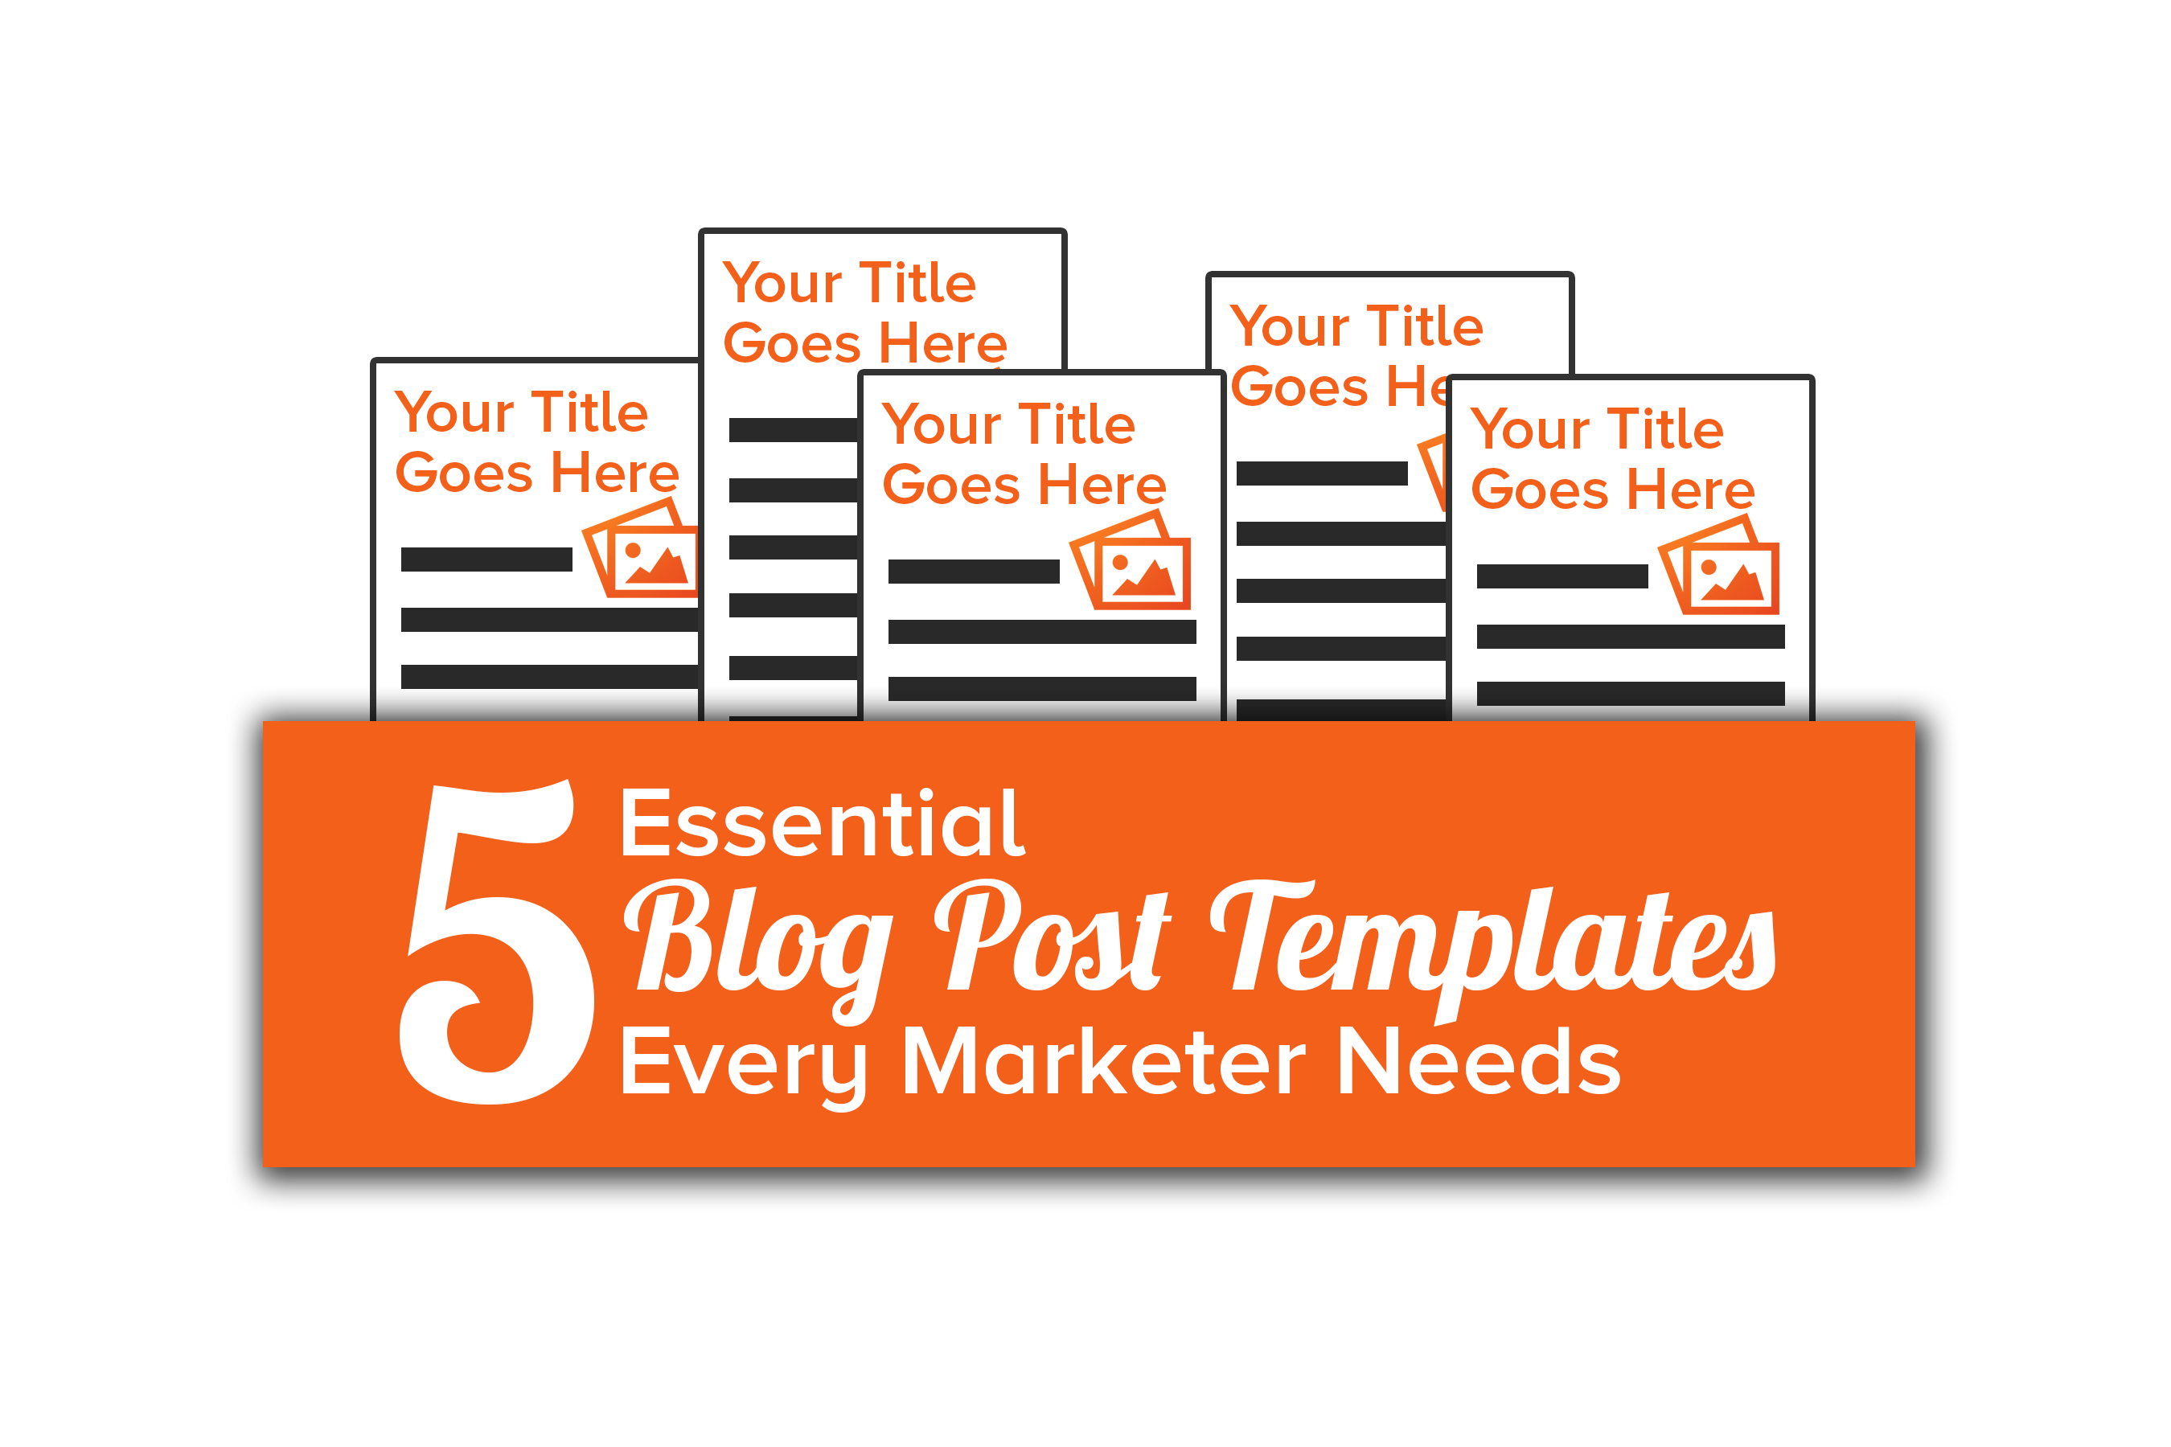
Hi there FIRST NAME,
Content creation is such an important part of an Inbound Marketing strategy, but it can be a tough hurdle to overcome.
Luckily, our partner HubSpot put together 5 blog post templates to help inspire you throughout the writing process!
This free offer includes the following blog post templates:
- The How-To Post
- The List-Based Post
- The Curated Collection Post
- The SlideShare Presentation Post
- The Newsjacking Post
Excited? Go ahead and topple writers block before it settles in by downloading these free templates today. You’ll be inspired in no time!
Cheers,
YOUR NAME
Social Tweets to Use:

- Use any 1 of these 5 blog post templates & have all the guidance you need at your fingertips to write a great post: INSERT SHORT LINK
- Don't start your blog post completely from scratch. Use these 5 blog post templates from @HubSpot for help! INSERT SHORT LINK
- Download 5 free blog post templates any marketer can use to plan, write, and publish great blog posts with ease. INSERT SHORT LINK
- 5 essential (and free!) blog post templates every marketer needs: INSERT SHORT LINK

