INFORMATION EMBARGOED
Austin, Texas – May 13, 2011
Falcon Containers Moves, Makes Massive Expansion
Falcon Containers has expanded its Austin-based headquarters to a site enabling the container company to double its capacity and triple its storage space.
The company – which provides portable and custom storage containers to customers like construction sites, retail businesses and the government – was founded by two former “dot-commers” in 2002 on a two-acre site northeast of Manor. This week, Falcon Containers started its expansion process by moving to a 51-acre site just east of Austin, located at 7717 Gilbert Road – just off the southeast corner of State Highway 130 and FM 973. Over the years, it’s grown from the two founders to its current count of 15 employees.
Falcon Containers is building Central Texas' first fully mobile container-based office structure on the new site, which will serve as the company’s headquarters. It will be built using the same kind of containers it provides to its customers. This 2,500-square-foot mobile building will be assembled from eight repurposed 40-foot shipping containers, with five on the first floor and three on the second floor. The interiors will have "clear span" areas that give dimensions greater than the standard eight-foot width of a container. At the same time, it will maintain the industrial look and feel of the container.
“Our new headquarters will also showcase an innovative, creative way to utilize containers,” said Stephen Shang, Falcon Container’s CEO. “Within our industry, we’re known for our unique ability to modify containers and turn them into anything from hunting cabins to simulated Iraqi villages. So this provides us another special opportunity to showcase how these containers can act as instant, portable building blocks for office space too.”
The new site also features a new fabrication and manufacturing facility, and the majority of its rental and sales inventory. For now, Falcon Containers is finishing out four of the 51 acres, which immediately enables the company to double its capacity and triple the space it has for storing containers. Before, Falcon Containers could only work on fabricating six containers at a time. Now, the company can work on 12 simultaneously, and undertake more complex operations.
Future plans for include a demo area for shipping container cabins, showcase for military training solutions, and other new products that "think inside the box."
The new location has been dubbed “Area 51” by the company – a nod to both the geographic size and a nickname of an industry that’s one of the company’s largest clients. “Area 51” also happens to be a well-known U.S. Air Force base in Nevada. Military pilots call the restricted airspace around the field “The Box” or “The Container” – which happens to be a nice play on words for a company in the storage container business.

For more information, please contact Mary Alice Kaspar at (512) 963-1096 or email makaspar@columbuscomm.com.
About Falcon Containers
Founded in 2003, Falcon Containers repurposes shipping containers to simplify their customers’ operations. Applications include portable storage containers, military training assets, customized conex containers, and shipping container homes. Falcon has served numerous customers in the Central Texas area and the US Department of Defense throughout the United States. More information can be found at http://www.FalconContainers.com.

[1] Harnish, V. (2010, Novemebr 29). Five Business Killers. How to stop doing everything that sucks the life out of your company so you can focus on growth instead, p. 1.
###

Rendering of Falcon Container’s Headquarters Building Made of Containers
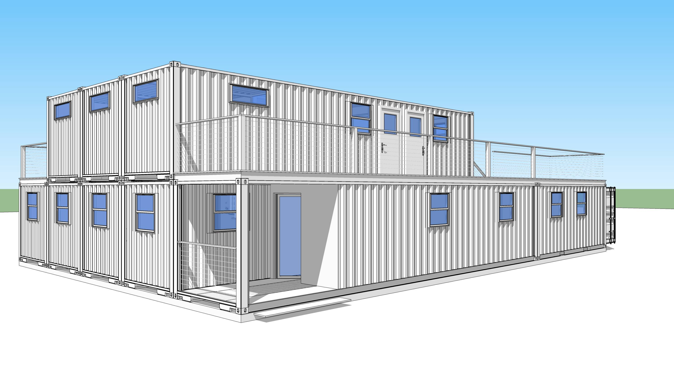
Partial Site Plan View of Area 51
