Own Your Piece of Paradise

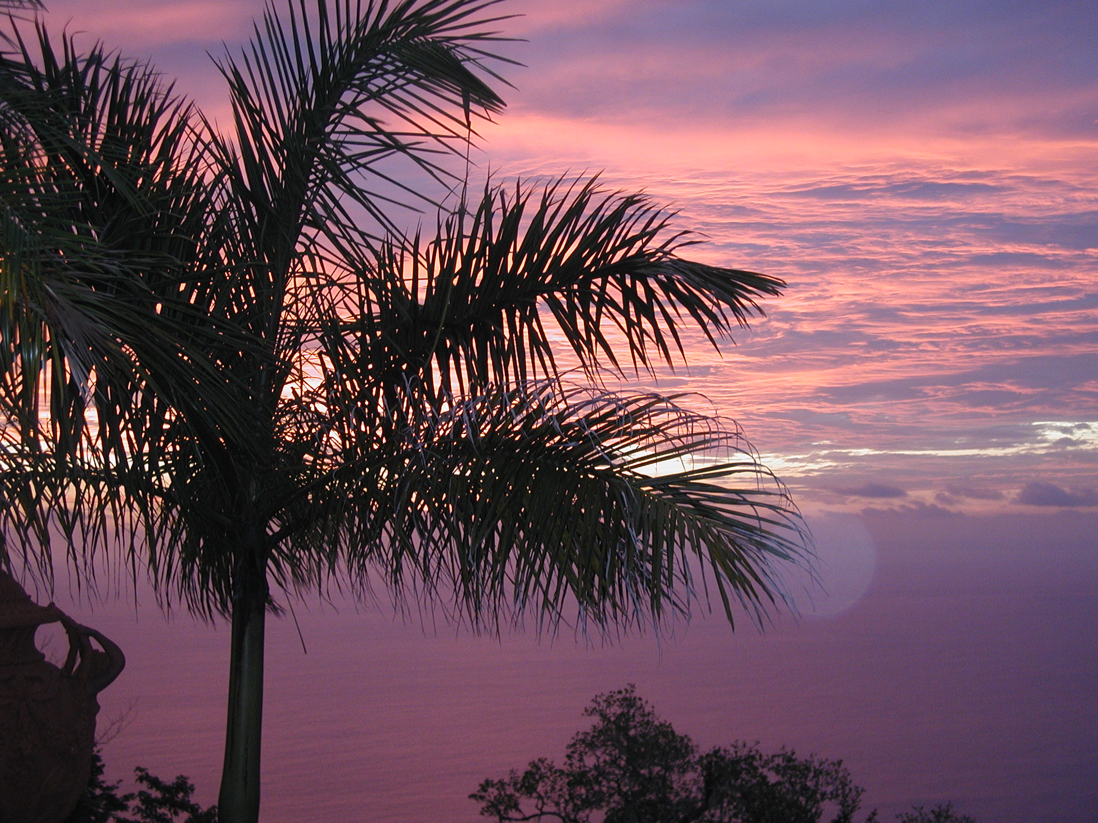

Costa Rica
Acreage Available in a Managed Development
Single Ocean View Lot

