Own Your Piece of Paradise

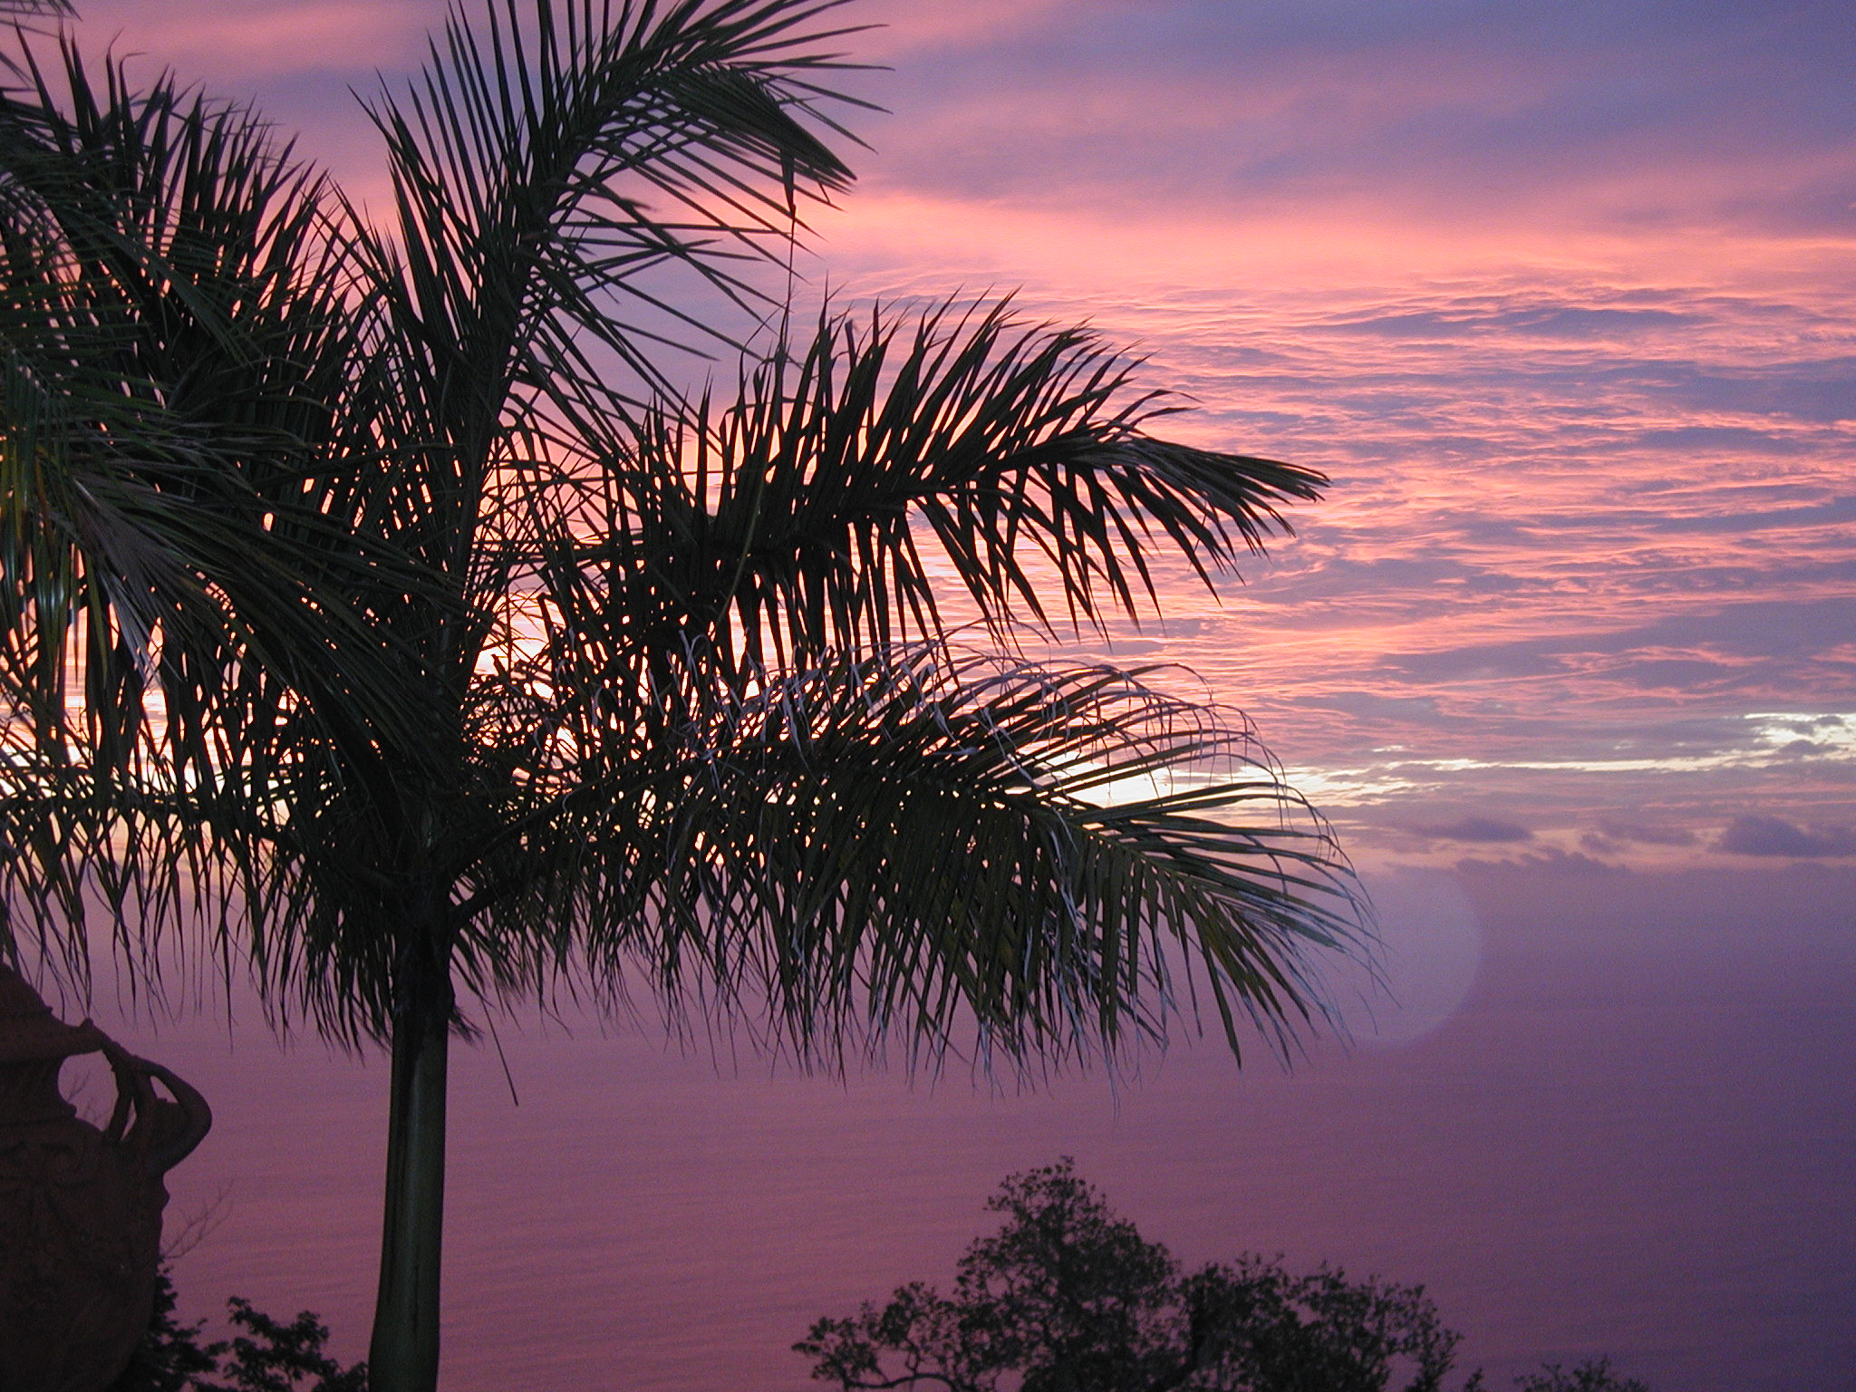

Costa Rica
Acreage Available in a Managed Development

Ocean View – 10+ Acres
