690 Knox St.
Torrance, CA 90502
(310) 263-3060
www.cmtc.com

MEDIA RELEASE

FOR IMMEDIATE RELEASE

Contact: Steve Brand (310) 263-3018
sbrand@cmtc.com

LA Mayor Eric Garcetti Encourages Students to “Make Things” at LA Trade-Tech Manufacturing Day Event

Los Angeles, CA – October 9, 2017 – Los Angeles Mayor Eric Garcetti, in his keynote address at Los Angeles Trade-Tech College on Friday, October 6, 2017, encouraged the over 750 high school students attending to “go out and make things.” The event, sponsored by CMTC and LA Trade-Tech, was held in conjunction with Manufacturing Day events taking place across the nation.

During his visit, Mayor Garcetti first met with a group of students from John Marshall High School. The school, which is located in the Los Feliz district of the City of Los Angeles, was recently named a California Department of Education Gold Ribbon Award winner for their implementation of rigorous academic and performance standards. During this discussion session, he shared with the students his thoughts about developing future career paths to take advantage of well-paying jobs in the manufacturing sector.

Mayor Garcetti then took the stage and gave a rousing speech in which he encouraged the students to look to the future – especially within the Los Angeles area – for manufacturing careers. "Everyone deserves a shot at higher education and a good-paying career," said Mayor Garcetti. "We have to create new opportunities that inspire our young people — and this event helped motivate hundreds of students to develop their skills and be part of building the future."
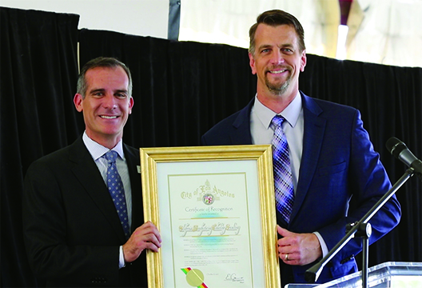
Mayor Garcetti then presented Gregg Profozich, Director of Advanced Manufacturing Technologies at CMTC, with a Certificate of Recognition thanking CMTC for their support of Manufacturing Day in Los Angeles. In his acceptance remarks, Mr. Profozich thanked the Mayor for his phenomenal support of manufacturing programs throughout Los Angeles and for his ongoing efforts in developing and promoting programs that assist manufacturers in growing their business. Mr. Profozich continued, “As part of CMTC’s commitment to the manufacturing community, we are very proud to be partnering with LA
Los Angeles Mayor Eric Garcetti (left) presents Gregg Profozich – Director of Advanced Manufacturing Technologies, CMTC (right) with a Certificate of Recognition.
Trade-Tech and the City of Los Angeles in providing students with this opportunity to learn about the manufacturing sector. This year, 200 manufacturers across California will open their doors to host and attend events, like this one, in a celebration of modern manufacturing. We hope that through events like today’s we will inspire the next generation of manufacturers.”

The students were subsequently given the opportunity to meet with Los Angeles area manufacturers and representatives from LA Trade-Tech where they received first-hand knowledge about the current state of manufacturing and the training needed for them to succeed in the future.

About CMTC

CMTC, a private non-profit corporation, was established in 1992 to provide consulting services to small and medium-sized manufacturers in California. In 2016, The U.S. Commerce Department’s National Institute of Standards and Technology (NIST) awarded CMTC a five-year agreement to be California’s Manufacturing Extension Partnership (MEP) Center. This agreement makes CMTC the lead organization for delivering services to small and medium-sized manufacturers in California with support of partners throughout the state. Through its collaboration with these partners, CMTC will enhance operational performance, new product development, market expansion and technology adoption for manufacturers in both urban and rural centers. For more information visit www.cmtc.com.

About LA Trade-Tech

Founded in 1925 as the Frank Wiggins Trade School, Trade-Tech is the oldest of the nine public two-year colleges in the Los Angeles Community College District (LACCD). Community colleges serve adults of all ages, meeting the needs of a society where "lifelong learning" is the rule and multiple careers and continual retraining are the norm. More than half of all LACCD students are older than 25 years of age, and more than a quarter are 35 or older. More than any other California system of higher education, community colleges offer a first - and a second - chance for anyone who wants to succeed.

###

