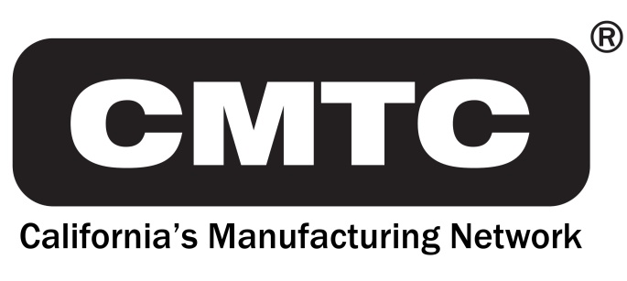
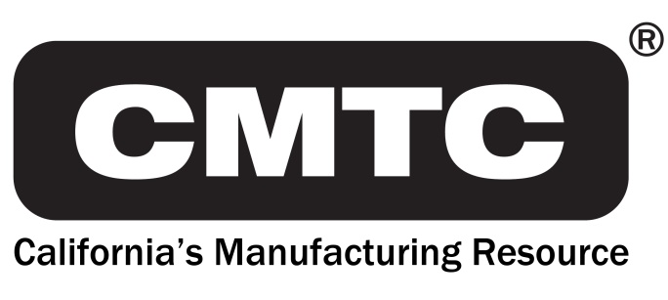
690 Knox St.
Torrance, CA 90502
(310) 263-3060
www.cmtc.com

FOR IMMEDIATE RELEASE
MEDIA RELEASE

Contact: Steve Brand (310) 263-3018
sbrand@cmtc.com

CMTC Assists in Program to Train Homeless Veterans in the Use of 3D Printers to Gain Needed Job Skills

Torrance, CA – October 5, 2017 – CMTC, in cooperation with 3D Veterans, will be facilitating a “boot camp” to teach veterans state-of-the-art 3D Printing training fundamentals. Chris Wentworth, Additive Manufacturing Practice Lead will be teaching veterans how to operate 3D printers for industrial use as a part of CMTC’s workforce development efforts. Says Chris, “This is an excellent opportunity for veterans to learn cutting edge job skills. 3D printing is rapidly becoming the standard in the advanced manufacturing arena so veterans taking this class will be able to compete in this growing field.”

The goal of this boot camp is to help veterans gain needed job skills to enter the workforce and also answer the workforce skill gap created by new technology such as 3D printing. Chris continues, “Our hope is to give these veterans valuable job skills that will help them start on a meaningful career in the technology and manufacturing field.”

For further information, please go to www.3dveterans.com.

About CMTC

CMTC, a private non-profit corporation, was established in 1992 to provide consulting services to small and medium-sized manufacturers in California. In 2016, The U.S. Commerce Department’s National Institute of Standards and Technology (NIST) awarded CMTC a five-year agreement to be California’s Manufacturing Extension Partnership (MEP) Center. This agreement makes CMTC the lead organization for delivering services to small and medium-sized manufacturers in California with support of partners throughout the state. Through its collaboration with these partners, CMTC will enhance operational performance, new product development, market expansion and technology adoption for manufacturers in both urban and rural centers. For more information visit www.cmtc.com. CMTCs ExporTech™ is the only national program that helps individual companies develop an export plan.

###

