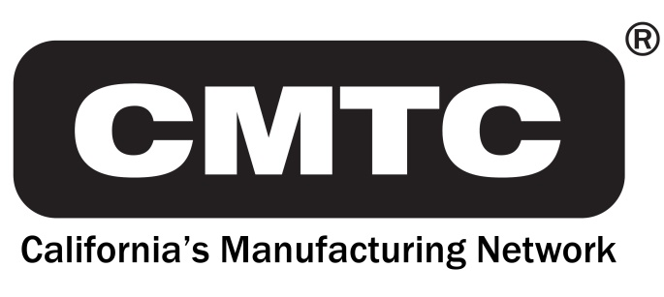
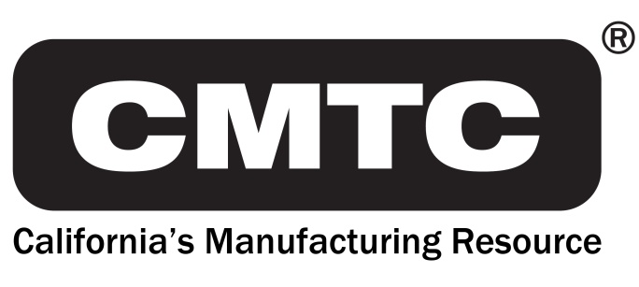
690 Knox St.
Torrance, CA 90502
(310) 263-3060
www.cmtc.com

FOR IMMEDIATE RELEASE
MEDIA RELEASE

Contact: Steve Brand (310) 263-3018
sbrand@cmtc.com

CMTC Partners with Leading Veterans and Manufacturing Organizations to Train California Veterans for New Careers in Advanced Manufacturing

Torrance, CA – November 21, 2017 – CMTC, in collaboration with America Makes and 3D Veterans, proudly announces its initiative to help military veterans in California launch new careers in the advanced manufacturing field. This program will train veterans to enter the high tech workforce within the aerospace and defense, automotive and medical device arenas throughout California.

CMTC will foster local partnerships in California by working with a Google/VA Center of Innovation/America Makes/3D Veterans pilot project. The purpose of this project is to recruit and support veterans as they choose from a wide range of vocational training programs. These new jobs are focused on advanced manufacturing technologies such as additive manufacturing/3D printing.

Chris Wentworth, CMTC's Additive Manufacturing Practice Lead said, “We are excited to begin this initiative to connect veterans with our extensive network of industry, academic and
non-profit partners seeking to assist Veterans launch new careers in advanced manufacturing. As a veteran myself that transitioned from the US Army over 20 years ago, having these resources available can make all the difference to a successful civilian career.”

Erin O’Donnell, Program Operations Coordinator at America Makes had this to say about the program, “America Makes and the National Center for Defense Manufacturing and Machining (NCDMM) are honored to be part of this important initiative to train returning veterans in the skills needed for the 21st century advanced manufacturing workplace. As a veteran, I know
first-hand the importance of such an opportunity and the impact this type of training can have for men and women transitioning from their military life to their new civilian roles.”

--more--

Manufacturing jobs represent a tremendous opportunity for veterans to position themselves for rewarding post-military careers. According to the Manufacturing Institute, 3.5 million manufacturing jobs will need to be filled between 2015 and 2025, and we plan to make sure veterans have the skills and opportunity to fills those jobs.

About CMTC

CMTC, a private non-profit corporation, was established in 1992 to provide consulting services to small and medium-sized manufacturers in California. In 2016, The U.S. Commerce Department’s National Institute of Standards and Technology (NIST) awarded CMTC a five-year agreement to be California’s Manufacturing Extension Partnership (MEP) Center. This agreement makes CMTC the lead organization for delivering services to small and medium-sized manufacturers in California with support of partners throughout the state. Through its collaboration with these partners, CMTC will enhance operational performance, new product development, market expansion and technology adoption for manufacturers in both urban and rural centers. For more information visit www.cmtc.com.

###

