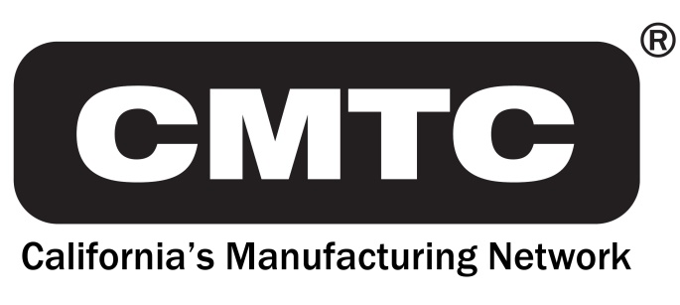
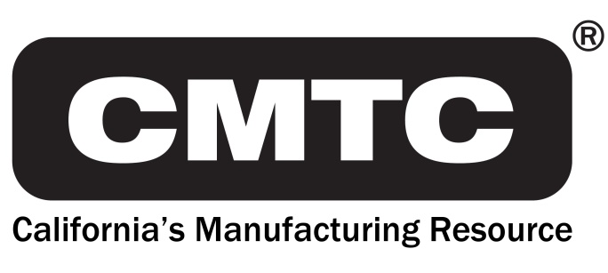
690 Knox St.
Torrance, CA 90502
(310) 263-3060
www.cmtc.com

FOR IMMEDIATE RELEASE
MEDIA RELEASE

Contact: Steve Brand (310) 263-3018
sbrand@cmtc.com

CMTC Client Advisor Kathleen Webber Named as a Top 100 Finalist in the San Diego Business Women of the Year Awards

Torrance, CA – October 18, 2017 – The San Diego Business Journal recently released the top 100 finalists for their 24th annual “Business Women of the Year Awards.” Chosen from over 1,000 nominations, this list of distinguished business women includes CMTC Client Advisor, Kathleen Webber. In her five years working at CMTC, Kathleen has served 154 small to medium-sized manufacturers in the aerospace, defense, automotive, consumer, food and industrial manufacturing sectors throughout San Diego and Imperial Counties. Due to her efforts, these businesses showed economic impacts which included; $120M in sales increases, $8M in cost savings and 3,127 jobs created or retained.

The San Diego Business Journal will host a special awards luncheon on Wednesday, November 15, 2017 to honor all of the top 100 finalists and announce this year’s “San Diego Business Women of the Year” winners.

---more---

Kathleen has over 30 years of management experience in the areas of operations management, organizational design and cultural alignment. Her colleagues describe her as driven to succeed, decisive, mission-focused, goal-oriented and exuding confidence. Her clients appreciate her direct approach, her ability to connect them with valuable solutions and her genuine interest in advancing their organizational mission through positive economic impact.

Most recently, Kathleen was involved in promoting Manufacturing Day 2017 by encouraging manufacturing companies to showcase their products through tours and high school visits. Locally led by the San Diego Regional Economic Development Corporation, Manufacturing Day is comprised of a series of weeklong events showcasing some of the 3,000 companies that manufacture in the San Diego-Tijuana region. The goal of the San Diego Manufacturing Day events is to inspire the next generation of manufacturing workers and all of the products that are made in San Diego.

About CMTC

CMTC, a private non-profit corporation, was established in 1992 to provide consulting services to small and medium-sized manufacturers in California. In 2016, The U.S. Commerce Department’s National Institute of Standards and Technology (NIST) awarded CMTC a five-year agreement to be California’s Manufacturing Extension Partnership (MEP) Center. This agreement makes CMTC the lead organization for delivering services to small and medium-sized manufacturers in California with support of partners throughout the state. Through its collaboration with these partners, CMTC will enhance operational performance, new product development, market expansion and technology adoption for manufacturers in both urban and rural centers. For more information visit www.cmtc.com.

###

