**West Bend Supports Wisconsin Long-Term Care Facilities with Equipment Grants**

***West Bend awarded six facilities across Wisconsin grants to purchase equipment to make patient moving and lifting safer for residents and caregivers***

WEST BEND, Wis. (May 31, 2018) – West Bend Mutual Insurance Company recently partnered with LeadingAge Wisconsin to award Safe Resident Assistance Endowment grants to six long-term care facilities. The grants will be used to purchase equipment to more safely and effectively move and lift residents. Such lifts and equipment are integral to creating a safe and dignified resident handling program.

The six 2018 recipients of the grant were:

* [Pigeon Falls Health Care Center](http://www.tchcc.com/pigeon-falls/pfhcc/) in Pigeon Falls;
* [Prairie Maison Nursing Home](http://www.chscwi.org/nursing-homes/prairie-maison/) in Prairie du Chien;
* [North Central Health Care](http://www.norcen.org/) in Wausau;
* [Cedar Community](http://www.cedarcommunity.org/) in West Bend;
* [The Fields of Washington County, Residential Care Apartment Complex](http://www.co.washington.wi.us/departments.iml?mdl=departments.mdl&ID=SAM), in West Bend; and
* [Golden Age Manor](http://goldenagemanor.com/) in Amery.

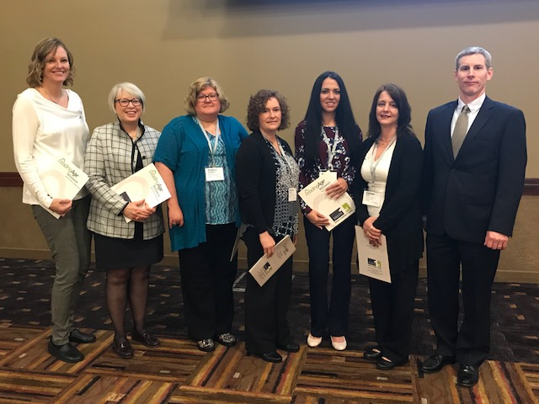As a major insurer of nursing homes and assisted living facilities in Wisconsin and across the Midwest, West Bend believes it is important to ensure both resident and caregiver safety, as well as to give back to Wisconsin’s long-term care provider community. The Endowment was established to provide state-of-the-art equipment to improve transferring or transfer assistance for residents and caregivers, while easing the financial burden for facilities. Since the Endowment’s creation in 2014, West Bend has awarded more than $125,000 in grants to over 30 Wisconsin facilities.

*Pictured left to right: Denise May, LeadingAge Wisconsin; Mari Beth Borek, Samaritan Campus (Fields of Washington County); Kim Gochanour, North Central Health Care; Rebecca Meyer, Pigeon Falls Health Care Center; Shannon Landt, Prairie Maison Nursing Home; Kathleen Spot, Cedar Community; and Dave Nettum, Argent. Not pictured: Dana Reese, Golden Age Manor.*

“Patient and caregiver safety is of utmost importance to us,” said Jim Keal, vice president of Argent, West Bend’s monoline workers’ compensation division. “Our Safe Resident Assistance Endowment and our partnership with LeadingAge Wisconsin provide us with the perfect opportunity to help ensure the safety and comfort of both caregivers and residents at quality facilities throughout Wisconsin.”

“LeadingAge Wisconsin applauds West Bend’s commitment to improving the quality care to our state’s nursing home residents,” said John Sauer, LeadingAge Wisconsin’s President/CEO. “Through this company’s generosity and charitable giving, more direct caregivers will have access to state-of-the-art equipment designed to safely serve residents in need of assistance with transfers and related cares.”