Electrical surges have been a loss leader for many years both in frequency and severity. We have put together a short presentation to help explain what electrical surges are, what effects they have on equipment, and how to help prevent losses. Please click on the links below to view and pass along as necessary.

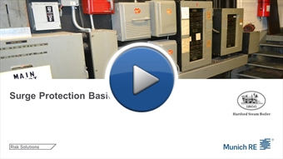

If you can't view the image above, copy and paste this URL into your browser:
https://www.brainshark.com/hsb/vu?pi=zEkzL1M2Cz4vD3z0&intk=113948010

