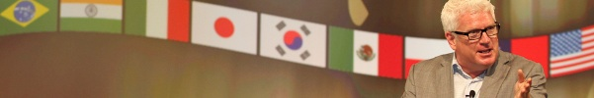

Vince Poscente’s -- Audio/Visual Requests
(Please NOTE… RED is important – BLUE is whatever works for your event)

• Wireless Lavaliere Microphone
- with fresh batteries and back-up microphone
- hooked into sound system

• Audio/Video
- Vince will bring a jump drive of audio and video (.mov/.wav + .aiff/.mp3)
- If you’d like advance access to the video & audio, we can send it via DropBox
- Projector + Screen(s) off to either side of the center-stage platform
- If the screen must be in the center, please ensure it is backlit
- Projector bright lumens and back-up bulb
- Audio patched into sound system

• Lighting: Stage Wash and House
- Lighting the stage is very important for a high energy presentation
- Stage wash or telescopic lighting (Please, no spot light.)
- House lights between 30% and 70% is best

• Riser
- The front of the riser should be no more than 20’ from the first row
- 12’ x 8’ riser or larger is best
- A 1’ riser for small audiences
- (the more people, higher the riser necessary)

• On Stage
- Center stage: a simple conference chair, no wheels, not folding please
- Stage right or left: a podium with water please

• Seating Preference
- 1st choice – theater, 2nd choice - classroom, 3rd choice – round table

• A/V Technician needed
- One hour prior for review of AV sequencing and mike check

• Title Slide
- Vince does not use PowerPoint. If you want a title slide please put the following with your graphic theme:

Vince Poscente
Full Speed Ahead
v@vinceposcente.com

Vince Poscente International 7227 Fisher Road, Dallas, TX 75214 USA
v@vinceposcente.com Cel 214.335.0856
Revised March 2016

