Thank you for your interest to present your work at xMAP® Connect 2017!

- Prepare a presentation title, the title included on the submission should be suitable for published material.
- Abstract text is limited to 3000 characters (approx 500 words).
- We ask to use 4 core elements: 1) background and aim, 2) methods, 3) results, 4) conclusions. We kindly ask you to use the format below.
- Please ensure the submission has been approved by all authors.
- By submitting an abstract, you agree to be present the 8th and 9th of November at the congress, should your abstract be selected.
- Please indicate if you would like to be a speaker or present a poster.

Contact details:
Name: Sian E. Faustini
Institute/ Organization: University of Birmingham Clinical Immunology Service
Address
Street: Vincent Drive
Postal code:B15 2TT
Country:UK
Phone number: +44 07865 450548
Email address:sef206@bham.ac.uk

Title: Using various immunological assays to assess immune responses to pneumococcal polysaccharide and conjugate vaccines in HIV.

1) Background and aim:

Streptococcus pneumoniae is a major cause of morbidity and mortality. Assessing responses to pneumococcal (Pn) vaccination is important to determine immunogenicity. The aims of this project were to 1) qualify the IgG subclass response to the plain polysaccharide Pneumovax-23 vaccine (PPV-23) and protein conjugated Prevenar-13 (PCV-13) Pn vaccine. This would be done both to individual Pn serotypes and to the combined serotypes in both vaccines. 2) Compare serotype specific with combined or whole pneumococcal assays.

2) Methods:
Pn serotype- specific antibodies from an HIV-infected cohort at University Hospitals Birmingham (N=153) were tested pre- and post- vaccination with PPV-23 or PCV-13, using a combination of multiplexed Luminex assays (MIA) and Binding Site anti-pneumococcal kits (PCP-IgG and PCP-IgG2).

Monoclonal antibodies (IgG1, IgG2, IgG3, and IgG4) were conjugated to phycoerythrin using a Lightning-Link conjugation method. The MIAs measured total IgG, IgG1, IgG2, IgG3, and IgG4 antibodies in patient sera to 11 Pn serotypes (1,3,4,5,6B,7F,9V,14,18C,19F,23F) and the PPV-23 and PCV-13 vaccine conjugated beads.

Pn-specific values were assigned to IgG1 and IgG2 for the standard reference serum 007sp from the old standard reference serum 89-SF using an equivalence-of-absorbance method based on previously assigned titres. The Pn-specific IgG and IgG2 assays were then compared to the Binding Site Whole PCP-IgG and IgG2 assays.

3) Results:

IgG subclass response to vaccination
PPV-23 vaccination produced a proportionally higher IgG2 response than IgG1, IgG3 or IgG4 (Figure 1). PCV-13 vaccination produced significant equivalent increases to all measured serotypes to IgG1 and IgG2. The Pn-specific IgG3 response was more prominent in the PCV-13 than the PPV-23 cohort. The Pn-specific IgG4 response is limited for both the PPV-23 and PCV-13.

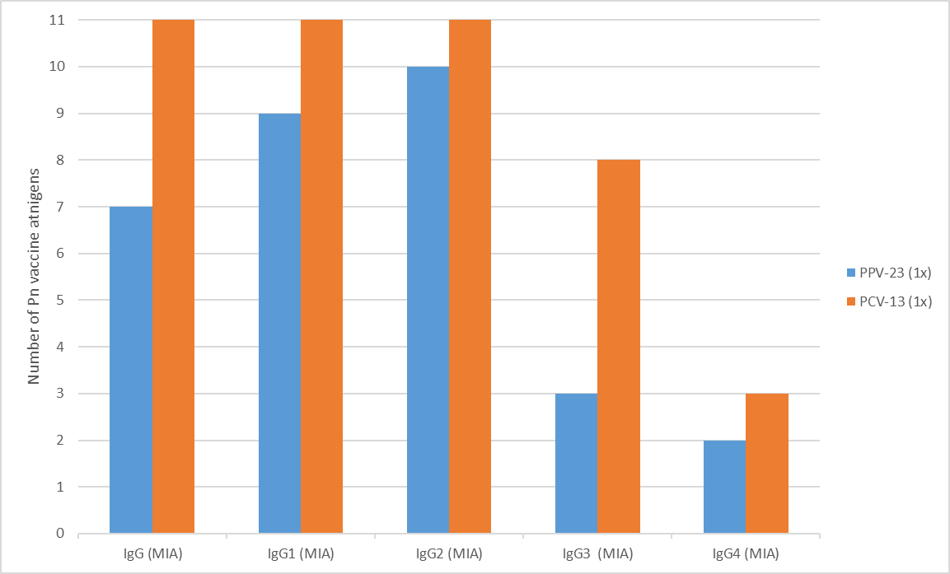
Comparison of serotype assays
Figure 1. Number of Pneumococcal Vaccine Antigens with a significant difference pre- to post- vaccination
For IgG serotype assays, protection is deemed significant when 2/3rds of measured serotypes reach threshold (0.35 µg/ml -WHO) (1). When our serotype data was compared with
the whole PCP-IgG (Binding Site Assay), 36.4% of patients, that were deemed protective by the PCP-IgG assay, had a significant number of serotypes that failed to reach threshold.

When comparing the whole PPV-23 and PCV-13 beads with the serotype data. ROC curve analysis for the prediction of patients who reach threshold for the serotype specific IgG assay (WHO) returned an area under the curve of 0.68 (p<0.001) against the whole PPV-23 bead and 0.87 (P<0.0001) against the whole PCV-13 bead.

For the PCP-IgG2 assay (Binding Site) (2), there were no post vaccine differences between PPV-23 and PCV-13 cohorts similar to the MIA data. However, the IgG2 response varied widely (1.34:9.38 fold change) between serotypes; differences which cannot be seen in the whole PCP-IgG2 assay.

4) Conclusion: This study has demonstrated differences in IgG subclass responses to PPV-23 and PCV-23 vaccines. This challenges previous thinking that a plain polysaccharide response is predominantly IgG2 and conjugate vaccine IgG1. This study also highlighted the variety of assays available and that these generate different results. The serotype specific assays demonstrate that responses to individual serotypes are very different for both vaccines and that this granularity cannot be visualized in combined serotype assays.

5) References:
1) Siber GR, Chang I, Baker S, Fernsten P, O’Brien KL, Santosham M, et al. Estimating the protective concentration of anti-pneumococcal capsular polysaccharide antibodies. Vaccine.2007 May 10; 25(19):3816–26.
2) Parker A, Irure Ventura J, Sims D, Echeverría de Carlos A, Gómez de la Torre R, Tricas Aizpún L, et al. Measurement of the IgG2 response to Pneumococcal capsular polysaccharides may identify an antibody deficiency in individuals referred for immunological investigation. J Immunoass Immunochem 2017 Jun 14.1–9.

Word Count: (500 max)

