Step 1: Follow the link to https://candidate.psiexams.com/.
How to Find Locations/Dates/Times for a PSI Testing Center
Step 2: Scroll down to the bottom of the page and click on Click Here under where it says check available dates before you register. | 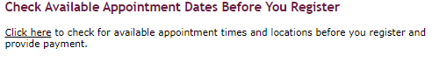
Step 3: Under Select Organization select Certification/Professional Associations. | 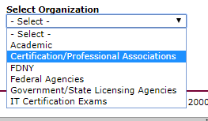
Step 4: Under Select Sponsor Name select National Healthcareer Association (NHA). | 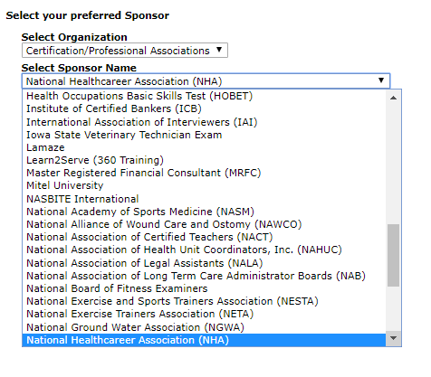
Step 5: Under Select the Examination Name select the bullet next to the exam you will be taking and then click on Continue. | 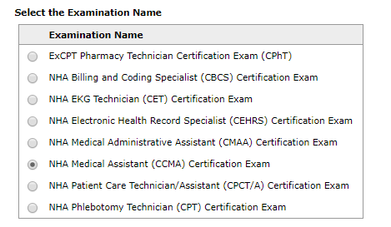
Step 6: Type in the city or zip code for where you would like to take your exam in the box and choose from the dropdown provided. Then click on Search. | 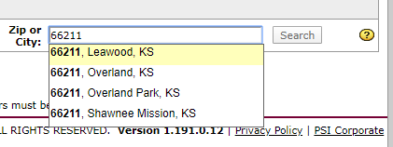
Step 7: Under Choose one or more test centers select the bullet next to the centers you would like to see dates and times for and then click on Continue. | 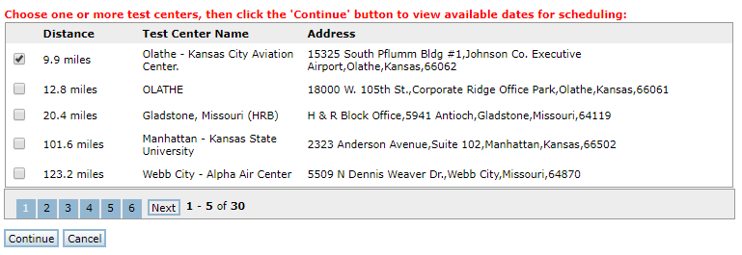
Step 8: Scroll through the list of dates/times available using the arrow in the lower right-hand side.  ***You will not be able to select a date and schedule your exam until 24 hours after you apply and pay for your exam through your account at https://www.nhanow.com/.*** | 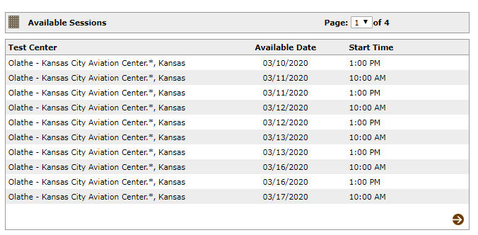
For additional questions, please contact us via Live Chat at nhanow.com.
Group Scheduling at PSI
Group Scheduling at PSI

