Completing Your Continuing Education Credits

Applicable for all NHA certifications except for ExCPT

Step 1: After logging in, www.nhanow.com, Continuing ED menu will appear on the lower left (after a certification is obtained)

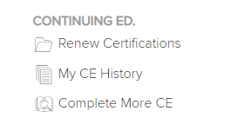

Renew Certification will allow you to view status
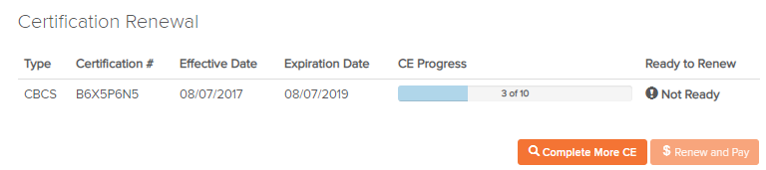

My CE History will show all previously completed credits
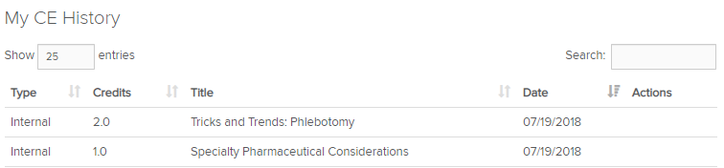

Complete More Credits will allow you to obtain more credits

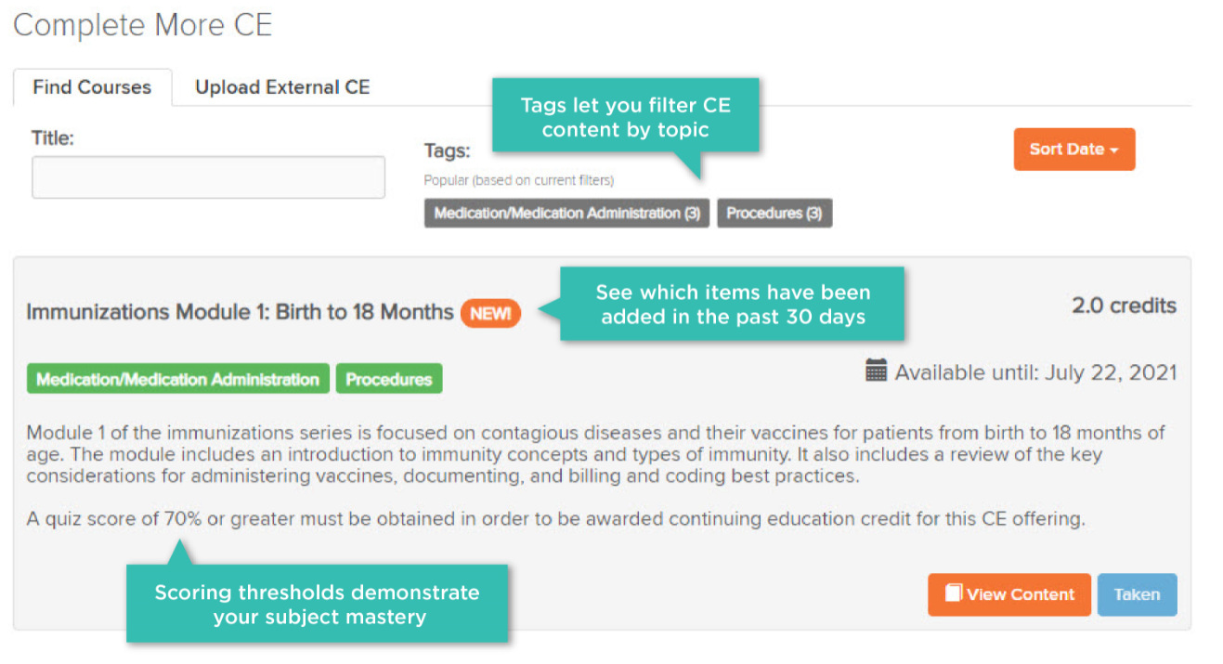
Some CE items now require a 70% score to obtain CE credit. The performance profile report
will be displayed once the quiz
is completed and you may print this report for your records
Once credits required have been completed you may Renew and Pay.

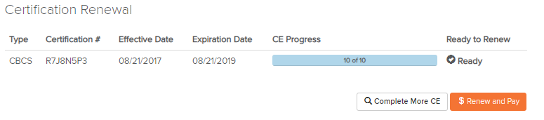

To renew, follow the steps below:
- Choose the certification(s) you would like Renew

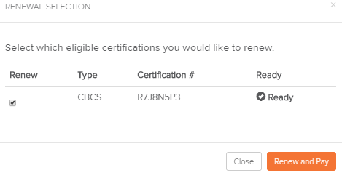

- Verify cart items and click Check out
- Verify mailing information and click on Continue Checkout (*make all address updates in your NHA account)
- Scroll to bottom of the page and fill in Credit Card Information, Expiration Date and 3-digit code (CVV) from the back-signature line of your credit card.
- Click on Purchase Items
- Print page for Receipt

2

