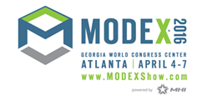

Keith Price, VP of Information Services, at Seneca Medical presented an educational seminar at MODEX today entitled:
How Seneca Medical Saves $1 Million Annually With Voice-Directed Picking and Continues to Raise the Bar
Keith shares how he accomplished the following with a Honeywell-Vocollect Voice solution from Speech Interface Design:
  - Deployed voice to more than 200 associates to all 6 of its Distribution Centers
- Accuracy at 99.9% with no auditing
- Productivity increased by 25+%
  - Operational Savings: $1 million/year
  - ROI/Payback Period: 6 months

Watch and listen to his presentation here. And, watch a video of his operation:

