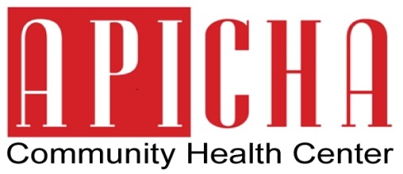
Contact:
Rhina Torres
Phone: (646) 884-5385
Email: rtorres@apicha.org
FOR IMMEDIATE RELEASE
August 5, 2013

APICHA Community Health Center to Host Health Fair
Healthy People, Happy Community

New York, NY – In celebration of National Health Center Week, APICHA Community Health Center is joining hundreds of health centers across the country by hosting its own health fair. The event will take place on Thursday, August 15, 2013 from 4:00 p.m. to 7:00 p.m. at its facility, located at 400 Broadway in Lower Manhattan (entrance at 70 Walker Street).
Health fair activities will include free screenings for diabetes, blood pressure, obesity, free HIV testing and Hepatitis B vaccinations. In addition, participants are welcome and encouraged to speak with our staff to receive a free insurance eligibility screening and consultation.
National Health Center Week is an annual campaign committed to enhancing the visibility of services and contributions provided by America’s Community Health Centers. For nearly 30 years, the National Association of Community Health Centers has helped medical centers and their patients transmit their mission and message by participating in the event. This year’s theme, "Celebrating America’s Health Centers: Transforming Health Care in Our Local Communities,” plans to showcase the impact Health Centers have in improving the health of their communities by delivering quality, cost effective, accessible care.
To learn more about the mission and accomplishments of Community Health Centers please visit the web site of the National Association of Community Health Centers at www.nachc.org.

To find out more about National Health Center Week, visit www.healthcenterweek.org

APICHA Community Health Center is a Federally Qualified Health Center Look-Alike providing general and HIV-specialty primary care, mental health and support services to underserved communities including those who identify as Lesbian, Gay, Bisexual and Transgender, people living with HIV, Asian and Pacific Islanders (A&PIs), and other people of color. Founded in 1989 to respond to the special needs of A&PIs, immigrants and people with limited English proficiency affected by HIV, APICHA has evolved into a comprehensive community health center and Level 3 Physician Practice Connections®–Patient‐Centered Medical Home, as recognized by the National Committee on Quality Assurance.

For more information about APICHA Community Health Center, please visit www.apicha.org.

