Want to take part of APICHA’s free
Are you between 18-24 years old?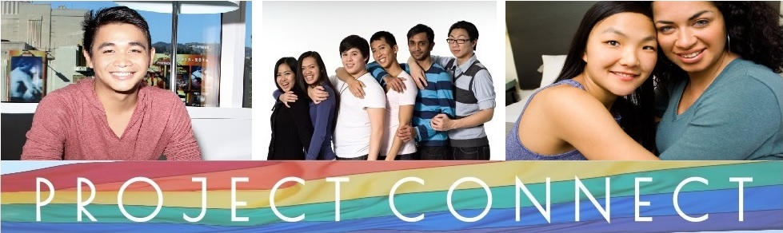
mentoring program?

Project Connect’s youth initiative, GAYME (LGBTQ Asian & Pacific Islander Youth Mentorship for Empowerment), connects LGBTQ A&PI youth (18 to 24 years old) with other youth and adults to share their experiences. GAYME utilizes an informal workshop method preferred by LGBTQ A&PI youth and includes group outings for social activities.

These groups allow youth and mentors to draw upon an array of different experiences to cultivate understanding and build a supportive community. Session topics include: self-image, acceptance of multiple identities, coming out, body image, budgeting, getting into college, affording college, career paths, and finding jobs/job security. Previous mentors have included LGBTQ A&PI doctors, community organizers, artists, writers, and more!

If you would like to know more or have any questions, get in touch with our Project Connect Coordinator: vbryant@apicha.org Phone: 646-744-0990

PERSONAL INFORMATION

Name: ________________________________________________ Date (DD/MM): ____________

Phone: __________________________ E-mail: ____________________________________

Ethnicity: _________________________ Date of Birth: _________________________

What is the best way for us to contact you? Phone Email Both

INTEREST SURVEY

Please answer all of the following questions. This survey will help Project Connect know more about you and your interests.

- How did you find out about the mentorship program?

- Do you speak any languages other than English? If so, which languages?

- What are some of your favorite things to do with other people?

- If you could learn about any job or career, what would it be?

- What is one goal you have for the future?

- What type of person do you most admire and why?

- Do you identify as LGBTQ? If so, are you out to anyone?

- What sort of involvement do you have in the LGBTQ community? (None is okay!)

- Why do you want to be a mentee?

- What topics are you most interested in discussing?

establishing healthy identity  coming out  career paths  body image | mental health  financial planning  physical health | sex and dating  bullying  _________________________  _________________________

- Do you have any questions about the program?

APPLICANT STATEMENT:

I certify that all information I have provided in order to apply for Project Connect’s LGBTQ Asian & Pacific Islander Youth Mentorship for Empowerment program is true, complete and correct.

Signature ___________________________________________ Date ________________

Please return this application to the front desk staff at the APICHA 2nd floor OR:

Mail:
APICHA
ATTN: Project Connect
400 Broadway
New York, NY 10013

E-mail:
vbryant@apicha.org

Or Fax:
212-334-7956

