Contact:
Rhina Torres
Phone: (646) 884-5385
Email: rtorres@apicha.org

FOR IMMEDIATE RELEASE
June 23, 2014

Apicha Community Health Center Celebrates
Growth at 24th Anniversary Benefit

New York, NY – Four outstanding individuals were honored on Thursday, May 22nd, 2014 at Apicha Community Health Center’s 24th Anniversary Gala celebration. Dr. Jean R. Lobell, Patrick J. McGovern, Alec Mapa, and Jane D. Schwartz were recognized for their critical efforts in the fight for equality, in the fight against HIV/AIDS, and in the fight for better healthcare.

The event was held at the Grand Hyatt in New York City and featured a cocktail hour, live entertainment and a sit-down dinner. Along with the reception and dinner, the evening included a silent auction, where guests bid on an extraordinary collection of relaxing spa services, luxury dinners, wine and spirit selections, home improvement services, and various entertainment certificates, among other items.

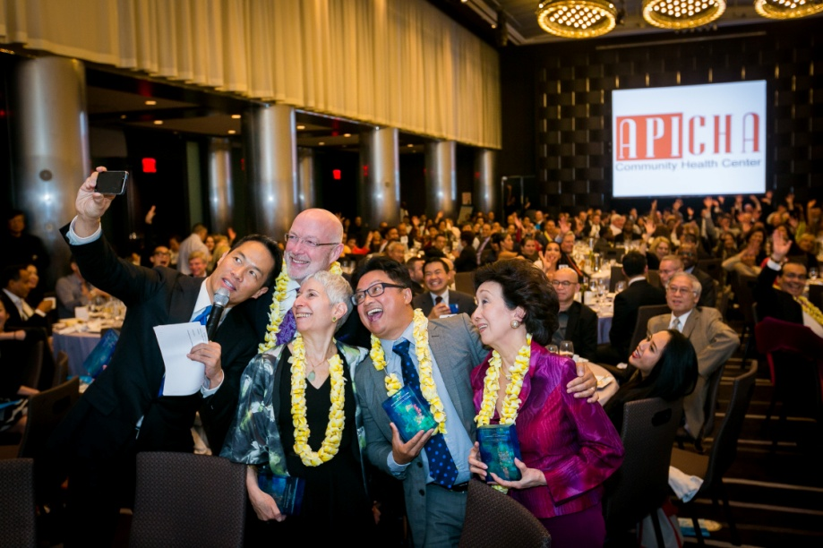
The evening’s biggest highlight was an unscripted reunion between former Apicha CHC client, District 6 Council Member Corey Johnson, and his former social worker, now a case manager. As an advocate for LGBT rights, the Council Member showed his gratitude for Apicha CHC and recounted his experience of receiving news of testing HIV+ as a 22 year old, some weeks before losing his health insurance. The evening concluded with an announcement of Apicha CHC’s new logo, icon and brand. Guests also received surprise tote bags with the agency’s newsletter and a copy of the Pride Guide 2014.
From left to right: Emcee Richard Lui of MSNBC News, Honorees Patrick McGovern, Jane Schwarz, Alex Mapa and Dr. Jean Lobell.

The contributions and additional proceeds from the gala both honor the agency’s 24th anniversary and serve to support a wide range of vital programs and services targeted to the LGBT community, people living with HIV/AIDS and other vulnerable people who experience serious barriers to accessing medical and other healthcare services.

The celebration featured musical arrangements of saxophonist Stephan Davis and was co-emceed by Arthur Chi’en of Fox 5 and Richard Lui of MSNBC News.

For more information, please visit www.apicha.org.

