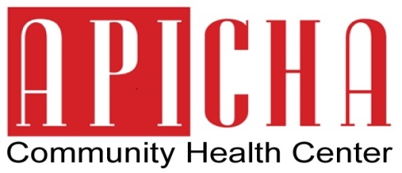

Contact:
Rhina Torres
Phone: (646) 884-5385
Email: rtorres@apicha.org
FOR IMMEDIATE RELEASE
December 19, 2013

APICHA Community Health Center Awarded Vital Access Provider/Safety Net Program Funding

New York, NY – APICHA Community Health Center (APICHA) is one of thirty seven awardees of funding from the New York State Department of Health’s Vital Access Provider/Safety Net Program, Phase II.

Over $6,000,000 was awarded to APICHA on December 5, 2013, recognizing APICHA as an essential institution that fulfills the healthcare needs of underserved populations throughout the city. Intent on transforming the healthcare system and increasing the availability of better health services for New Yorkers, the funds were awarded to hospitals, nursing homes, free standing clinics, and home health that have financial difficulties but are critical in the delivery of quality healthcare to communities across the state.

“We applaud the New York State Department of Health for acknowledging the essential role of organizations like APICHA have in addressing the need of healthcare access of New York’s most vulnerable communities,” says APICHA CEO Therese Rodriguez. “Our decades of experience providing HIV prevention and care services have prepared us to be part of the solution to achieve the goals set by the New York State Department of Health of providing quality, cost-efficient healthcare.”

For the past 23 years, APICHA has demonstrated an extraordinary ability to bring awareness and care to people living with HIV/AIDS in New York City. APICHA has grown from an HIV/AIDS coalition for Asians and Pacific Islanders (APIs) to a health home that recently opened a Trans Health clinic in 2011. As a Federally Qualified Health Center Look-Alike, APICHA provides general and HIV-specialty primary care, mental health and support services to underserved communities including those who identify as Lesbian, Gay, Bisexual and Transgender, APIs, and other people of color.

The funding will be used over the next three years to achieve enhanced financial and operational capacity, including hiring of additional primary care and mental health providers, support services staff and other essential administrative staff. With this staff enhancement, APICHA will be able to serve more people and provide better access to care.

For more information about APICHA Community Health Center please visit www.apicha.org.

MISSION STATEMENT
To improve the health of our community and to increase access to comprehensive primary care, preventive health services, mental health and supportive services. We are committed to excellence and to providing culturally competent services that enhance the quality of life.

We advocate for and provide a welcoming environment for underserved and vulnerable people, especially Asians and Pacific Islanders, the LGBT Community and individuals living with and affected by HIV/AIDS.

