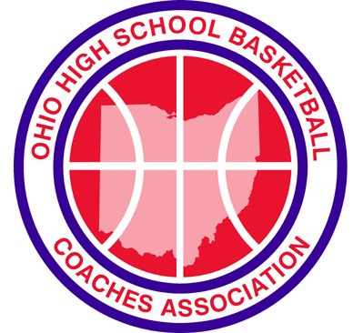
OHIO HIGH SCHOOL BASKETBALL COACHES

HALL OF FAME NOMINATION FORM

Nominating School: |  |  |  |  |  |  |  |  |  | OHSBCA District NO:
Name of Nominee: |  |  |  |  |  |  |  |  |  | Boys / Girls Nomination:
Nominee’s School to be Recognized :
Number of Years as Head Coach: |  |  |  |  |  |  | Total Wins as Head Coach:
Total Wins as Boys Head Coach: |  |  |  |  |  |  | Total Wins as Girls Head Coach:
Graduated High School: |  |  |  |  |  |  |  |  |  |  | Year:
Graduated College School: |  |  |  |  |  |  |  |  |  |  | Year:
Member of OHSBCA (List Span: e.g. 1982-2002)
CAREER HEAD COACHING RECORD – Ohio Coaching Record ONLY
School |  |  |  | Boys/Girls |  |  | Years |  |  | Dates |  | Wins |  | Losses
Total Record at Varsity Level
NOMINEE’S INFORMATION
Present Address & Phone (Include Area Code) |  |  |  |  |  |  |  |  | If Deceased, Name & Address of Closest Relative
CHAMPIONSHIPS & RUNNER - UPS WON
 | Type | Years
League
Sectional
District
Regional
State
Other

List highlights and individual accomplishments of Coaching Careers - (Ex.: Coach of the Year, Coach of North / South Game, Undefeated Seasons, Office held at State and Local Level, Head Coach of Other Sports and records. Please list on a separate page. All highlights and accomplishments must be from the State of Ohio.

Please include the following Local Newspaper information for the Nominee.

Newspaper:
Address:
City: |  | State: |  | Zip:
Telephone Number:

Please submit the nomination to: Greg Nossaman
Olentangy Liberty High School
DUE OCTOBER 1st 3584 Home Road
Powell, OH 43065

Phone: 740 – 657 – 4209
Email: greg_nossaman@olsd.us

