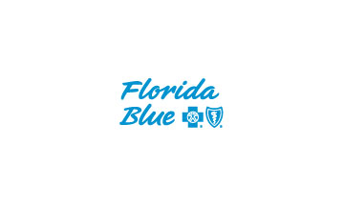

Florida Blue Medicare Contact List

Agent Service Center:
Phone: 800-267-3156

IT:
Phone: 904-905-8737 Option 5
Online: http://servicedesk.bcbsfl.com

Paper Application Fax:
Fax: 904-565-4352
Expedited
Fax: 904-997-5715
Format: [Fax:9049975715]
*send fax through email.

BenefitsCheckUp Tool:
Website: www.benefitscheckup.org

Enrollment:
Phone: 800-926-6565

Provider Services:
Phone 800-267-3156
Dental: Florida Combined Life
Phone: 800-223-4892

Silver Sneakers:
Phone: 888-423-4632

Hearing: True Hearing
Phone: 844-330-8545

Transportation: LogistiCare
Phone: 855-875-5194

Over the Counter: Convey Health Solutions
Phone: 855-824-2011

Vision: iCare Health Solutions
Phone: 855-610-1855

Miguel Cruz
Director Medicare Sales
Miguel.Cruz@bcbsfl.com
(954)234-4291

Vanesa Moris
Medicare Marketing Event Spec SFL
Vanesa.Moris@bcbsfl.com
(305)804-1998

Stephany Estrada
Medicare Sales Assistant
Stephany.Estrada@bcbsfl.com
(305)812-9268

