17 Equations That Changed the World-There’s More Than That!!!

Part 2
Greg Caswell

Background
Mathematics has been a part of our lives forever and is used in numerous ways in our everyday lives. Recently, created by Ian Stewart, listed on Dr. Paul Coxon’s Twitter account and discussed on mathematics blogger Larry Philip’s site is a list of the “17 Equations that Changed the Course of History,” many of which have been mentioned on the Big Bang Theory TV series.



However, the list is incomplete. There are numerous equations that help to determine the reliability of electronics products that DfR believes should be included. These formulas are all integral to DfR’s Sherlock software and are the basis for the validation of the results obtained in an ADA analysis. Last month we looked a several of them in Part 1 of this white paper. Part II delineates the rest of the formulas.

Flex Cracking of Multilayer Ceramic Capacitors

Multilayer Ceramic Capacitors (MLCC), also known as Chip Capacitors, are among the most common, and most fragile, of components used in Circuit Card Assemblies (CCAs). Flex cracking, caused by excessive bending of the printed circuit board under the MLCC, is one of the most common reasons for field failures in electronic devices and is almost exclusively driven by design decisions. The work that relates the failures of ceramics due to printed circuit board bending coincides with the acceptance of using surface mount components on organic based substrates in the mid-eighties.⁽¹⁾ Before this, surface mount devices were typically only used on ceramic substrates and actual failures due to bending were quite rare. Instead most publications that evaluated cracking in capacitors tended to focus on those driven by thermal shock conditions.

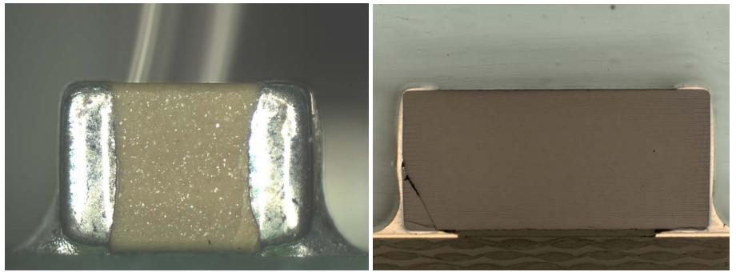

Prior Work
One of the first papers to address the structural reliability of leadless ceramic components on an organic substrate was written by Cozzolino and Ewell ⁽²⁾ in 1980. The paper was the first to apply a physics of failure based approach to capacitor cracking. Critical material properties were measured through a variety of experimental techniques, including indentation to calculate fracture toughness, strain gages to measure residual strains, and ultrasonic methods to obtain elastic properties. Cozzolino also provided a basis for applying fracture mechanics through the use of finite element stress analysis and the calculation of stress intensity factors. ⁽³⁾ However, the paper did not directly address the relationship between substrate flexure and failures but instead focused on crack initiation and growth due to thermal shock.

Work by McKinney and Rice ⁽⁴⁾ in 1986 investigated the failure characteristics of surface mount capacitors. The study provided valuable data on the fracture behavior and mechanical properties of ceramic capacitors but did not extend the results to bending failures of capacitors on a substrate.

The paper “Cracks: The Hidden Defect”⁽⁵⁾written in 1988 by John Maxwell was one of the first to provide semiqualifiable guidelines to preventing capacitor failures due to substrate flexure. The study covered the morphology of cracks caused by thermal shock, pick and place, and board bending. It also provided guidelines on how components should be located on a board to minimize failures to due board bending. However, the guidelines were relatively broad, based only on a geometric interpretation of bending. This interpretation is shown in Figure 1. Using this approach, Maxwell recommends that the minimum board radius of curvature should be greater than 60 inches to avoid flex cracking. The source of this recommendation was not provided.

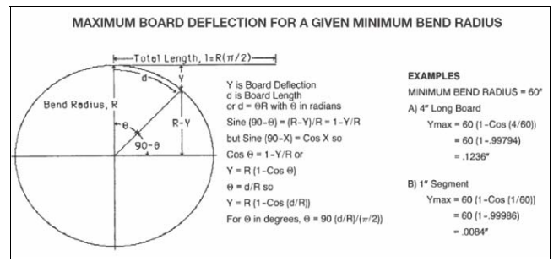

Figure 1: Geometric interpretation of board bending

Work done by Condra ⁽⁶⁾ in 1992 addressed the failures of ceramic chip capacitors on alumina substrates. Environmental issues such as vibration and thermal cycling were investigated as a possible cause of capacitor cracking. The study was limited to fractional factorial experimental testing that investigated the effects of various parameters on capacitor failures. These parameters included manufacturer, soldering technique, and conformal coating, as well as temperature, humidity and vibration. The testing indicated that vibration when combined with temperature cycling could increase the number of failed ceramic capacitors. However, due to the lack of failure analysis, cracking as the root cause of these failures could not be confirmed. In regards to flex cracking, no guidelines were suggested, though the work did indicate that rework of the capacitors could greatly influence failure rates.

The next major study involving capacitor cracking was conducted by Prymak and Bergenthal ⁽⁷⁾ of Kemet Electronics in 1995. They conducted numerous 3 point bend test experiments on ceramic capacitors and provided a statistical analysis of the results. The report contains data on the behavior of the capacitors during flex testing and the probability of failure for two sizes of capacitors, 0805 and 1206, on a 1.6 mm thick printed wiring board. This effort resulted in the first rudimentary attempt at a failure model, with the authors providing a probability of failure due to flex cracking as a function of displacement.

Panchwagh⁽⁸⁾ investigated the internal stresses generated in ceramic capacitors during wave soldering. Using finite element analysis they investigated the effects of capacitor dimensions on the capacitor stresses incurred during wave soldering. The research did not extend into flexural cracking of the capacitors. One of the first papers that focused on predicting component failures due to substrate bending using numerical modeling was written by Franken et al.⁽⁹⁾ The study covered a series of experiments and the attempts to model the failure behavior using finite element analysis. The report contains data on the materials and properties that make up a ceramic capacitor, the effect that increased solder joint thickness has on the failure probability of the capacitor during bending and the potential effects that residual stresses can have on the failure probability. Example, the authors did not correlate any other parameters to the failure probability of the device.

Industry Response
Many ceramic capacitor manufacturers recognize the potential of failing ceramic capacitors when the printed wiring board is subjected to bending. The response from industry has involved numerous manufacturer publications to address the problem. Included in these papers are general guidelines with regard to placement and orientation of the capacitors on the board to minimize the potential of bending failures. There has also been industry sponsored standards developed to provide guidelines on how to assess the robustness of capacitors during board flex events. The tests involve soldering a capacitor to a 90 mm x 40 mm x 1.6 mm thick FR-4 test coupon. The coupon is then subjected to a three point bend test as shown in Figure 2.

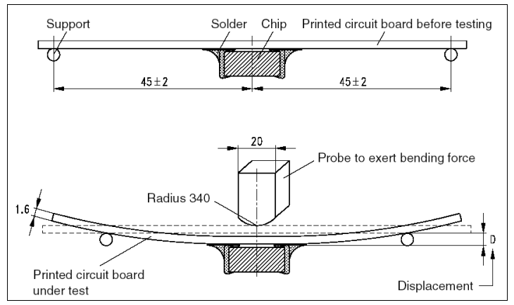

Figure 2: EIA-J RC 3402 [22]

This is a qualification type test and the board is deflected to the desired level and the capacitor is tested while the board is in the bent state. Passing of the test is accomplished if there are no visible cracks and the capacitance has not varied by more than a specified amount (classification dependent). Some standards for the test method are:

1. AEC-Q200, Automotive Electronics Council (2 mm deflection)
2. EIA-198D / PN-2271 (United States) (2 mm deflection)
3. IEC 384-10 4.35 (Europe)
4. EIA-J RC 3402 (Japan)

Unless noted, the tests do not specify the deflection of the device. This is left up to each manufacturer. Most manufacturers usually specify that their components can pass either a 1 mm or a 2 mm deflection limit. Some major manufacturers and their deflection limits are shown in Table 1. Manufacturers not listed do not publish a deflection limit.

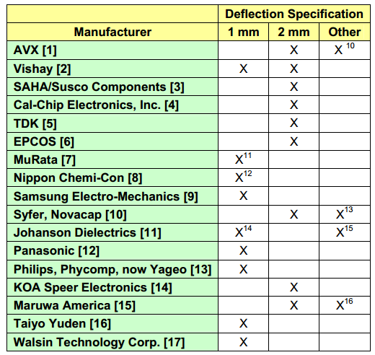

Table 1: Manufacturer deflection specifications

In-Circuit Testing (ICT) Analysis

What is ICT Analysis (Board Bending)?
There are a number of post-soldering processes during the manufacturing process that can induce a sudden and excessive flex, or bend, to the printed circuit board. The process of primary concern is in-circuit testing (ICT) with a bed of nails fixture, but other relevant activities include heat sink attachment, daughter card or connector insertions, standoff attachment, depaneling, and even inappropriate support of a large board with heavy components.

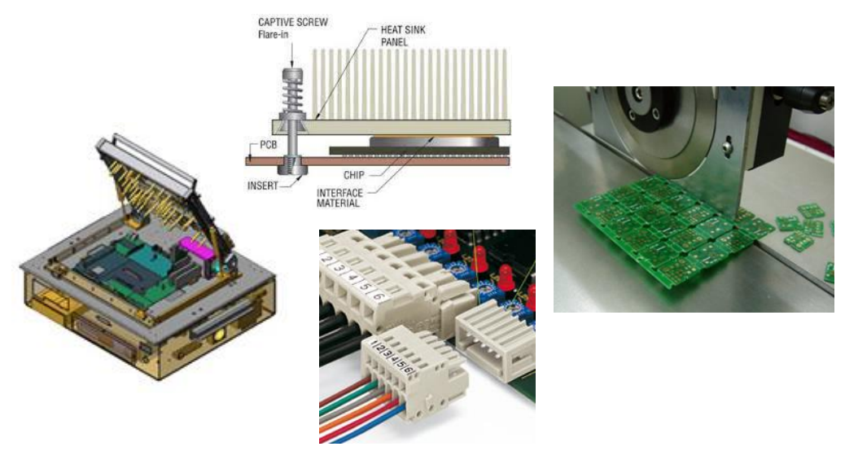

Depending upon the location, magnitude and speed in which the flexure occurs, components and solder joints on the board can be damaged. Common failure modes include ceramic capacitor flex cracking (left) and pad cratering (right).

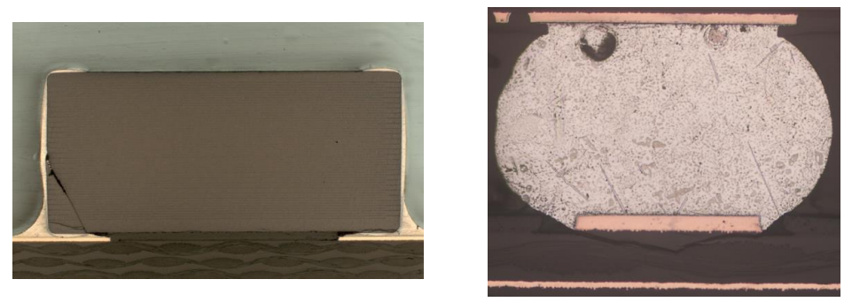

What are the drivers for failures during Board Bending?
Flexure or bending of a printed board is influenced by the load being applied, the area and location of the load, the area and location of support, the printed board material, and the printed board thickness. Component or interconnect failure is then determined by board level strain.

How does the software assess failures during Board Bending?
The Sherlock board bending (ICT) module is a Finite Element Analysis based simulation that utilizes board level strain and component parameters to determine the susceptibility of electronic packages to interconnect failures during a board bending event. The component factors which determine the critical board level strain a component can endure are a combination of physics based calculations and empirical parameters (developed by Steinberg).

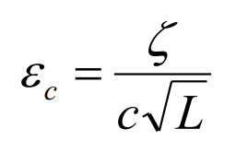
ζ is represents the base critical strain (600 microstrain; see below for explanation)
c is a component packaging constant (typically between 0.75 and 2.25)
L is component length

The finite element simulation is used to determine board level strains with the applied boundary conditions and point loads (which represent probe forces). Sherlock then post processes the board level strain results and extracts the maximum board level strain within the component footprint.
This board level strain is compared to the critical board level strain determined previously.

The initial critical board level strain was determined using data published in IPC-9704 for board bending events at high strain rates. Since the strain rate during the flex event is unknown, the software assumes that the maximum strain rate is occurring and utilizes the most conservative component board strain limits. For a board of standard thickness, 1.5mm or 63mil, this is 600 microstrain.

Note, because Sherlock is using finite element method to compute the maximum principal strain under the component, Sherlock does not require the board thickness adjustments that are used in
IPC-9704. As mentioned above, Sherlock does use information on the component package type and size to adjust the maximum principal strain.

Validation Data – Maximum Board Level Strain

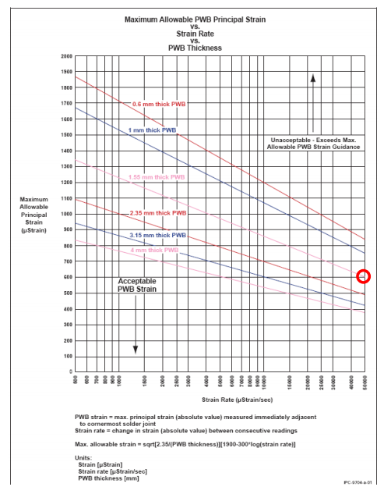

Figure 4: IPC-9704 guidelines for board level strains during board bending. Red circle
indicate the highest strain rate for a 1.55mm printed board.

What is Conductive Anodic Filament (CAF) Formation?
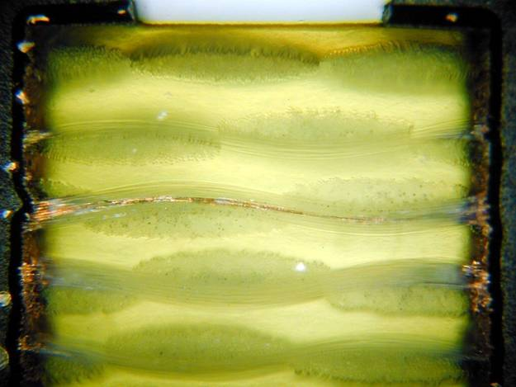
CAF is the migration of copper filaments within a printed circuit board under an applied bias. When the copper filaments bridge adjacent conductors, they can cause an abrupt, unpredictable loss of insulation resistance. When sufficient current is available, the mechanism can lead to burning and charring of the printed circuit board (PCB).

This failure mechanism was first reported by Ball Laboratories in 1976. The migration almost always occurs along the weave of the glass fiber bundle embedded within the laminate and prepreg layers that make up a rigid printed circuit board. Due to the presence of drilling damage and the large surface area of copper, the dominant failure site for CAF is between adjacent plated through holes (PTHs).

What are the drivers for CAF?
CAF is influenced by electric field (voltage / spacing), temperature, humidity, laminate material, soldering temperatures, and the presence of manufacturing defects (hollow fibers, poor wet-out, drilling damage).

How does the software assess CAF?
The software benchmarks the printed board design and quality processes to industry best practices.

Design is assessed because of CAF’s sensitivity to spacing and the increased influence of drilling damage at small separations between PTHs. In assessing the design, the software measures the wall-to-wall distance between the plated through holes (PTHs) along the orthogonal axes. The orthogonal axes (North, South, East, West) follow the weave of the glass fiber bundle.

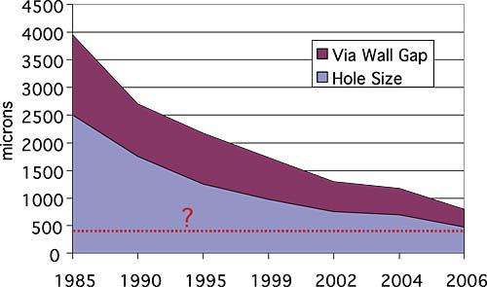
This distance is compared to the capability of the printed board industry to consistently build CAF-free printed boards. This capability is typically baselined to 20 mil (0.5 mm) wall-to-wall spacing along orthogonal axes. The current industry standard for minimum wall-to-wall spacing is based upon a fine-pitch ball grid array with 0.75 or 0.8 mm pitch and a 10 mil or 12 mil drill hole. Worst case, 0.75 mm (30 mil) pitch with 12 mil drill diameter, results in a wall-to-wall spacing of 18 mil (0.45 mm). This is roughly in line with trends plotted by Sun Microsystems and National Physical Laboratory. These values assume a nominal tolerance on hole location, which is typically 2 to 3 mil.

There are a number of suppliers and current designs that have wall-to-wall spacings less than 20 mil. While this combination of supplier, material, and design may be robust, the software encourages the designer to confirm the need for spacings less than 20 mil. At this time, wall-to-wall spacings less than 10 mil relatively rare, very aggressive, and are strongly discouraged for high-reliability applications.

Quality processes are assessed due to the critical influence of manufacturing defects. Comprehensive and consistent assessments of CAF susceptibility have been proven to reduce the risk of CAF events. Industry best practice is to re-perform a CAF assessment with the introduction of a new product family and to have the assessment performed by the original equipment manufacturer (OEM) or a neutral third party.

The frequency and type of qualification is compared to industry best practices and the wall-to-wall spacing to develop a reliability score for this mechanism.

Note, the software does not perform a reliability prediction for CAF. Existing reliability models are not accurate as they are unable to predict the presence of defects, which greatly influence the time-to-failure. The software instead benchmarks the design and quality processes to industry best practices.

Validation Data
There is no validation data as the CAF module does not predict a time to failure. Because CAF is very dependent upon the presence of manufacturing defects, current models do not accurately capture the absolute risks due to CAF and are best used as acceleration transforms to interpret test results or to develop qualification procedures.

What is Integrated Circuit (IC) Wearout?

Because complex integrated circuits within their designs may face wearout or even failure within the period of useful life, it is necessary to investigate the effects of use and environmental conditions on these components. The main concern is that submicron process technologies drive device wearout into the regions of useful life wellbefore wearout was initially anticipated to occur.

Semiconductor life calculations were performed using an integrated circuit reliability prediction software tool developed within DfR Solutions. The software uses component accelerated test data and physics-of-failure (PoF) based die-level failure mechanism models to calculate the failure rate of integrated circuit components during their useful lifetime. Integrated circuit complexity and transistor behavior are contributing factors during the calculation of the failure rate. Four failure mechanisms are modeled in this software using readily available, published models from the semiconductor reliability community, NASA/JPL, and research from the Professor Joey Bernstein from BarIlan University. These mechanisms are Electromigration (EM), Time Dependent Dielectric Breakdown (TDDB), Hot Carrier Injection (HCI) and Negative Bias Temperature Instability (NBTI). Taking the reliability bathtub curve (see Figure 5) into consideration, research shows that EM and TDDB are considered steady-state failure modes (constant random failure) where as HCI and NBTI have wearout behavior.

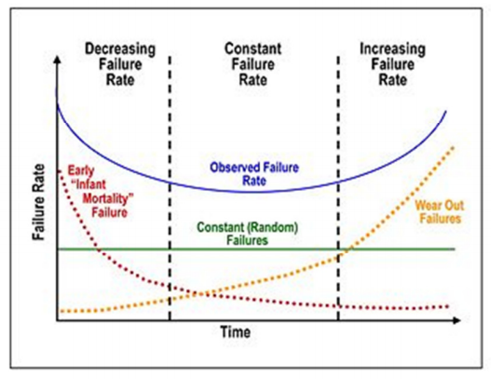

Figure 5 – Bathtub Curve Illustrating Wearout Mode

Each of these failure mechanisms is driven by a combination of temperature, voltage, current, and frequency. Traditional reliability predictions assume temperature, and sometimes voltage as the only accelerators of failure. Each failure mechanism affects the on-die circuitry in a unique way.
Therefore, each is modeled independently and later combined using associated weighting factors proprietary to this software. This software uses circuit complexity, test and field operating conditions, derating values, and transistor behavior as mathematical parameters. Since there is not one dominant parameter set, each mechanism could have the largest contribution to a component's failure rate. In general, there is no dominant failure mechanism, thus for a specific component as few as one or as many as all four mechanisms can affect it.

Failure rates were calculated using a specialized set of time to failure (TTF) equations. Time to Fail is the approximate reciprocal of failure rate. Mean time to failure (MTTF) is the mean or expected value of the probability distribution defined as a function of time. MTTF is used with non-repairable systems, like an integrated circuit.Non-repairable systems can fail only once. For repairable systems, like a re-workable printed circuit board or assembly, mean time between failures (MTBF) is used as the metric for probability distribution. Repairable systems can fail several times. In general, it takes more time for the first failure to occur than it does for subsequent failures to occur. The mathematics are the same for MTTF and MTBF. Since this analysis method is for integrated circuits, they can be replaced on the assembly, they themselves are non-repairable circuitry.

Overview of Integrated Circuit Failure Mechanisms

A brief explanation of each failure mechanism is necessary to understand their independence from each other. Electromigration (EM) affects the interconnects in an integrated circuit. It is characterized by the migration of metal atoms in a conductor downstream of the electron flow.
The result of electromigration is opens or voids in some portions of the conductor and corresponding hillocks in other portions. It is worth noting that although electromigration affects metal (wires and vias), it is a prevalent failure mechanism for semiconductor devices because stress migration and atomic diffusion of metals occur at the metal portion of metal oxide semiconductor (MOS) devices and the conductors between them.

Time Dependent Dielectric Breakdown (TDDB) is a failure mechanism which design rules cannot prevent. Design rules do, however, limit the total gate dielectric area exposed to a given electric field. The gate dielectric breaks down over a long period of time due to a comparatively low electric field, relatively speaking between technology nodes. In advanced nodes and considering dimensions of features, larger fields are worse. The breakdown is caused by formation of a conducting path through the gate oxide to the substrate due to electron tunneling current. If the tunneling current is sufficient, it will cause permanent damage to the oxide and surrounding material. This damage will result in performance degradation and eventual failure of the device.
If the tunneling current remains very low, it will increase the field necessary for the gate to turn on and impede its functionality. Research has shown that in smaller technology nodes (starting around 0.1 micron) that TDDB has become time independent or having a constant failure rate. In larger nodes, several breakdown sites will progressively weaken the dielectric, but in these smaller nodes, the area of the breakdown site is compromising larger and larger percentages of the total area of the oxide - whereas one breakdown site can cause immediate failure.

Hot Carrier Injection (HCI) occurs in both conducting nMOS and pMOS devices stressed with drain bias voltage. High electric fields energize the carriers (electrons or holes), which are injected into the gate oxide region. The degraded gate dielectric can then more readily trap electrons or holes, causing a change in threshold voltage, which in turn results in a shift in the subthreshold leakage current. Hot Carrier Injection is accelerated by an increase in bias voltage and is predominately worse during lower stress temperatures, e.g., room temperature. Therefore, HCI damage is unlike the other failure mechanisms as its damage will not be replicated in a High Temperature Operating Life test, or HTOL, which is commonly used for accelerated testing (typical HTOL conditions are operate the device under test at a maximum ambient temperature calculated from the power dissipation and junction temperature of the device while at maximum operating voltage ratings).

Negative Bias Temperature Instability (NBTI) occurs only in pMOS devices stressed with negative gate bias voltage at elevated temperatures. Like HCI, degradation occurs in the gate oxide region allowing electrons and holes to become trapped. NBTI is driven by smaller electric fields than HCI which makes it a more significant threat at smaller technology nodes where smaller electric fields are used in conjunction with smaller gate lengths. The interface trap density generated by NBTI has an inverse proportionality to oxide thickness.

Validation of Integrated Circuit Reliability Prediction
DfR Solutions conducted a validation study for the integrated circuit reliability calculator. Field return data was gathered from a family of telecommunication products. All products within this family had common mission profiles, environmental stresses and users. Failed parts were categorized and the five most common integrated circuit failures were identified. These components are shown in Table 2 below. Field return data including electrical and thermal measurements were used to correlate component-level failure rates to independent predictions made by the multiple mechanism model used by the integrated circuit reliability calculator.

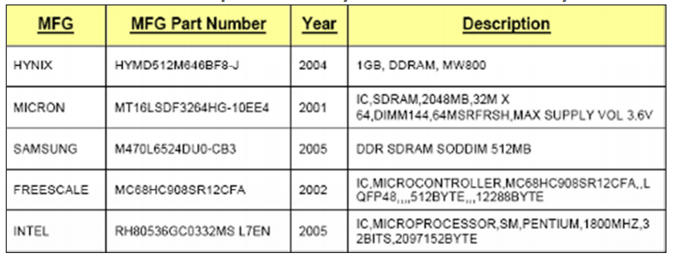
Table 2: Components Analyzed for Validation Study

Integrated Circuit Lifetime Prediction - Field Returns

Lifetime predictions for five common integrated circuits was performed and compared to field return data. Field return data is shown in Table 3. The duty cycle under "Specifications" corresponds to the number of 8-hour shifts per day that the system was used. A duty cycle adjustment to the calculated failure rate was made for components that operated less than full duty cycle (24-hours per day). The applicable technology node is displayed in this column as well. Field temperature was measured with thermocouples as the ambient temperature near each component during the field return study.

Component complexity and electrical characteristics were extracted from corresponding component documentation. This data is shown in Table 4. Equivalent function sub-circuits are used as part of the calculator to organize the complexity of the integrated circuit being analyzed into functional group cells. For example: 1 bit of SRAM,1 bit of DRAM, one stage of a ring oscillator, and select modules within Analog-to-Digital (ADC) circuitry. For memory devices, there is a placeholder in the functional groups distribution; a one (1) represents any memory density as the functional group weight of this type is 100%.

The standard procedure for integrated circuit analysis uses high temperature operating life
(HTOL) test conditions: ambient temperature, supply voltage, and core voltages. The HTOL ambient temperature was calculated for each component. Thermal information was gathered from the datasheet and each manufacturer's website. Junction temperature, power dissipation, and junction-to-air thermal resistance are used to calculate ambient temperature. Junction-to-air thermal resistance can either be found on a component's datasheet or in thermal characteristic databases for package type and size; i.e. Texas Instruments or NXP Semiconductors websites.
Table 5 shows the thermal and electrical characteristics, for both test and field conditions, of each component analyzed.

Inputs on the calculator are the test parameters and results from the standard JEDEC test:
• 25 devices under test
• 1000 hour test duration
• zero (0) failures
• 50% confidence level

Table 3: Calculator Inputs: Field Return Data
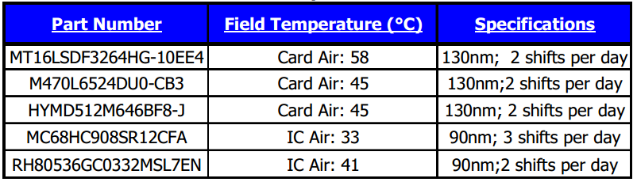

Table 4: Calculator Inputs: Component Data Sheets

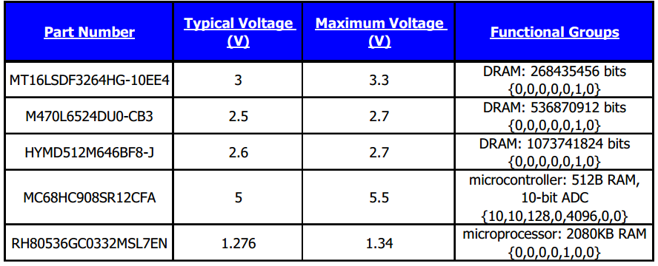

Table 5: Calculator Inputs: Test and Field Operating Conditions
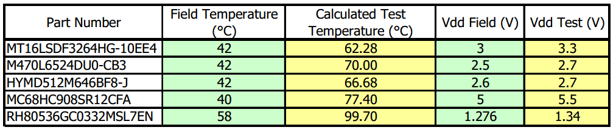

The results in Table 6 and the corresponding graphs clearly demonstrate the accuracy and repeatability of the multi-mechanism model to predict the field performance of complex integrated circuits. It also demonstrates the fallacy of the single FIT paradigm typically promoted by integrated circuit manufacturers based on standard industry qualification test procedures. It can be seen that complex integrated circuits do have higher failure rates than standard industry qualification test procedures predict.

Components whose predicted failure rate is relatively large compared to similar device types, i.e.
Hynix SDRAM, can be categorized as more sensitive to electrical and environmental tolerances.
They will be subjected to greater stresses at the periphery of these sensitive operating ranges.
Components with large operating ranges are typically operated at an average nominal value.
Therefore, small fluctuations away from the mean of these larger ranges will not excessively stress the components. Figure 6 below illustrates stress differences exhibited on components with different operating ranges. It shows the operational range of two components with different magnitudes of device tolerances. The same system operating range is overlaid on both components. The component on the right is more sensitive to temperature fluctuations and has tighter tolerances. Under the same conditions, this component experiences greater stresses.

The Hynix SDRAM is much like this example having a maximum voltage rating closer to the typical voltage rating whereas the other components analyzed have a larger degree of operational freedom.

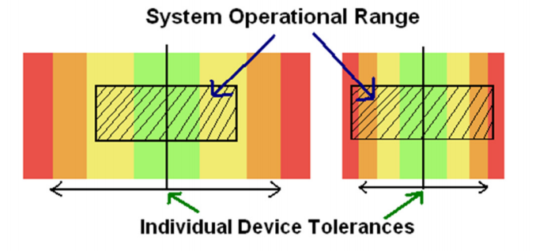
Figure 6: Stress Difference Exhibited on Components with Different Magnitudes of Device Tolerances

The use of the DfR tool will allow for much more accurate prediction of the integrated circuit reliability as shown in Figure 7 and will allow designers and program managers to perform tradeoff analysis, set cost effective maintenance schedules, and avoid critical failure behavior in mission critical applications.

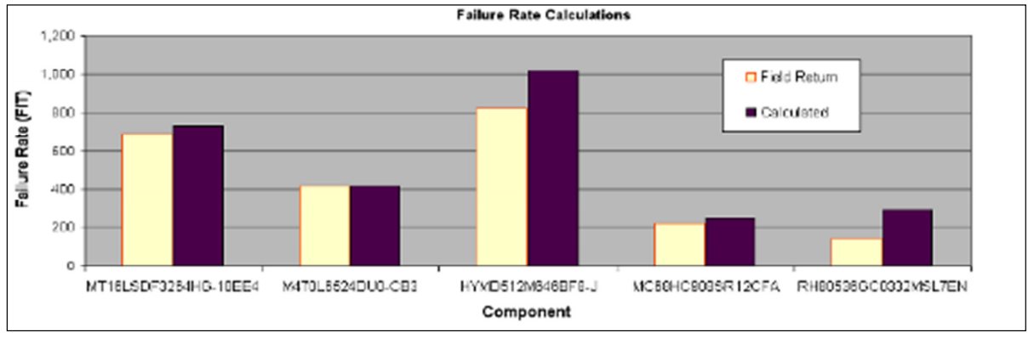

Table 6: Failure Rates of Components Under Analysis

References:

Flex Cracking of Multilayer Ceramic Capacitors
- Electronic Packaging and Interconnect Handbook, Harper, C. A. editor-in-chief – 2nd
ed. McGraw-Hill 1997, Pages 5.2 -5.3
- M. Cozzolino, G. Ewell, “A Fracture Mechanics Approach to Structural Reliability of Ceramic Capacitors”, Ieee Transactions on Components, Hybrids, and Manufacturing Technology, Vol. CHMT-3, No. 2, June 1980
- Irwin, G.R., and Kies, J.A., “Critical Energy Rate Analysis of Fracture Strength”, Welding Research Supplement, April 1954, pp. 193-s – 198-s.
- McKinney, K. R., Rice, R. W., “Mechanical Failure Characteristics of Ceramic Multilayer Capacitors” J. Amer. Ceram. Soc., vol.69, no. 10, p. C-228 – C-230, 1986
- Maxwell, J., “Cracks: The Hidden Defect”, Tech. Rep., AVX Corp., 1988
- L. Condra, G. Johnson, and A. Christou, “Reliability of Surface Mount Capacitors Subjected to Wave Soldering”, IEEE Trans. CHMT, Vol. 15(4), pp. 542- 552, 1992.
- Kemet, “Capacitance Monitoring While Flex Testing”, Jim Bergenthal and John D. Prymak
- T. Panchwagh and P. McCluskey, “Reliability of Surface Mount Capacitors Subjected to Wave Soldering” ,International Journal of Microelectronics Packaging, Vol. 2, No. 1, February 1996
- Franken, K., Maier, H., Prume, K., Waser, R., “Finite ElementAnalysis of Ceramic Multilayer Capacitors: Failure Probability Caused by Wave Soldering and Bending Loads”, J. Amer. Ceram. Soc., vol. 83, no. 6, p. 1433-1440 (2000)
- AVX offers a soft-termination capacitor with a deflection limit of 5 mm
- GRM03, GRM15 capacitors, PWB thickness 0.8 mm
- Printed wiring board thickness 1.0 mm (1.6 is the standard)
- Syfer offers a polymer-termination capacitor with a deflection limit of 5 mm
- NPO class dielectrics
- X7R, Deflection specification 0.5 mm on FR-4
- Flexion termination, 8 mm deflection

Conductive Anodic Filament
- Susceptibility of Glass-Reinforced Epoxy Laminates to Conductive Anodic Filamentation, Chris Hunt, March 1, 2007, Circuitree, www.circuitree.com/CDA/Archives/BNP_GUID_9-5-2006_A_10000000000000060537
- K. Sauter, Evaluating PWB design, manufacturing process, and laminate material impacts on CAF resistance; CircuiTree, 10-19 (2002)
- W. Ready et. al., Microstructure of conductive anodic filaments formed during accelerated testing of printed wiring boards, Circuit World, 21, 5-10 (1995)
- J. Augis, et. al., A humidity threshold for conductive anodic filaments in epoxy glass printed wiring boards, Proc. 3rd Inter. SAMPE Elec. Conf., 1023-1030 (1989)
- Keith Rogers, Craig Hillman, and Suzanne Nachbor, Conductive Filament Formation Failure in a Printed Circuit Board, Circuit World, Vol. 25 (3), pp. 6-8, 1999 (www.dfrsolutions.com/uploads/publications/1999_CFF_Hillman-Nachbor.pdf)

IC Wearout
- IPC-TR-579, Round Robin Reliability Evaluation of Small Diameter Plated-Through Holes

