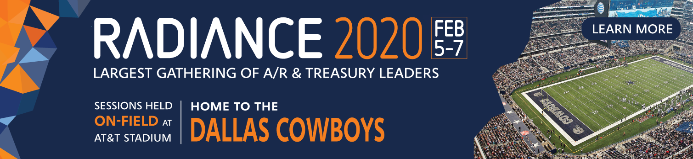

Hi [manager name],

I would like your approval to attend HighRadius’ annual Order-to-Cash and Treasury Unconference, **Radiance 2020** at AT&T Stadium, Dallas from February 5th-7th 2020.

I believe attending Radiance 2020 ([radiance.highradius.com](https://radiance.highradius.com/)) will help me gain actionable insights to drive higher efficiency to our existing processes, and improve the key metrics including DSO, cost-savings and working capital.

**Conference Highlights and Advantages for our Company:**

* I will get the opportunity to be a part of 100+ peer-led sessions and panel discussions by thought leaders on industry best practices and case studies
* 1:1 value benchmarking workshops to gain insights on our existing processes
* Network, interact and learn from the 1000+ attendees from organizations including adidas, Uber, Danone, Honeywell, GE, AB InBev and more
* LIVE product demos and opportunity to talk with their team behind the AI technology

I feel confident that I’ll bring back a ton of useful notes and takeaways for the team. The conference also provides **slides and videos** of presentations that we could use internally as well.

I plan on reaching out to the Radiance team to facilitate an introduction with the following presenters to improve our operations:

[

]

These are my projected costs for attending Radiance 2019:

• Airfare – $

• Hotel – $127/night negotiate rate at the Doubletree

• Registration (meals included) – $695 (early bird until Dec 15th) / $995 (regular)

• Miscellaneous (local travel, incidentals) – $

I believe this event will have a significant ROI for our organization.

I would appreciate your approval of this request.