Guide on how to take the computer based safety courses
SafetySkills will send you a notification of the training that is assigned to you – please follow the below instructions and kindly take the course before the deadline.

Login to SafetySkills
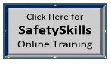
Use the link in the SafetySkills email notification or click on the SafetySkills icon on the EHS SharePoint Site. http://agcweb/cphd/EHS/Safety%20courses/Forms/AllItems.aspx

Login is your initials and not the full AGC email unless you only have two initials then your login is your full AGC email.
Password: First time you log in you are asked to create a password.

If you forget your username or password –Then use the option “Forgot login or password” and you will get an email with your username and a link to create a new password.

My Training
Once you login, you can launch courses that you have been assigned under “My Training”
To launch a course, select the "Name" and hhe course will open in a separate window.

Course is not working - Then use Google Chrome instead of Internet Explorer as your Internet Explorer might not be the most updated version.

Complete the course by taking the quiz and remember to always check if there is a last page to click on, to make sure that you have completed the course.

Certificate
After you complete the training, you can open your certificate by clicking on “view”
If you want then print the certificate and place it your “training folder”.
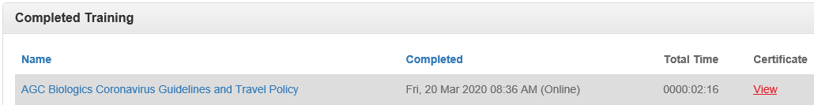

If you have any questions or problems then contact:
EHS Manager and SafetySkills System Administrator - Shahida Hamid

