Frequently Asked Questions for the Graduate School of Bankers
Residential Life Information Technology

- What are the supported device Operating Systems?
- The LSU wireless network supports Windows 7 and above, Mac OS X and above, Linux, as well as most mobile device operating systems.

- Will I need anything special installed on my computer in order to connect to the LSU wireless network?
- The LSU wireless network supports wireless adapters /cards that are Wi-Fi certified and support WPA/WPA2 enterprise. We highly recommend that you get an adapter that supports the following wireless standards and bands: 802.11a/n (5GHz) and 802.11g/n (2.4GHz).

- What speed is the LSU wireless network?
- The LSU wireless network 802.11a/b/g connections in common areas will have a maximum connection speed of up to 54Mbps (11Mbps on 802.11b).

- Will I need a username and password to logon to the LSU wireless network?
- Yes.
Username: banking@lsu.edu
Password: (You will receive password upon arrival at Session.)

- Which LSU wireless network do I connect to?
- You will connect to eduroam more details about eduroam are listed below

- Will I be able to VPN to my bank’s network from LSU’s network?
- No. For security purposes, none of the connections in the residence halls/apartments can VPN to another network.

- Can I use a dial-up service instead of the high speed connections?
- No. There are no telephones in the rooms.

- What is the policy statement for LSU’s network?
- A copy of “Computer Users’ Responsibilities” is attached in this information packet.

- Is there a support number that I can call if I experience problems with my connection?
- Yes, please contact the Residential Life IT Help Desk Monday through Friday 8am to 4:30 pm for support. For help call (225) 578-0560 from your cell phone.

Enjoy your Stay at LSU
Configure Computer for connection to the LSU wireless network (eduroam)

We recommend that you first disable or uninstall any of the following if they are on your computer:

- Internet Connection Sharing (ICS)
- Firewalls (McAfee Firewall, Norton Personal Firewall, BlackICE Defender, Tiny Firewall, Norton Internet Security) *Microsoft Windows Firewall can be used
- DSL and Cable modem software

The above programs may prevent you from connecting to the LSU wireless network. You can enable your firewall software after you have verified your successful connection to the LSU wireless network.

Connecting to the LSU wireless network (eduroam)

Connecting to eduroam with Windows operating systems
1. Click the Start button and in the Search field type: ncpa.cpl and press enter
2. Right-click on Wireless Network Connection and select Connect/Disconnect.

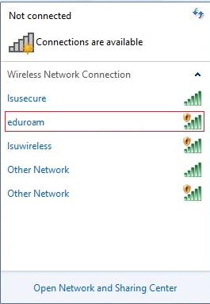

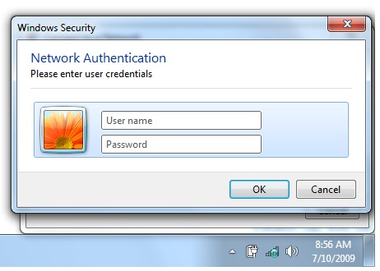

4. Enter your assigned User name and password.
User name: banking @lsu.edu
Password: (You will receive password upon arrival at Session.)

3. Click on eduroam, then click Connect.

Connecting to campus wireless (eduroam) via Step-by-Step Instructions on all supported operating systems

Mac OS X Operating Systems -
Mac OS X Yosemite (10.10)
Mac OS X Mavericks (10.9)
Mac OS X Mountain Lion (10.8)
Mac OS X Snow Leopard (10.6)
Mac OS X Tiger (10.4) & Below

Mobile Devices:
Mobile Devices: LSU Overview
Android
Windows Phone 7
Chromebook
iPhone & iPod Touch
iPad
Nook
Kindle Fire
RAZR
XOOM

Windows Operating Systems –

Windows 10
Windows 8.1
Windows 8 Metro
Windows 7

Linux

Linux

Note: It is highly recommended that you utilize the LSU wireless (eduroam) network during your stay on campus. If there are extenuating circumstances that require you use the wired network, you should contact the Residential Life IT helpdesk at 225-578-0560 for further assistance.

