N e w s R e l e a s e
Media Contact: Nora DePalma
nora.depalma@oreilly-depalma.com
770.772.4726
Social:
@SteamTherapy
facebook.com/mrsteamtherapy
MrSteam AirTempo™ Wireless Control Dramatically Simplifies
Steam Shower Installation, Saving Time and Expense
LONG ISLAND CITY, N.Y. (february 23, 2016) — MrSteam recently unveiled the steam-shower industry’s first wireless control for residential applications. The new, user-friendly AirTempo Control™ offers users exceptional functionality and the convenience of remote control, while also providing substantial time- and labor-savings to installers.
Ease of installation: Powered by replaceable, long-lasting lithium batteries, the AirTempo Control communicates wirelessly, eliminating the time, hassle and expense of running a cable from the control to the generator. Installation is largely a matter of deciding where to locate the AirTempo, which mounts in seconds with no tools required.
The wireless AirTempo Control from MrSteam eliminates the hassle of hard-wiring the shower control to the steam generator, cutting installation costs while providing the user with all the benefits of remote control.
“In a typical installation, you must run wire from the generator behind the wall through conduit to the control, avoiding other wires and high-current devices,” explains MrSteam president Michael Pinkus. “With wireless, you avoid all that cutting and routing, as well as the most nerve-wracking process of all: cutting a hole in the shower’s marble, tile or granite walls to mount the control and route the cable.”
If the user decides she doesn’t like where the control is mounted, relocation is relatively easily, according to Pinkus, adding: “It may often take a few steam sessions to determine the optimal location.”
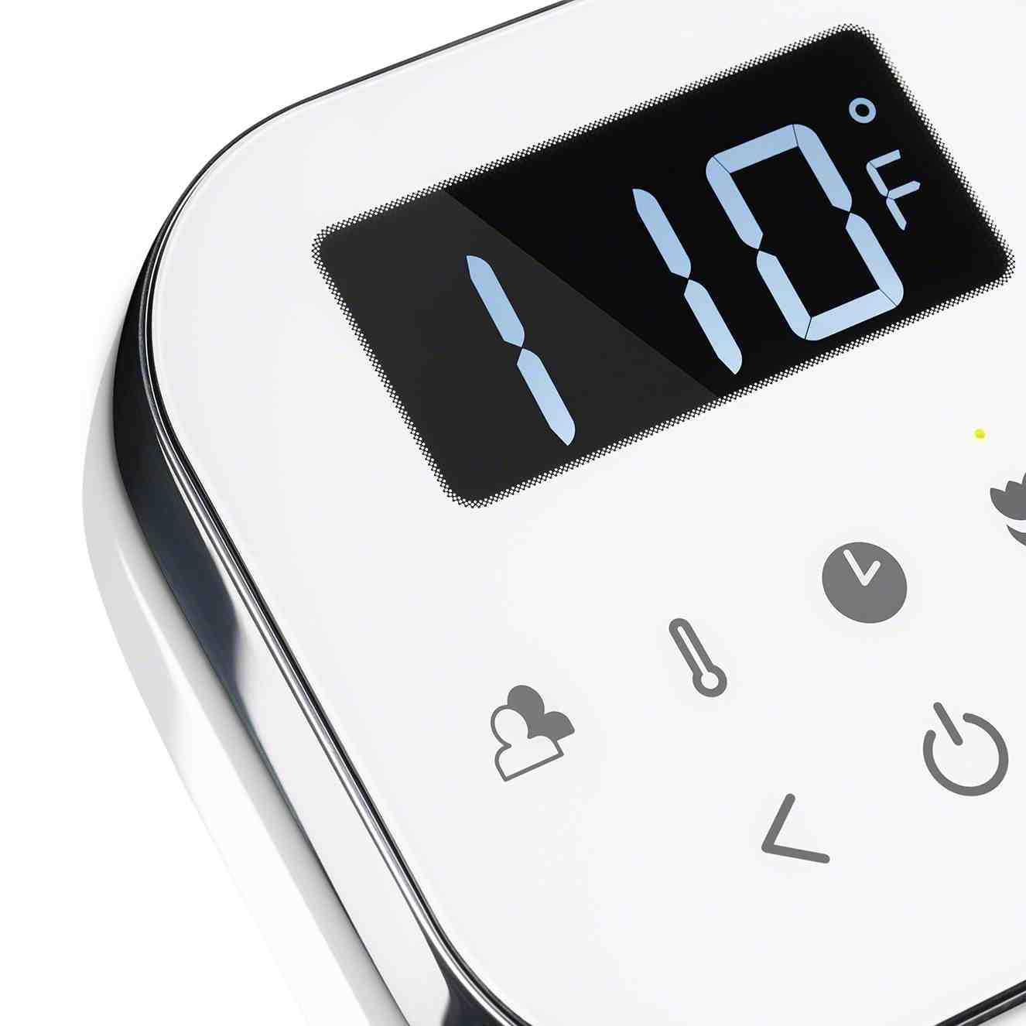
Ease of use: Because the AirTempo is untethered to any equipment, the end user can remove it from its dock for use as a remote control outside the steam shower; e.g., in an exercise room, on a bedroom nightstand or by the coffeemaker on a kitchen countertop. The user can activate the steam bath remotely in advance of entering the shower. Should she find herself delayed, no problem: The generator automatically shuts off if the control is not returned to its dock within five minutes.
“When the user steps into the steam room, she simply slides the remote back onto the dock,” says Pinkus. “The key point is, she doesn’t need a separate remote to activate the steam shower.”
Wireless also permits far greater flexibility in the placement of the generator in relation to the steam shower. In lieu of hard-wiring through walls and ceilings, the AirTempo communicates with the generator through a small electronic receiver that attaches to the generator with a cord. The control itself has a transmission range of 60 feet, but the receiver extends it by another two thirds, allowing the AirTempo and the generator to communicate from a distance of 100 feet.
The touch-activated, fused silica glass screen panel responds quickly to user inputs. But after a few seconds of nonuse, the panel reverts to sleep mode automatically to save energy.
Mounting options: Because the control needs no wires, it can be surface-mounted to almost any steam-room wall, even — in another breakthrough for the steam industry — on a glass wall. This type of mounting is not an option with a conventional wired control, because such an installation would require making a hole in the glass to route the cable.
A flush-mount option is also available, with MrSteam providing a plated forged-brass bezel for mounting in the wall. The control can also be mounted inside or outside the steam shower. If the latter option is chosen, a remote temperature sensor must be installed inside the shower enclosure.
-more on next page-
Highly sensitive to even slight changes in ambient temperature, the AirTempo sensor technology and its proprietary software regulate the steam and maintain optimal, steam-room temperatures.
Energy-saving operation: Intuitive to operate, AirTempo technology features a large and easy-to-read LED display with a pleasant blue readout against a black or white face. Icons indicate the current status of the AromaSteam and ChromaSteam® lighting.
The touch-activated glass screen panel responds quickly to user inputs. But if left idle, the panel reverts to sleep mode automatically to save energy while still maintaining the programmed temperature.
AirTempo comes standard with a polished chrome trim for an elegant, upscale design. When it is time to remodel the bath, this decorative trim can be changed out without having to purchase a new control. Additional designer finishes — polished nickel, brushed nickel, polished brass, brushed bronze, oil rubbed bronze and even custom-plating options — are available to complement any bath décor. A high-grade, cool-to-the-touch steamhead in a matching finish is part of every AirTempo package.
The AirTempo has a suggested retail price starting at $1,100; designer finishes are extra. AirTempo is available exclusively through MrSteam dealers nationwide. Locate an authorized MrSteam dealer at www.mrsteam.com.
ABOUT MRSTEAM
MrSteam® provides the finest quality steam showers and towel warmers for residential and commercial use. Mr. Steam products, such as iSteam®, help support a healthy lifestyle with innovative accessories, including the AromaSteam aromatic oils system, the ChromaSteam® mood lighting system, in-shower MusicTherapy® speakers, and in-shower seating to enhance the steam-bathing experience. For more information, please visit www.mrsteam.com or call toll-free: 1-800-76-STEAM.

