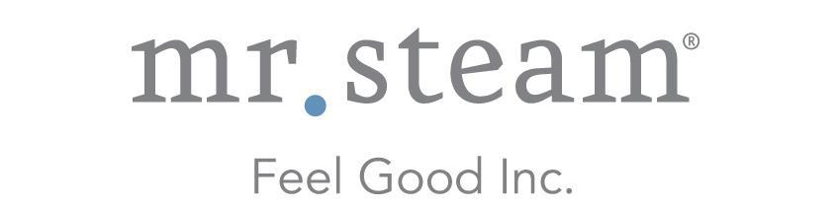

N e w s R e l e a s e
Media Contact: Nora DePalma
nora.depalma@oreilly-depalma.com
770.772.4726
Social: @SteamTherapy
facebook.com/mrsteamtherapy

MrSteam Expands Business Opportunities with
New Sales and Marketing Appointments
LONG ISLAND CITY, NEW YORK (march 21, 2017) — MrSteam, the trusted manufacturer of a wide selection of innovative steam shower products and accessories, announces the appointment of Sandra Pearce as Marketing Manager and T.J. Mullally as Southern Regional and E-Commerce Sales Manager. These new positions will allow MrSteam to respond to the rapidly growing interest in home steam showers and other spa-like amenities, while providing key support in marketing and brand messaging as the MrSteam brand continues to expand.
Pearce brings more than 25 years of sales and marketing experience to MrSteam, most recently as an independent Marketing and Business Development Consultant. Guided by her background in customer engagement and inbound marketing campaign development working for leading brands in the health and wellness industry, Pearce will oversee content, production, and distribution of all marketing and publicity materials. She is tasked with creating a diverse suite of marketing tools, in addition to developing messaging and presentations for showrooms. Previously, Pearce served as Marketing Director at Apex Energetics and Marketing Manager at MPA Media. She studied at Cerritos College.
Sandra Pearce has been appointed Marketing Manager for MrSteam.
- more -

In his new position, Mullally brings a wealth of industry know-how, as he works to increase e-commerce sales, as well as manage showroom sales in the southern states. Prior to joining MrSteam, he was employed as the Director of Business Development at PIRCH kitchen and bath showrooms, Director of Sales for Graff Faucets, and National Sales Manager for JACLO. Mullally also functioned as an executive officer of the Decorative Plumbing and Hardware Association (DPHA). He served as a Staff Sergeant in the U.S. Army and attended Georgia State University.
T.J. Mullally has been appointed Southern Regional and E-Commerce Sales Manager for MrSteam.

For more information, please visit www.mrsteam.com.

ABOUT MRSTEAM
MrSteam® provides the finest quality steam showers and towel warmers for residential and commercial use. Mr. Steam products such as iSteam® help support a healthy lifestyle with innovative accessories, including AromaSteam™ aromatic oils system, ChromaSteam™ mood lighting system, in-shower MusicTherapy® speakers, and in-shower seating to enhance the steam bathing experience. For more information, please visit www.mrsteam.com or call toll-free: 1-800-76-STEAM.

###

