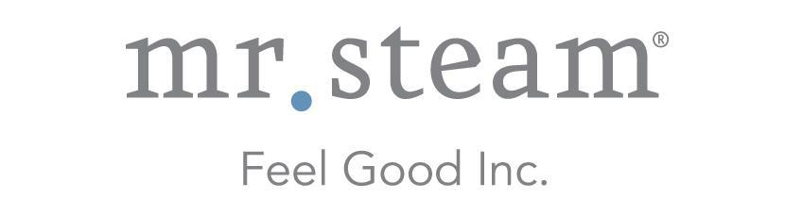

N e w s R e l e a s e
Media Contact: Nora DePalma
nora.depalma@betterpr.com
770.772.4726
Social:
@SteamTherapy
facebook.com/mrsteamtherapy

MrSteam Launches New Lexington Towel Warmer Collection, Combining Flawless Form and Function

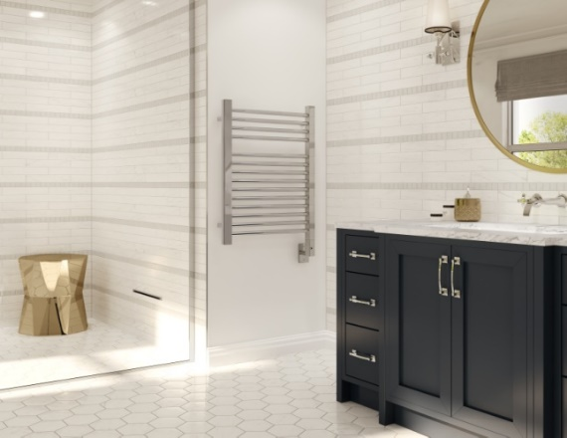
LONG ISLAND CITY, NEW YORK (December 11, 2017) — With wider bars to extend the warmth on towels, the new Lexington Collection towel warmers from MrSteam are perfect enhancements for contemporary spa bathrooms.

Made of high-quality stainless steel in polished or brushed stainless finishes, the five wall-mounted models of the Lexington Collection come standard with a digital timer allowing for convenient pre-start and automatic shutoff.
Lexington Collection towel warmers from MrSteam are made of high-quality stainless steel in polished or brushed stainless finishes and fit equally well in urban, contemporary and loft style settings.

What other styles attempt to conceal, the Lexington Collection’s industrial design daringly puts on display. With tubing and slats, these pieces fit equally well in urban, contemporary and loft style settings, turning bold structural elements into showpieces.

“Everyone loves stepping out of a shower or steam bath into a gently warmed towel,” said Martha Orellana, vice president of marketing for MrSteam. “The wider bars of the new Lexington Collection spread heat to a greater area, providing even more of the “ahh factor” that MrSteam towel warmers are known for.”

Lexington Collection towel warmer styles are available in heights ranging from 24 inches to 41 inches with MSRP from $2,060 to $3,060, based on size and finish. All models carry a two-year warranty and are cULus-Listed. They are available exclusively through MrSteam dealers, searchable at mrsteam.com/dealer-locator.

ABOUT MRSTEAM
MrSteam® provides the finest quality steam showers and towel warmers for residential and commercial use. Mr. Steam products, such as iSteam®, help support a healthy lifestyle with innovative accessories, including the AromaSteam aromatic oils system, the ChromaSteam® mood lighting system, in-shower MusicTherapy® speakers, and in-shower seating to enhance the steam-bathing experience. For more information, please visit www.mrsteam.com or call toll-free: 1-800-76-STEAM.

###

