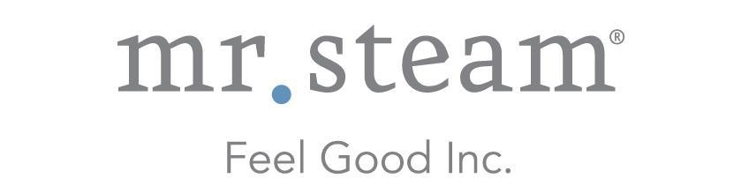

N e w s R e l e a s e
Media Contact: Nora DePalma
nora.depalma@oreilly-depalma.com
770.772.4726
Social:
@SteamTherapy
facebook.com/mrsteamtherapy

Enhanced iSteam®3 SteamShower Control Offers
Luxurious New Options to Personalize
the Home Spa Experience

LONG ISLAND CITY, NEW YORK (July 11, 2017) — Delivering unsurpassed swipe-touch functionality and sleek, contemporary styling, the iSteam®3 control from MrSteam offers a variety of exciting new options designed to perfectly adapt to the preferences of every bather, seamlessly personalizing the steam shower environment.
Now available in black and white finishes, iSteam3 now provides the option to choose a black or white display screen mode, fully accommodating the user’s tastes and steam shower design. The iSteam3 is design-matched to the high-grade AromaSteam SteamHeads and pairs seamlessly with the industry-leading MrSteam E Series Residential Steam Generators.
The new iSteam3 home SteamShower Control from MrSteam offers enhanced luxury options for customization, including a choice of black or white screen modes, as well as
six language options.

Even installing the control is a more relaxing experience with the iSteam3, which features a special new “flip” function that allows the interface to rotate 180 degrees in the event that the control is unintentionally installed upside down.

Appealing to a wide range of customers, the iSteam3 control interface now offers a choice of six different languages, including English, German, French, Spanish, Italian and Russian. Users can easily change the language through the “Settings” screen. For additional convenience, iSteam3 also provides a real-time clock feature and the controls can be password protected.

New features available with the iSteam3 include the ability to store settings for up to eight different users to deliver the ultimate in relaxation and customized luxury. The innovative AutoStart feature has been enhanced to now offer up to eight different users the convenience of pre-starting their steam shower to warm up in advance to their personalized, preferred temperature.

Designed for exceptional performance in the hot and humid environment of a home steam shower, the iSteam3 control offers a superb user experience and intuitive navigation. The bather can control a wide array of features with the simple touch of a finger, including temperature, duration, AromaSteam, ChromaSteam®3 and AudioSteam®3. Additionally, users can control functions of the steam shower on the go with the free SteamLinx App from their smartphone or mobile device.

The iSteam3 has a suggested retail price of $1,400. Locate an authorized iSteam3 dealer at mrsteam.com.

ABOUT MRSTEAM
MrSteam® provides the finest quality steam showers and towel warmers for residential and commercial use. MrSteam products such as iSteam®3 help support a wellness lifestyle with innovative accessories, including AromaSteam aromatic oil injection system, ChromaSteam®3 mood lighting system, in-shower AudioSteam®3 music system, and in-shower seating to enhance the steam bathing experience. For more information, please visit www.mrsteam.com or call toll-free: 1-800-76-STEAM.

