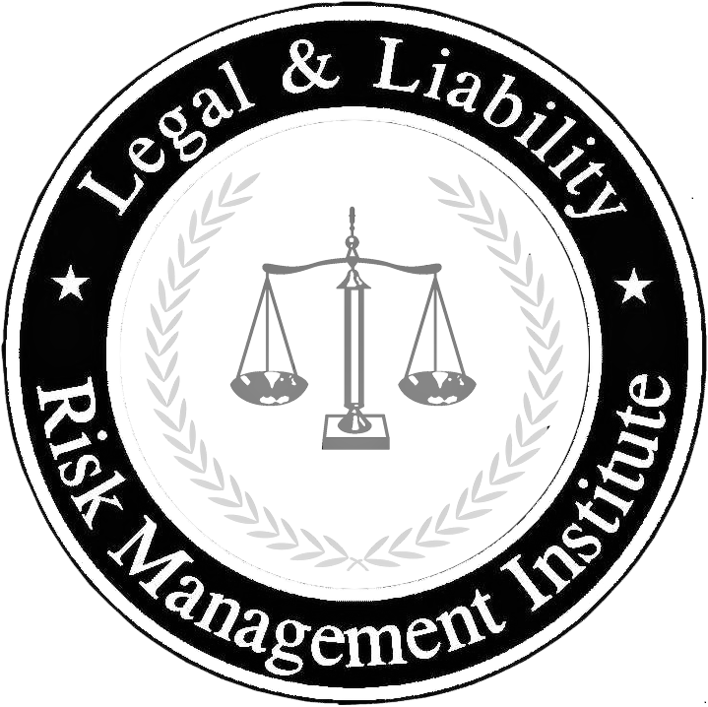

**Access Jack Ryan’s April 14th Covid- 19**

**Webinar Video Links Below:**

**[Covid-19 Webinar](https://youtu.be/FpiGeklrM-M)**

**Over the past few weeks Law Enforcement in the United States has had to deal with the National Emergency caused by the Corona Virus. The purpose of this webinar is to discuss law enforcement’s response to this crisis on several layers to include:**

**· Operations: Limiting Service Operations to Limit Exposure**

**· Enforcement Issues: Legal Basis for Enforcing State of Emergency Regulations**

**· Internal Functioning: Changing the Internal Functions to Limit Exposure**

**·  Contamination/Decontamination Issues**

**·  Levels of Exposure and the Proper Response: When an Officer is Exposed**

**This one-hour session will be a nuts and bolts informational session providing practical information gleaned from over a thousand law enforcement agencies nationwide and the manner in which they are operating and responding during this National Pandemic.**

Have questions? Call us at **(317) 386-8325** for assistance.

**Legal and Liability**

**Risk Management Institute**

**Reduce Liability ⦁ Enhance Professionalism**