ATTENTION
INSTRUCTIONS FOR USING THIS MODEL
COVID-19 PANDEMIC PREPAREDNESS & RESPONSE PLAN
This template is a guide that Cognibox makes available to help you write your own COVID-19 Pandemic Preparedness and Response Plan for your business. This template is neither exhaustive nor perfectly adapted to your reality.
The COVID-19 pandemic is evolving so rapidly that Cognibox cannot guarantee that this model is up to date and adapted to the current situation. Please consult the websites of your local government and public health authorities for their latest recommendations/guidelines.
The examples contained in this model are not intended to be realistic or relevant to your context; they are presented only as examples to illustrate the principles mentioned.
Finally, Cognibox does not guarantee that your customers will approve your COVID-19 Pandemic Preparedness and Response Plan, even if you use this template; each customer reserves the right of final validation of your plan.
You must therefore:
- Remove sections not applicable to:
  - The nature of your activities.
  - The size of your business.
  - Any other factors specific to your business.
- Add missing and necessary sections according to:
  - Specific requirements that your customers may request.
  - The nature of your activities.
  - The size of your company.
  - Any other factors specific to your business.
- Replace all text highlighted in grey with your own text
- Replace all examples with text suited to your own situation
- Of course, remove this instruction page
For additional information on drafting a Pandemic Preparedness and Response Plan for COVID-19, please visit: Resources

COVID-19 PANDEMIC PREPAREDNESS & RESPONSE PLAN
- INTRODUCTION
Our company, Company Name, has developed this plan, which consolidates all the measures we are taking to respond to the COVID-19 pandemic.
With this plan, we wish to communicate to our stakeholders, including our employees and customers, that our company is prepared to:
- Act promptly and effectively to participate in the collective effort to halt the spread of the pandemic.
- Maintain the continuity of our operations in order to continue to provide the level of service expected by our customers.
- Integrate the health and safety requirements that our customers have specifically developed to respond to the pandemic.
- ROLES AND RESPONSIBILITIES
Our company has designated a Choose an item. responsible for defining, implementing, updating and monitoring the effectiveness of our COVID-19 Pandemic Preparedness and Response Plan. Choose an item.
ROLE | NAME AND TITLE | DEPARTMENT /LOCATION | PHONE/CELL  EMAIL ADDRESS
Responsible party | Name  Title | Department/location | Phone/cell  Email Address
Choose an item. | Name  Title | Department/location | Phone/cell  Email Address
Choose an item. | Name  Title | Department/location | Phone/cell  Email Address
Choose an item. | Name  Title | Department/location | Phone/cell  Email Address
Choose an item. | Name  Title | Department/location | Phone/cell  Email Address

- BUSINESS CONTINUITY
  - Pandemic Impact Analysis and Adjustments
We assess various factors that influence our business during a pandemic and consequently implement mitigation measures. The main principles underlying our impact analysis are summarized in the following illustration:
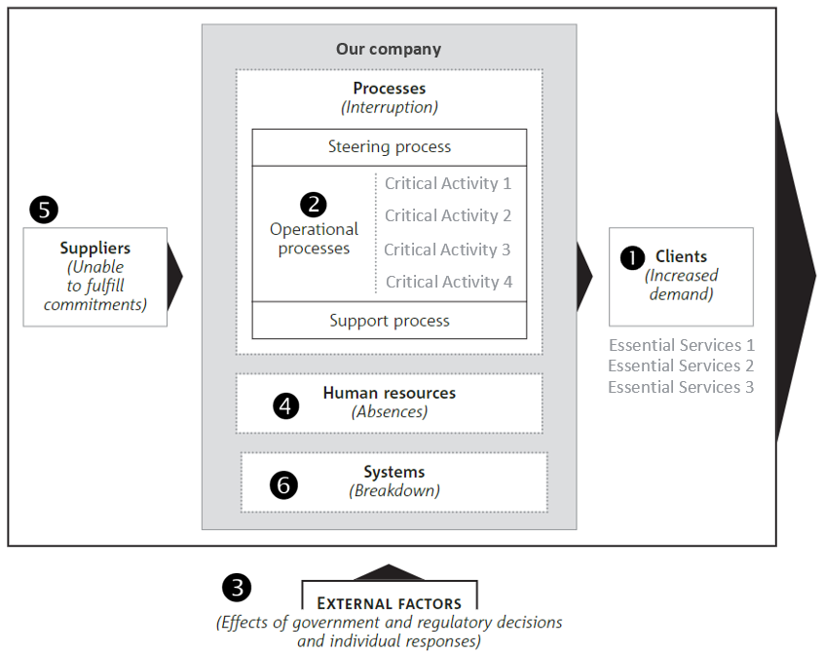
Our analysis of the impact of the pandemic is updated periodically, according to the evolution of the situation, considering the changes in factors such as government directives, needs expressed by our customers, availability of our workforce, medical advances (e.g. discovery of a vaccine), etc.
The table at the end of this section shows the results of our analysis and the mitigation measures we have put in place.
Customer Requests: We regularly contact our customers to obtain the following information:
- What essential services do our customers expect from our company?
- What services do our customers ask us to cancel/delay?
- For each essential service required, do our customers have increased or decreased demand?
- Do our customers have changes in their requirements for our delivery of essential services?
See chart below for a summary of our customers' requests.
Critical Activities: We have identified the operational activities of our company that are needed to the continuation of our business, i.e. those required to perform the essential services requested by our customers and those that create the most value for our company. We have also identified our support processes necessary for the execution of our operational activities and the overall steering process (management of the business).
See chart below for a summary of our critical activities.
- Government Decisions: We follow and implement announcements and directives from federal and provincial/state governments, as well as local public health authorities. Our sources of information are as follows:
- Choose an item.
- Choose an item.
- Choose an item.
- Other (indicate source – local health authority, Province/State, City...) - add/remove bullets as required
- Other (indicate source - local health authority, Province/State, City...) - add/remove bullets as required
- Other (indicate source - local health authority, Province/State, City...) - add/remove bullets as required
- Human Resources: We have developed a workforce reduction scenario based on the feasibility or not of remote work, the demographics of our workforce, the evolution of the pandemic in our region and government measures applicable to date. This scenario is expected to change as the pandemic evolves. To date, it assumes a reduction of approximately Choose an item. of our regular staff, considering the particularities of our workforce. Our company is affected by:
- Choose an item.
- Choose an item.
- Choose an item.
- Choose an item.
- Other (specify) - add/remove bullets as required
- Other (specify) - add/remove bullets as required
- Other (specify) - add/remove bullets as required
Based on this workforce reduction scenario, the needs of our customers for essential services and our identified critical activities, we will regularly assess how we can make up for the shortage of staff and how to ensure the competence of alternate staff (e.g. assigning employees to other positions, hiring temporary employees/contractors, etc.).
When we make reassignments or temporary hires, we ensure that the reassigned individuals meet the competency criteria for the task, particularly for regulated trades. In addition, we ensure that when we train an employee/temporary staff to perform a new task, we also train them in relation to the OHS hazards associated with the task. See chart below for measures to supplement our labor requirements to perform our critical activities.
Finally, our Human Resources policies have been updated to ensure that our employees do not engage in behaviors that are contrary to public health policies. See chart below for specific measures.
Suppliers: We regularly assess our supply chain to provide us with the inputs needed to carry out our critical activities. We assess whether the supply chain is compromised by the pandemic and, if so, find alternatives and other solutions. Otherwise, as a last alternative, we will halt the affected operations and notify our customers. See chart below for our assessment of the strength of our supply chain and the mitigation measures we are taking, if any.
Systems: We regularly evaluate our systems that enable us to carry out our critical activities. We periodically ensure that they remain adequate and reliable as circumstances change. Our critical systems are as follows:
- System 1 (e.g. cloud server, AutoCAD, inventory control system, payroll system, etc.) - add/remove bullets as required
- System 2 (e.g. cloud server, AutoCAD, inventory control system, payroll system, etc.) - add/remove bullets as required
- System 3 (e.g. cloud server, AutoCAD, inventory control system, payroll system, etc.) - add/remove bullets as required
- System 4 (e.g. cloud server, AutoCAD, inventory control system, payroll system, etc.) - add/remove bullets as required
- System 5 (e.g. cloud server, AutoCAD, inventory control system, payroll system, etc.) - add/remove bullets as required
- System 6 (e.g. cloud server, AutoCAD, inventory control system, payroll system, etc.) - add/remove bullets as required

 | CUSTOMERS NEEDS |  | SUPPLY CHAIN |  |  | WORKFORCE
Critical activities and critical support processes | Confirmation by customer(s) of essential service | Demand decreasing, increasing, unaffected | Supplies, parts, equipment, systems required | Supplier contacted | Supply chain weakened and number of alternatives | Opportunity to train employees/hire temps or contractor | Telework
Name of activity (e.g. Plumbing - emergency repairs) | Choose an item.  Justify (e.g. Yes, confirmed by 3/5 customers; 2/5 customers closed). | Choose an item.  Justify (e.g. Decreasing because some customers are operating with reduced staff, while others have closed their sites, so less likely to have plumbing breakdowns) | List (e.g.: 1. Piping  2. Welding gas  3. Etc.) | List (e.g.: 1. Wolseley & Deschênes  2. Air Liquide  3. Etc.) | List (e.g.: 1. Two possible suppliers; no stock shortage; maintain online/phone orders; can pick up at their distribution center  2. Usual supplier; Air Liquide has kept its branches open, and they are an essential service, so no supply problems  3. Etc.) | List (e.g.: 1. Cross-training impossible (regulated trade)  2. Confirmed possibility to hire a contractor; contractor will be qualified in Cognibox as our company  3. Etc.) | Choose an item.  Justify (ex: Impossible for this activity, except for a part of the management)
Name of the activity (e.g. Concierge service) | Choose an item.  Justify (e.g. Yes, confirmed by 7/7 customers) | Choose an item.  Justify (e.g. Increased frequency, number of items to be cleaned and addition of disinfection) | List (e.g.: 1. Cleaning and disinfecting products  2. Non-usual PPE, such as masks, gloves, safety glasses  3. Etc.) | List (e.g.: 1. Lépine Sanitary Products and Sany Products  2. Levitt-Safety & Grainger  3. Etc.) | List (e.g.: 1. Possible out of stock, but several other suppliers available  2. Some stock shortage in progress; tight inventory management  3. Etc.) | List (e.g.: 1. Possible cross-training (need training on hazardous materials and COVID-19)  2. Etc.) | Choose an item.  Justify (e.g.: Impossible for this activity, except for part of the management)
Name of the activity (e.g. Accounting Department) | Choose an item.  Justify (e.g. N/A as intrinsic service) | Choose an item.  Justify (e.g. Unaffected, as some services offered have increased while others have decreased) | List (e.g.: 1. Home computer equipment  2. Internet provider  3. Etc.) | List (e.g.: 1. Laptop supplier  2. MS Solutions  3. Etc.) | List (e.g.: 1. Sufficient equipment  2. Functional telework; access with cloud and Internet solutions provider  3. Etc.) | List (e.g.: 1. Possibility to have accounting done by external accounting advisors, with PSB Boisjoli  2. Etc.) | Choose an item.  Justify (e.g.: Yes, possible for all accounting staff)

  - Communication
We have established ways to quickly reach our key stakeholders, such as our employees performing our critical activities, our customers requiring our essential services, and our essential suppliers and business partners.
We minimize our in-person interactions with our customers, suppliers and employees by using technology, such as using the Name (e.g.: Zoom, Team, FaceTime, Skype…) Choose an item. to talk, see and share items to be discussed.
Finally, we stay in touch in real time with all parties using different means of communication. We have ensured that we have all the contact information of our contributors in our computer system and communication devices, namely:
- Means of communication 1 (e.g. cell phone, Outlook, Zoom, Team, FaceTime, Skype...) - add/remove bullets as required
- Means of communication 2 (e.g. cell phone, Outlook, Zoom, Team, FaceTime, Skype...) - add/remove bullets as required
- Means of communication 3 (e.g. cell phone, Outlook, Zoom, Team, FaceTime, Skype...) - add/remove bullets as required
- Means of communication 4 (e.g. cell phone, Outlook, Zoom, Team, FaceTime, Skype...) - add/remove bullets as required
- MEASURES TO ELIMINATE THE SPREAD OF CORONAVIRUS
  - Corporate Measures
We have established and communicated to our employees the following rules, which they are required to apply as part of their duties for our company. We align our actions with those of government and public health authorities.
- Compliance with our customers’ COVID-19 rules
Our customers have implemented specific rules regarding their measures to control the spread of COVID-19. We proactively ask our customers what their measures are and communicate them to all our employees going to their sites, emphasizing the need to comply with them in full.
Among other things, our employees comply with our customers' screening controls for entry to their sites. They all know that they must answer honestly and that they must inform us and our customers of any change in their condition related to the screening criteria.
- Self-isolation/quarantine
We prohibit our employees from reporting to work, including at our customers' sites, if they meet any of the following conditions. If they do, we recommend that they follow government guidelines for isolation/quarantine.
Conditions for not reporting to work:
- Choose an item.
- Choose an item.
- Choose an item.
- Other (specify) - add/remove bullets as required
- Other (specify) - add/remove bullets as required
- Other (specify) - add/remove bullets as required
We refer our employees to the public health authority self-assessment tool, in our case Choose an item. which provides official government guidance on the need/possibility for COVID-19 testing and the type of isolation/quarantine required: Choose an item..
- Return to work after diagnosis of COVID-19
We prohibit all our employees from reporting to work if they have COVID-19. They may return to work only if they meet one of the following conditions:
  - Fever completely gone for at least three days AND improved respiratory symptoms (cough, difficulty breathing) AND at least seven days have passed since the initial onset of symptoms
or
- Fever completely gone AND improved respiratory symptoms (cough, difficulty breathing) AND negative results from the public authority's COVID-19 testing protocol (to date = two negative tests 24 hours apart)
It should be noted that return-to-work conditions are an evolving aspect of COVID-19. We will update these as recommended by government authorities.
- Social distancing / Physical distancing
We have taken the following steps to comply with public health guidelines on social/physical distancing:
- Instructing employees to work a minimum of 2 meters apart
For tasks that do not allow this distancing, we perform a risk analysis on the floor, i.e. we take a moment before starting the task to assess the physical distancing, asking if there is another way to perform the task. If the answer is no and the task is absolutely essential, we ensure that our employees wear the appropriate personal protective equipment and require that they wash their hands before and after the task, and that they do not touch their faces during the task.
- Use of technological applications instead of in-person meetings
Our employees use video-based technology applications whenever possible to communicate with each other, between the site and the office, with customers, etc., instead of visits, whenever possible. If not possible, they comply with the minimum distance measurement of 2 meters.
- Telework for all critical support staff
All of our support staff are teleworking. Our office is closed, except for certain accesses (e.g.: parts and tools warehouse, computer equipment, office equipment, etc.).
- Title other measure related to social distancing
Explanation of the measure
- Title other measure related to social distancing
Explanation of the measure
- Individual protection
We have asked our employees to follow various measures to protect themselves and the health and safety of their colleagues and our customers. In fact, we have assigned to all our employees the training Name of the training (e.g.: COVID-19 E-Learning from Cognibox) to ensure that they are all aware of these measures.
- Hand hygiene
All our sites have supplies/installations for our employees to wash/disinfect their hands. We have asked for our customers' cooperation to have access to running water at their sites and, if this is not possible, we have provided alternative means. We have asked our employees to follow the World Health Organization's method for effective hand washing and disinfection (https://www.who.int/gpsc/tools/GPSC-HandRub-Wash.pdf?ua=1). We have also instructed them not to touch their faces until they have washed their hands or removed their gloves.
- Respiratory hygiene
We have asked our employees to adopt the respiratory hygiene practices recommended by public health authorities, i.e.:
  - Use a tissue, dispose of the tissue in the garbage after use and wash hands as required
  - Cough in elbow
- Title other measure related to individual protection
Explanation of the measure
- Title other measure related to individual protection
Explanation of the measure
- Cleaning/disinfecting surfaces and objects
We have taken the following measures to reduce the spread of the virus by touching a contaminated surface:
- Individual use of equipment
We ask our employees not to share materials (tools, equipment, supplies, etc.), as much as possible. Our teams bring everything they need to the sites in enough quantities so that each employee does not have to borrow or use someone else's equipment. If it is impossible to comply with this measure, the following must apply.
- Cleaning
We ask our employees to clean all equipment used to carry out their tasks (including transport vehicles). We provide our employees with cleaners and other cleaning supplies, and we have taught them safe and proper cleaning techniques. We check with our customers to see if they have containers available on site to dispose of cleaning products. If not, employees bring containers and dispose appropriately of the used supplies.
- Title other measure related to cleaning/disinfecting
Explanation of the measure
- Title other measure related to cleaning/disinfecting
Explanation of the measure

