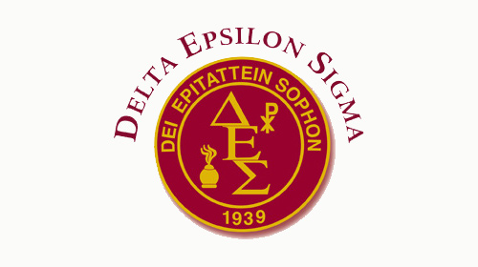
Application for Membership – Saint Leo University Chapter
Delta Epsilon Sigma is a national scholastic honor society for students, faculty, and alumni of colleges and universities with a Catholic tradition. It was founded in 1939 to recognize academic accomplishments, to foster scholarly and community service activities, and to encourage a sense of intellectual community among its members. The criteria for membership of the Saint Leo University chapter, Delta Nu, are an earned minimum GPA of 3.5 or higher and successful completion of 60 credit hours. Membership dues are $70.00 payable upon application. If you would like to also order an honor stole to wear at graduation, please add an additional $20.
First Name:
Last Name:
Student ID Number:
Major:
Home Address (where the Journal will be sent):
Street:
City: State: Zip:
Phone number:
Email:
Leadership, Community, and Volunteer Service: Provide a brief summary below detailing recent activities you have been involved with on campus or off that demonstrate community service and/or volunteerism:

__________________________________________________________________________________________________
Return this completed application with a check or money order for $70.00 payable to Saint Leo University.

Please mail to:

Dr. Valerie Wright
Saint Leo University
School of Education & Social Services
33701 State Road 52
St. Leo, FL 33574

