Day & Zimmermann Corporate Supply Chain is unable to review and process your company as a supplier until the free Ariba registration and subsequent D&Z Supplier Registration Questionnaire are completed. Registration will remain open for 10 days. If the registration is not completed within 10 days, a Corporate Supply Chain team member will need to re-send the invitation.
The invitation will be similar to below:
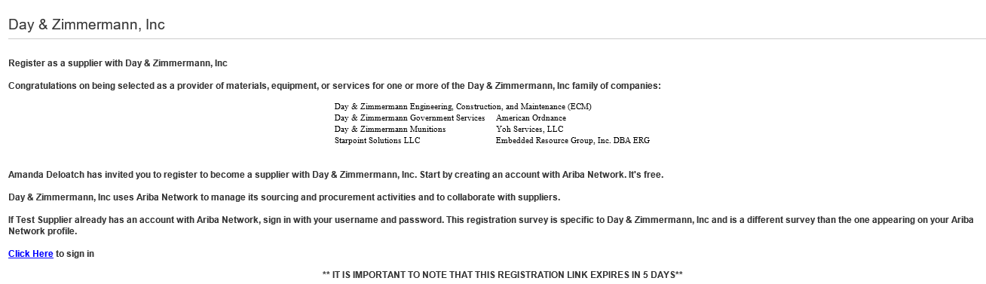

Step 1. Click the link in the invitation email to begin registration. You will have the option to sign up for a new account or log in to an existing Ariba account. If you already have an Ariba Network Account, do not log directly into your account without using the link from the email.

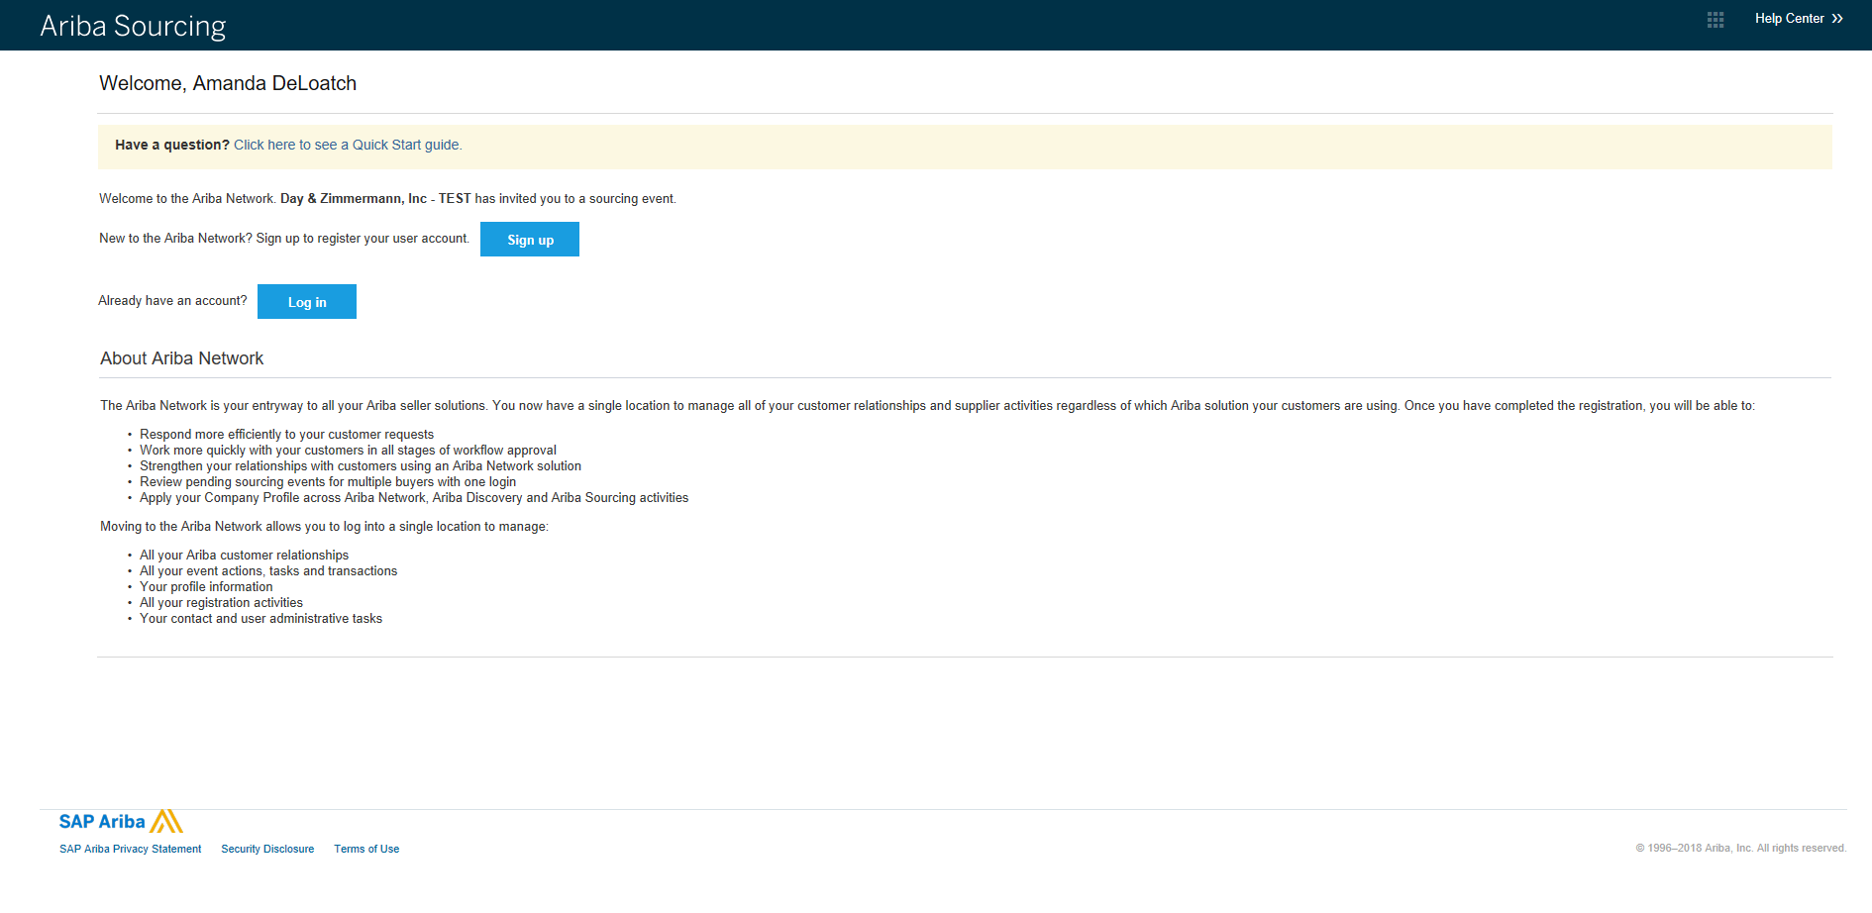

Step 2. (new Ariba suppliers only) Create a free SAP Ariba supplier account. Fields marked with an asterisk are required. Check the boxes at the bottom of the screen to accept the Ariba Terms and Conditions then click create and continue to proceed to the next screen.

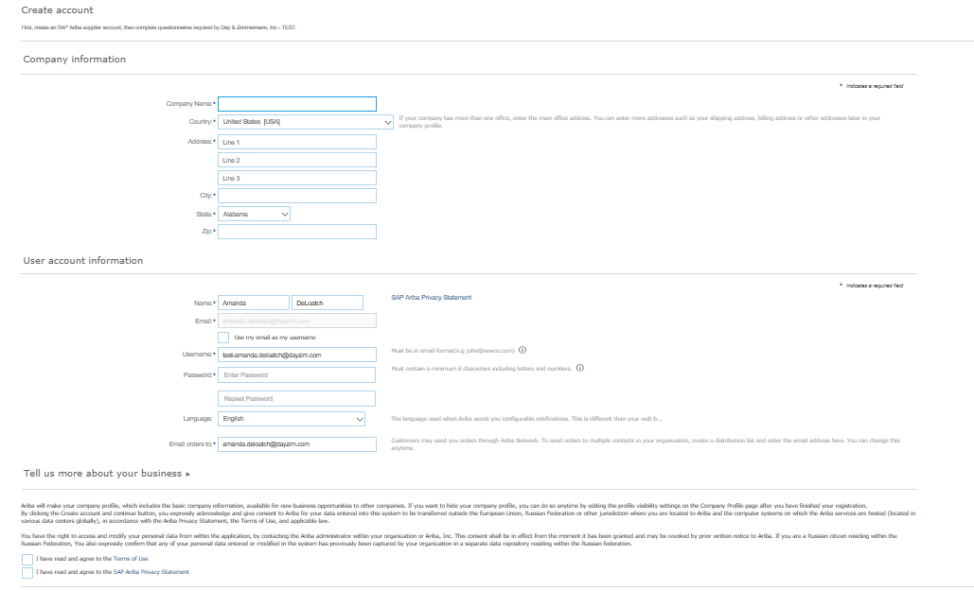

Step 3. Complete the Day & Zimmermann Supplier Registration Questionnaire. Required fields are marked with an asterisk. A current version W9 or W8 (if applicable) and a voided check/bank letter (to confirm the bank account name and numbers) are required in this section. Complete all information then click “Submit entire response” at the bottom of the page.
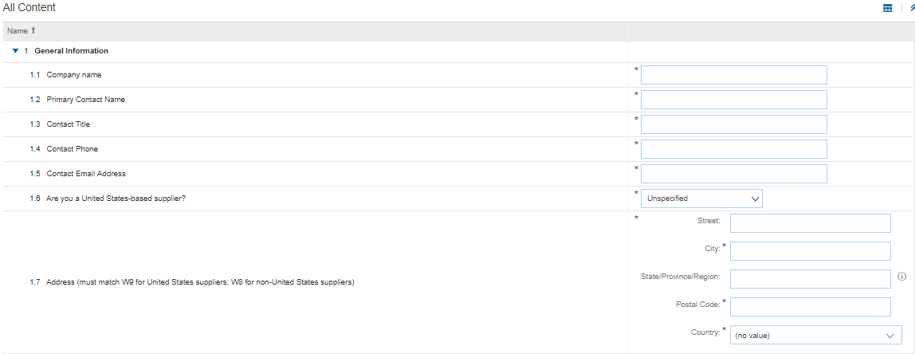
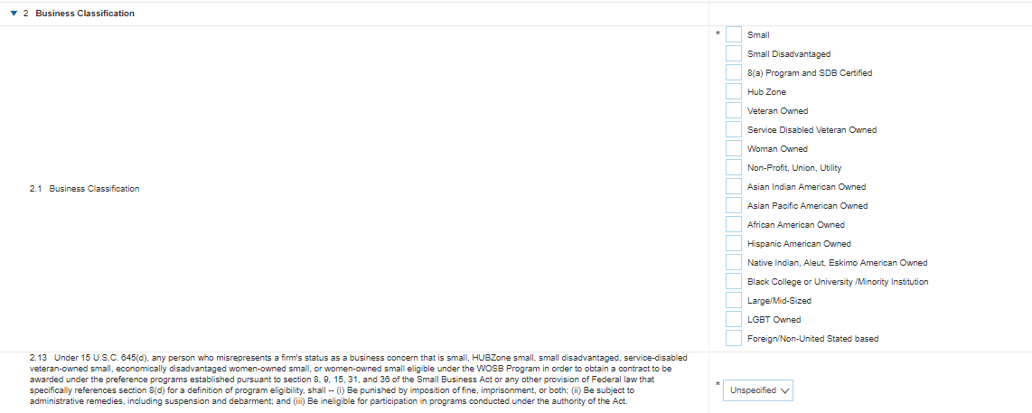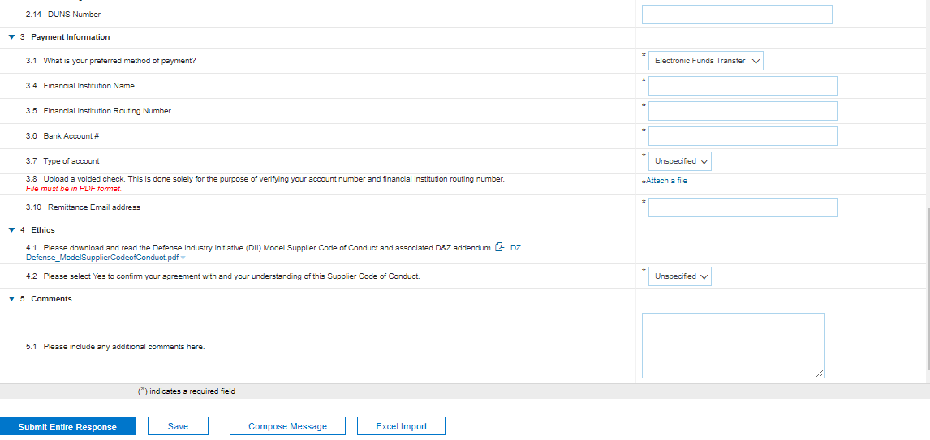
Important Note: If you do not finish the registration questionnaire when you first create an Ariba account or when you first log into it as an existing Ariba supplier, the link from the invitation email will no longer work. You will get an error page that says ‘link has already expired’, similar to below (even though it hasn’t been 5 days yet). If this happens, visit service.ariba.com to complete the questionnaire.
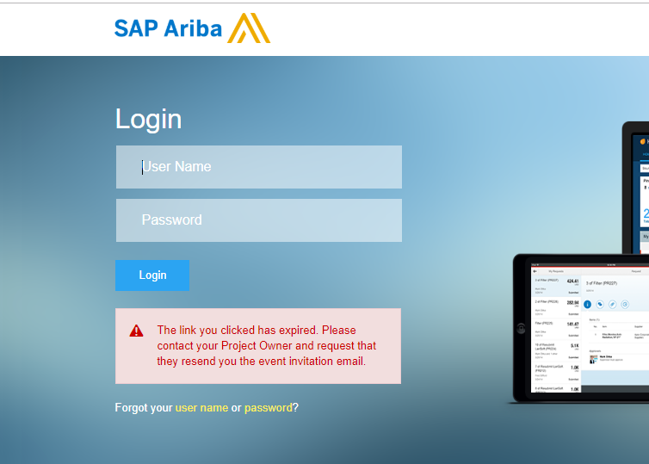
- Log in to service.ariba.com, click the grid box at the top of the screen and toggle down to ‘Proposals’.
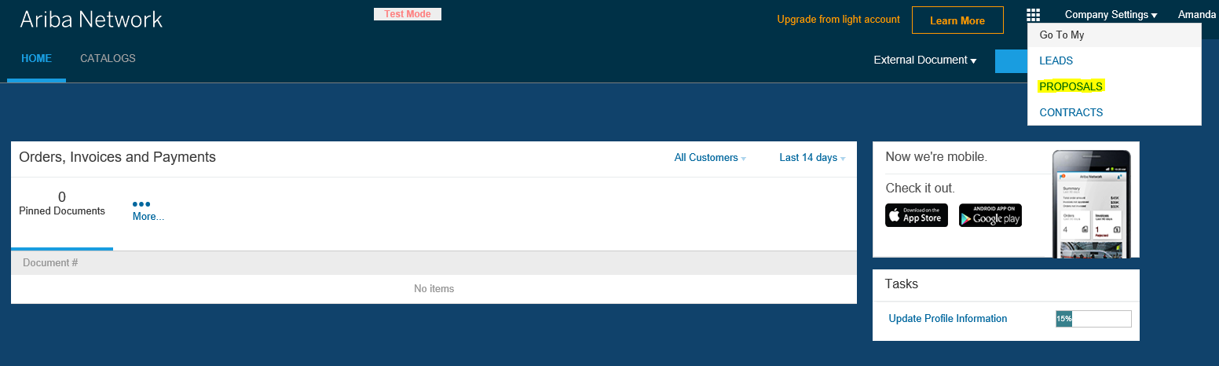
- You should then see the Day & Zimmermann Questionnaire right on that page (note: if you have multiple customers on the Ariba Network, you may need to select ‘Day & Zimmermann’ first to see our specific questionnaire).
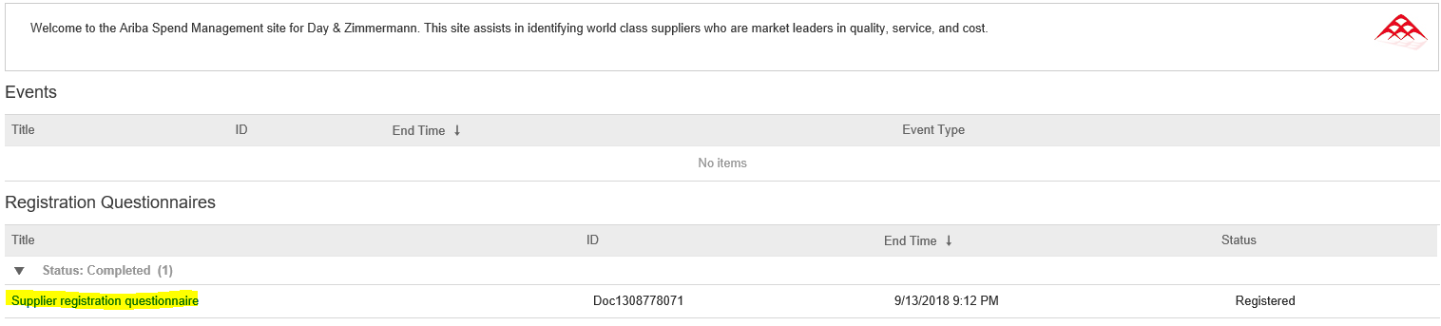

- If service.ariba.com does not work, visit seller.ariba.com.
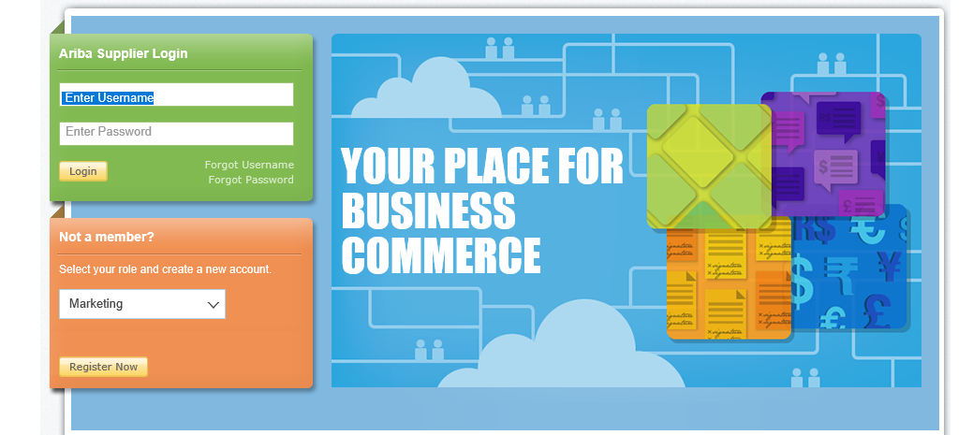

- This link brings you to a page to complete the survey for your basic AN information (this is not the D&Z questionnaire). To get to the D&Z questionnaire and bypass the basic AN Network survey, click the ‘close’ button at the top and then it brings up D&Z questionnaire.
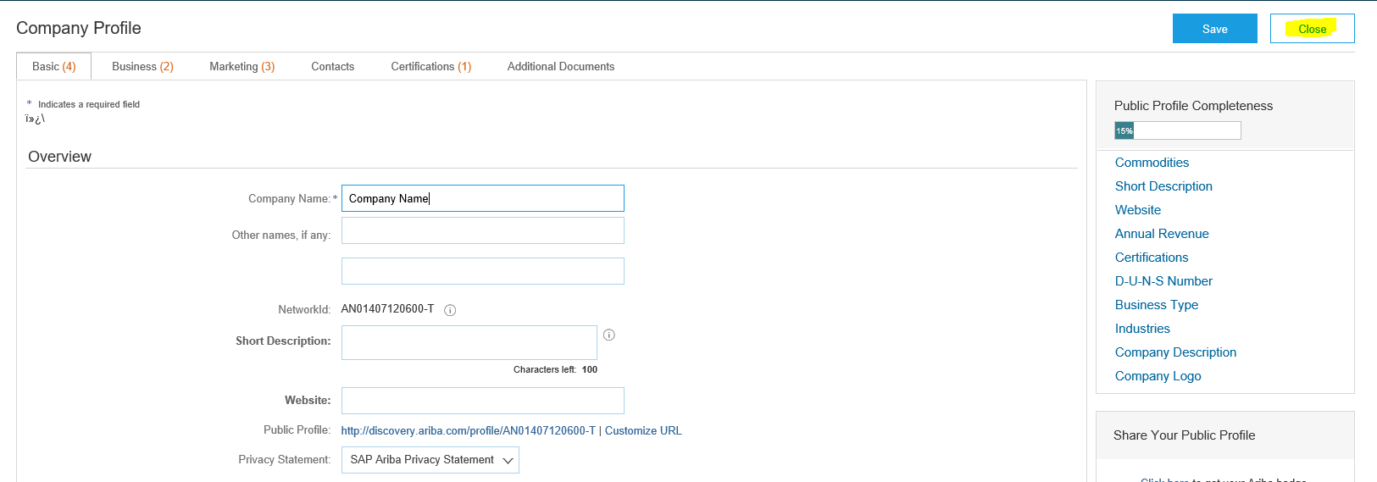

Corporate Supply Chain will review the record for completeness. Note that the Supplier Registration Questionnaire may be returned to you if there is a requirement to obtain more information or if clarification is needed regarding any answers you have provided.

If Supplier needs to update their questionnaire response any time after original submittal:
- Go to service.ariba.com to see the questionnaire
- Once logged into service.ariba.com, click the grid box at the top of the screen and toggle down to ‘Proposals’.
- You should then see the Day & Zimmermann questionnaire on that page (note, if you have multiple customers on the Ariba Network, you may need to select ‘Day & Zimmermann’ first to see our specific questionnaire)
- Click ‘revise survey’ to update any fields and submit the questionnaire again.

Need Help:
- User name and Password are unique to you and your company. You may reset the password by clicking the “forgot password” link on the Ariba website or by contacting Ariba directly. Day & Zimmermann Corporate Supply Chain cannot reset an Ariba password.
- Please do not send requested documents via email – they must be uploaded within your Ariba account in the D&Z supplier questionnaire.
- If you have questions about the Supplier Registration Questionnaire, reach out to Debbie Prestileo or Amanda DeLoatch in Corporate supply Chain.

