Martin Luther High School Music Department Presents
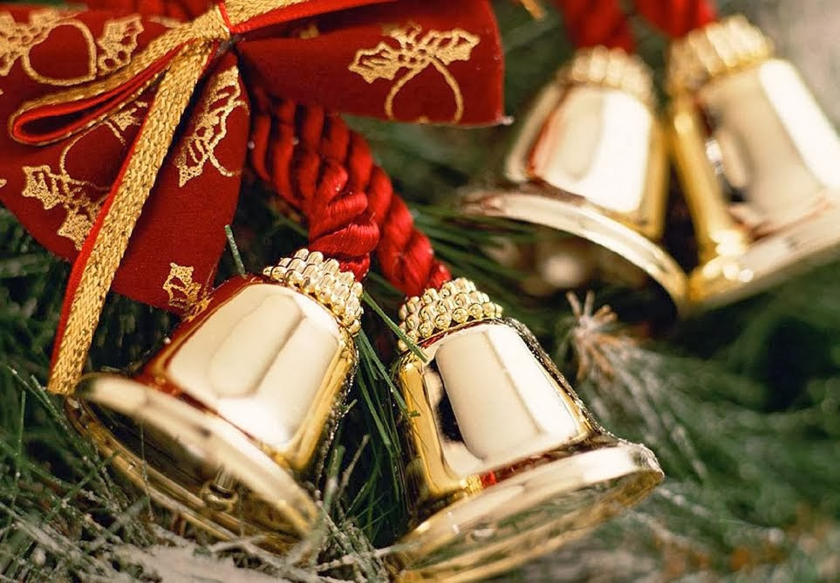
Carols
FOR THE
KING

Featuring the Troubadours, Men’s Choir, Chorus, Concert Choir, Brass Choir, Woodwind Choirs, & Symphonic Band

Concerts are at 7:00 p.m. on Friday, December 8th and Saturday, December 9th
Performances are in the Martin Luther High School Worship/Fine Arts Center.
----------------------------------------------------------------------------------------------------------------------------------------------------------------------------------------------------------------------------------------------------------------------------
Number of Tickets

Reserved Assigned Seats: (center & wing) Friday, Dec. 8 Saturday, Dec. 9
7:00 p.m. 7:00 p.m.

Adults $9.00 ___________ ___________

Seniors (60), K-12,
ML Staff &Students,
LHSAGM Passes $5.00 ___________ ___________

General Admission: (unassigned side)

Adults $6.00 ___________ ___________

Seniors (60) and K-12 $4.00 ___________ ___________

ML Staff &Students

LHSAGM Passes FREE ___________ ___________

Name:
Bring or send your order to:

Martin Luther High School
c/o Mrs. Lisa Kamprath
5201 South 76th Street
Greendale, WI 53129

E-mail:

Phone:_______________ Student:________________

Special seating (reserved only): wheelchair or walker (circle one)

Details:
Phone orders not accepted. Place your order early by direct mail, through your student, or by email (lkamprath@martinlutherhs.org). Payment (cash or check only) must accompany your order. Tickets will be held for you at the door, or you may enclose a self-addressed, stamped envelope for return, or you may pick them up in the office between the hours of 7:30 A.M. and 4:00 P.M.
You may also have your student pick up the tickets from Mrs. Kamprath.

