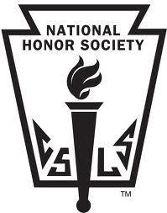
Martin Luther High School
National Honor Society Service Hour Log 2015-2016

Name: _______________________________________________ Grade: 11 12

Sanctioned Event?  (check box) | Date(s) | Brief Description of Service | Hours Served | Signature

- Service hours and sanctioned events are due no later than the May 6th NHS meeting.
- Fifty (50) service hours and three (3) NHS sanctioned events are required for each school year.
- These fifty (50) hours include the twenty (20) required for Theology classes.
- You may use hours served during sanctioned events as part of your fifty (50) hours.
- NHS hours may be submitted to Mrs. Jacobsen or an NHS officer.

Official Use
Form Submitted to _____________________________ Date Submitted: ______________________

Hours Logged: Form #: __________

