EBCD MEDITECH Content Updates – 2019.3  
Behavioral Health Routines in Nursing Module

Overview

This document is a high-level overview for end user education purposes about significant changes for the Behavioral Health routine in the inpatient nursing module. Additional nursing module enhancements may be seen in the [EBCD Content Updates section](http://teamrooms.hca.corpad.net/sites/EBCD_Ent_Site/_layouts/15/start.aspx#/Tools%20and%20Templates/Forms/AllItems.aspx?RootFolder=%2Fsites%2FEBCD%5FEnt%5FSite%2FTools%20and%20Templates%2F03%2DEducation%2FContent%20Updates&FolderCTID=0x01200033795B734D296D43995FA9BA1F04246D&View=%7B9B91E0F3%2D6AEB%2D4188%2D9C89%2DD2FDAAAE19B2%7D) of the [EBCD Atlas Connect page](http://connect.medcity.net/web/informatics/ebcd).

Inpatient Rehab Facility Enhancements education will be posted separately.

How to use this guide

The enhancements are listed by intervention. They include which module(s) affected along with the impact associated with the intervention.

The enhancements are listed in alphabetical order and provide a rationale behind the change and screenshot example(s). This document focuses on end user enhancements designated as high and medium impact.

Impact Legend:

|  |  |  |  |
| --- | --- | --- | --- |
| Safety/Regulatory |  | Clinical Initiative |  |
| Reimbursement/Billing |  | Enhancements/Wins |  |

Be aware the enhancements may not be in your test environment at the time this document is published. Your facility/IT Division support team will notify you when the updates will be available in your software.

Please read the MEDITECH selected prompts and follow the yellow information boxes onscreen as you become aware of changes in the documentation.

# Behavioral Health Routine

## BH Recovery Plan/Restraints

The *Behavioral Health Recovery Plan* has been updated to include two new problems for **Restraint safety precautions** and **Violence risk** instead of the old **Violence/restraints risk** under Health behavior problem/risk.The Behavioral Health Recovery Plan has alerts to guide the nurse through the transition.

**Please note**: Due to the 6 problem limit the patient will only be able to have a total of 6 problems on their Recovery Plan.

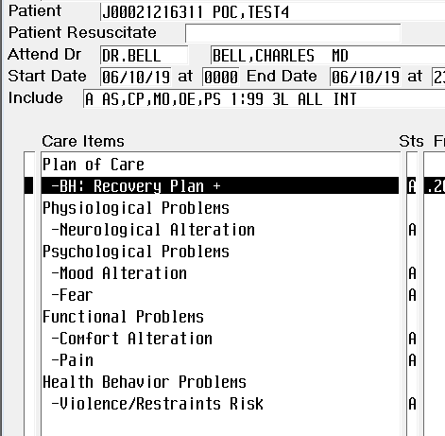

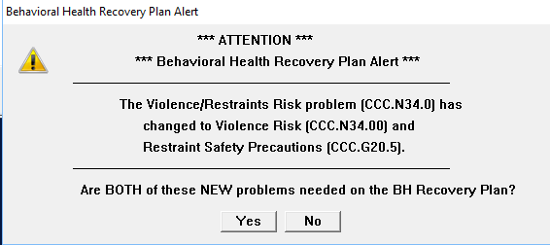

## Restraints

The **Safety, Risk, Regulatory** assessment no longer includes the *Assess Restraints* option. Use the standalone **Restraint Documentation +** intervention to document Restraints.

Skip-logic programming guides the user through the proper documentation pathway for violent and non-violent type episodes.

### Start Phase:

The yellow information box displays the clinical justification from the most recent *active* provider order.

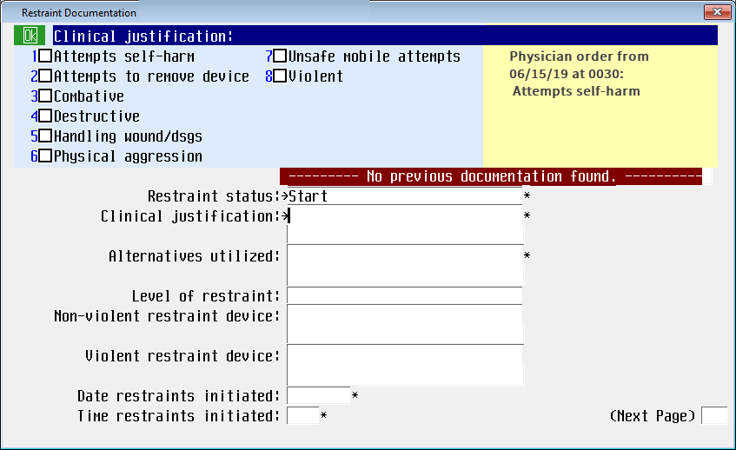

*Observed restraints appropriately intact* has an option of **Not applicable**. A pop message will display if not applicable is not an appropriate response for the documented restraint device.

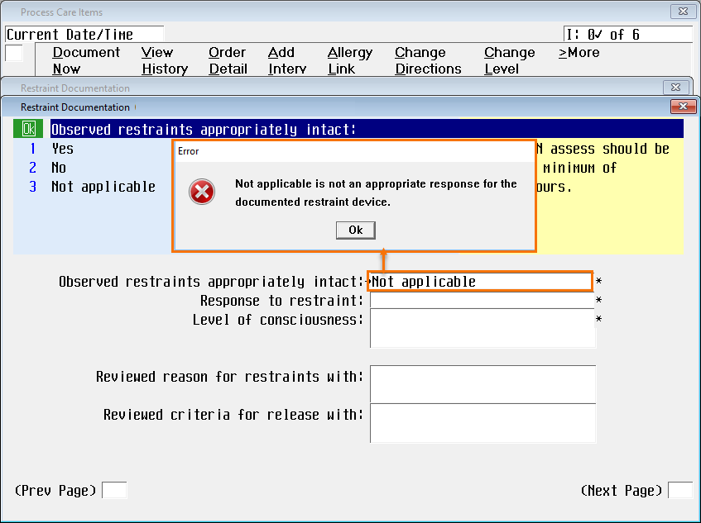

The suggested problem for *Restraint Safety Precautions* will display in the popup and should be added to the patient’s plan of care the first time you receive the popup message.   
For multiple restraint episodes, if the problem is closed out on the plan of care and a second episode is started, then nurse will have to add the problem to the plan of care.

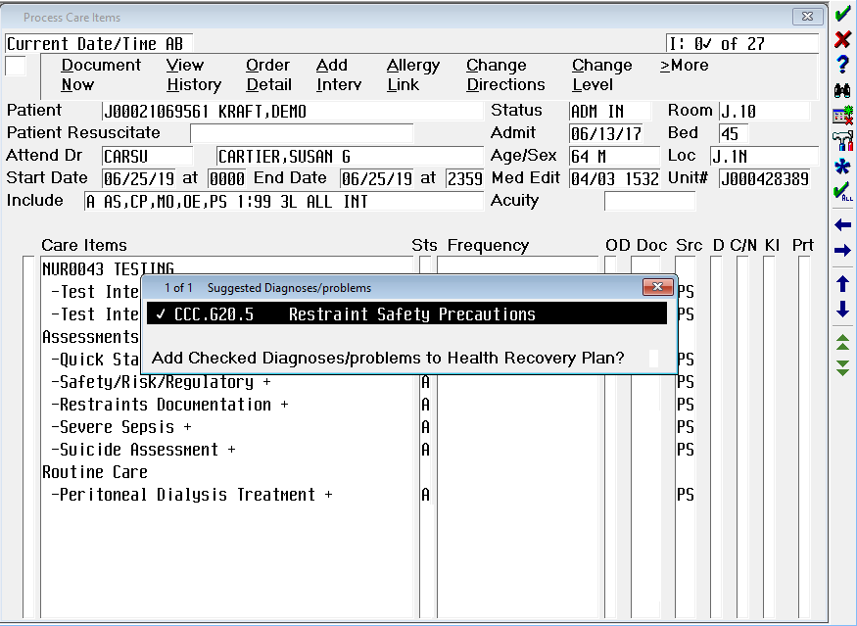

### Monitor Phase:

* Added a **Not applicable** (NA) option for patients in seclusion restraint ONLY.   
  Since you can select multiple restraint devices (on previous page), **NA** is not an option if either **Seclusion** is selected in addition to the other restraint choices. For example, if **Seclusion** and **Bedrails** are both selected, **NA** is not be allowed.



* *Alternatives attempted*, is now an option to capture as part of the assessment. It has the same group response options as *Alternative utilized*.

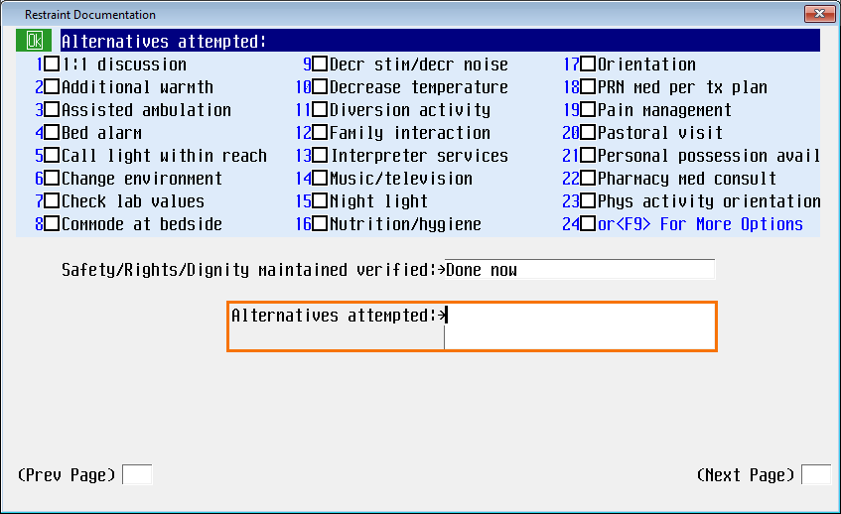

* *Skin under/around restraint verified* and *Circulation distal to restraint verified* queries have   
  **Not applicable** added to the group response option when applicable for the restraint device(s) selected. (For example, if **Seclusion** restraint was chosen as a device type, then *Circulation distal to restraint verified* is not applicable.).

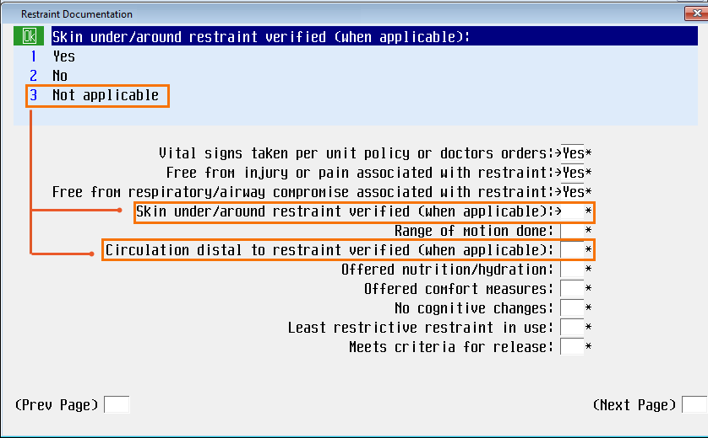

* *Meets criteria for release* has a new yellow information box reminding the nurse that the response here doesn’t discontinue the episode, but s/he must go back in to the intervention and discontinue the episode once the patient meets the criteria for release.

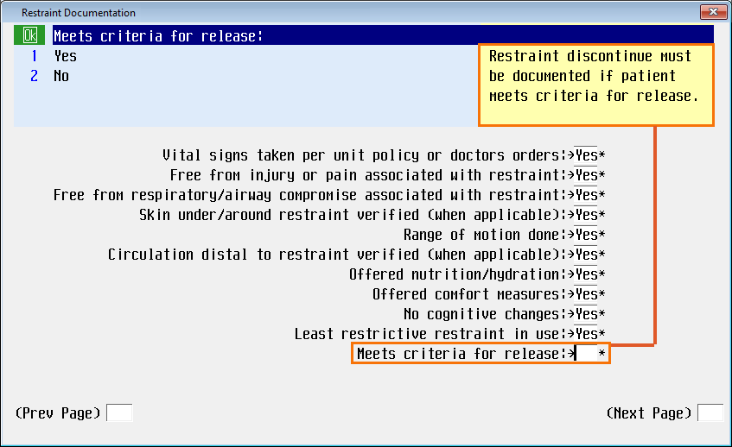

### Safety, Rights, Dignity Phase:

* *Alternatives attempted* was added to this phase as well.

#### 

* *Skin under/around restraint verified* and *Circulation distal to restraint verified* queries now have a **NA** group response option, allowing this option when applicable for the restraint device selected (same workflow as *Monitor* phase).



### Discontinue Phase:

* *Criteria for restraint release met* now has an option of **No**. The yellow information box outlines when **No** may be the appropriate selection
* Here the nurse can acknowledge that the patient may **not** meet the criteria for release, but **due to change in device, change in clinical justification, a new provider order**, the nurse is discontinuing this episode would go back in to the patient’s documentation and start a new episode.
* 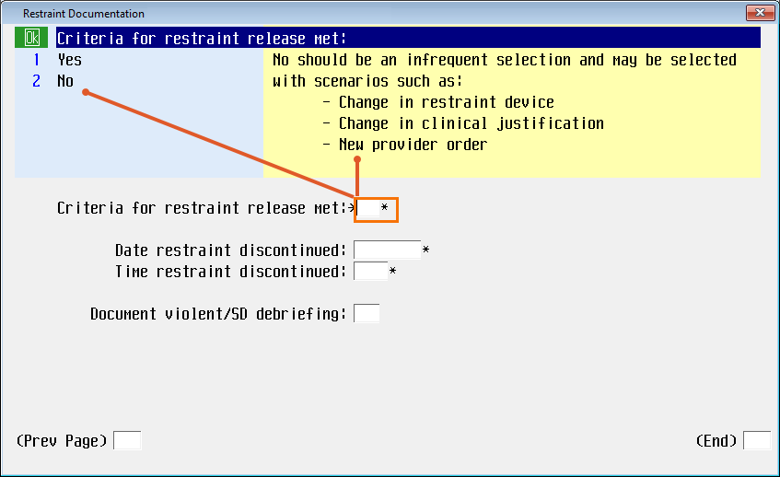

## Suicide Assessment - BH

The updated suicide assessment programming accommodates both the behavioral health and acute care populations, noting that the assessment criteria which may be applicable to the BH population may not always by applicable in the acute care patient population. These updates align with all patient populations.

*Behavioral Health must document a response to each of the three questions.

In the *Suicidal thoughts* field:

1. If **Current**, **Past six months** OR **Lifetime** is selected as part of the response choices, the user will complete the entire suicide assessment. **The Patient at risk for suicide**: will default **Yes,**

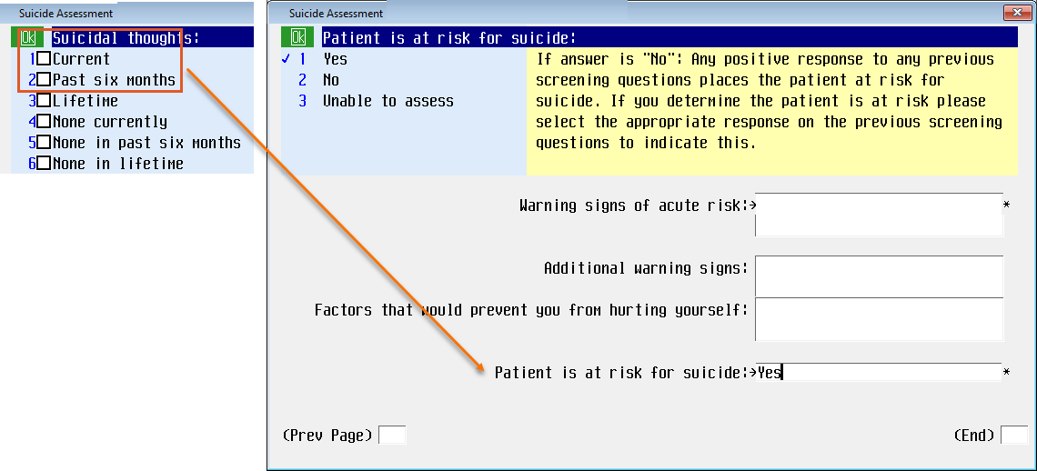

1. If the patient does not currently have suicidal thoughts, none in the last six months AND none in lifetime; the programming logic will skip the assessment fields and default a **No** in the *Patient at risk for suicide*.

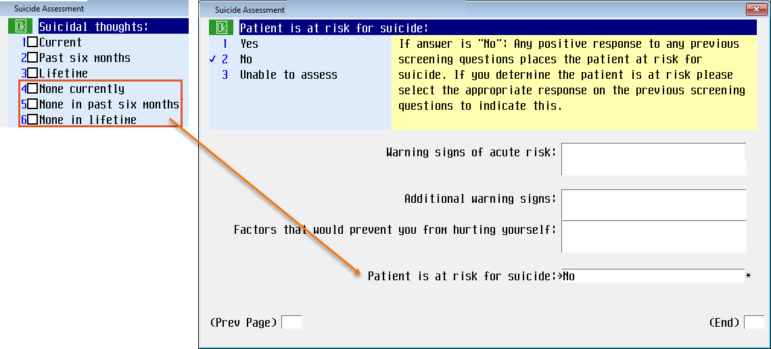

1. If the field has a response of **none in lifetime**, the programming logic will skip the assessment fields and default a response of **No** in the *Patient at risk for suicide* field.

The warning message at the end of the suicide screening has been updated as follows:

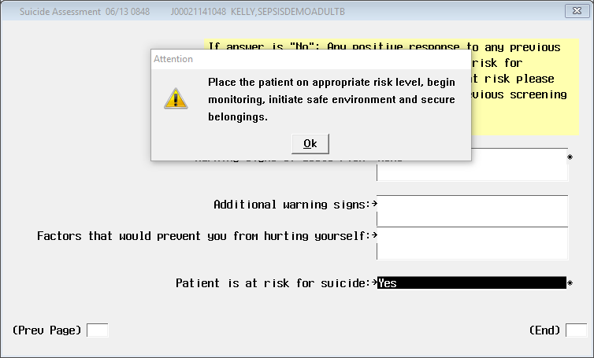

On the Behavioral Health history screens, Legal Hold was removed as an option from Barriers in living situation relevant for discharge planning.

