EBCD MEDITECH Content Updates – 2019.3  
ED Module

Overview

This document is a high-level overview for end user education purposes about significant changes within the Nursing, ED Module. Additional enhancements may be seen in the [EBCD Content Updates section](http://teamrooms.hca.corpad.net/sites/EBCD_Ent_Site/_layouts/15/start.aspx#/Tools%20and%20Templates/Forms/AllItems.aspx?RootFolder=%2Fsites%2FEBCD%5FEnt%5FSite%2FTools%20and%20Templates%2F03%2DEducation%2FContent%20Updates&FolderCTID=0x01200033795B734D296D43995FA9BA1F04246D&View=%7B9B91E0F3%2D6AEB%2D4188%2D9C89%2DD2FDAAAE19B2%7D) of the [EBCD Atlas Connect page](http://connect.medcity.net/web/informatics/ebcd).

How to use this guide

The enhancements are listed by intervention. They include which module(s) affected along with the impact associated with the intervention.

The enhancements are listed in alphabetical order and provide a rationale behind the change and screenshot example(s). This document focuses on end user enhancements designated as high and medium impact.

Impact Legend:

|  |  |  |  |
| --- | --- | --- | --- |
| Safety/Regulatory |  | Clinical Initiative |  |
| Reimbursement/Billing |  | Enhancements/Wins |  |

Be aware the enhancements may not be in your test environment at the time this document is published. Your facility/IT Division support team will notify you when the updates will be available in your software.

Please read the MEDITECH selected prompts and follow the yellow information boxes onscreen as you become aware of changes in the documentation.

*Click the topic name to be taken to the specific documentation within this update:*

Summary of Revisions 2

Legal Hold Status: Health History 3

Patient Email verification 4

Restraints 6

Suicide Assessment: 11

Urinary Catheter Indications for Chronic Indwelling Catheter 13

# Summary of Revisions

| **Date** | **Revision** |
| --- | --- |
| 8/9/19 | Published for Enterprise |

## Legal Hold Status: Health History

A newly standardized method captures the legal hold status throughout the patient encounter. This aligns with current process used to populate the facesheet (regulatory requirement) and patient handoff/SBAR.

On the EDM Health History (*within* Detailed Assessment, Non Urgent General Focus, Paramedic Intake Screening), **Legal Hold** was removed as an option from ‘Barriers in living situation relevant for discharge planning’ field.

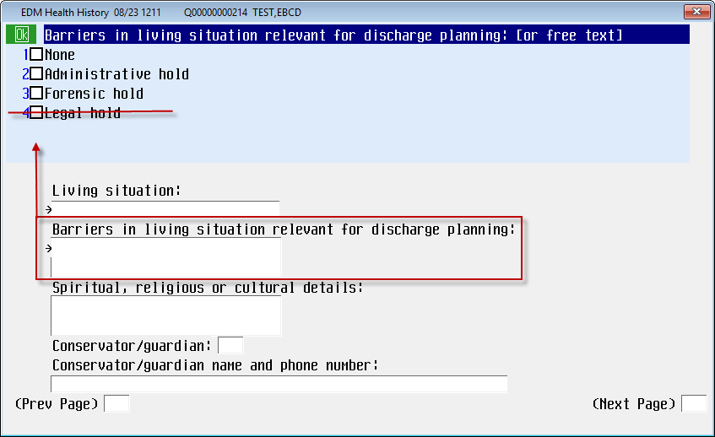

## Patient Email verification

The patient’s email address is captured in the MEDITECH Admissions module. This email will now be verified in the Inpatient Nursing, ED and OR Modules.

There is considerable evidence in the published literature on survey research that the patient’s pre-notification will increase response rates. There are numerous opportunities to let patients know they will receive a questionnaire. Data shows that when the patient’s nurse makes a “meaningful, personal ask” of the patient to please complete the survey, the patient is more likely to take the survey. Any pre-notification method must be neutral. It must not ask the patient for a specific response (e.g. don't say or post sayings like, Give us a "5").

**Note**: CMS has specific guidelines for communicating to patients regarding CAHPS surveys

Note: This email address field is editable, but not required, in EDM, NUR and OR.

The email address flows from Inpatient, ED and OR Modules but will not be bi-directional at this time. Follow your facility process to communicate changes to the patient’s information.

The following Screens now include a new Patient email address field:

* Admission Health History
* Inpatient Discharge Instructions
* SURG: Admission Health History
* ED Disposition

The *Patient Email Address* field is available to verify the patient’s current email address. If an email address was entered via the Admission module, the last response will default in the field and in the red highlighted area:

* Last recorded by: REG – no edits found – displays when only the original Registration entry has been found.
* Last recorded by: REG on [date/time] - displays when the registration entry has been updated since the original registration.
* Last recorded by: Nursing on [date/time] - displays when *Patient Email Address* field in the nursing documentation screens has updated since the Registration has been entered (either original or edited).
* Last recorded by: No email found. - displays when no email address has been documented. If no response entered in the Inpatient Admission questionnaire then nurse can free text enter the email address (up to 40 characters).

EDM Example: Disposition DX/TX/ADM/LPT

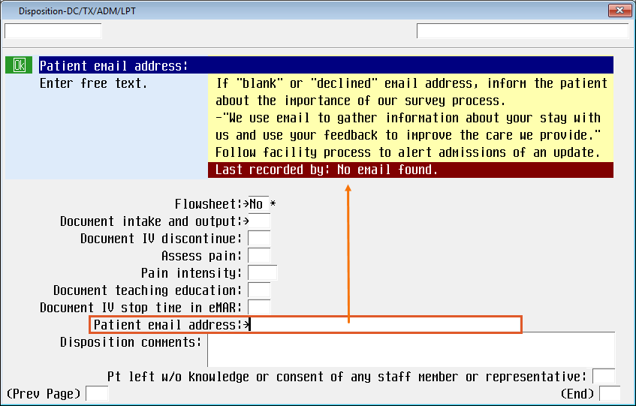

## Restraints

Skip-logic programming guides the user through the proper documentation pathway for violent and non-violent type episodes.

### Start Phase:

The yellow information box displays the clinical justification from the most recent *active* provider order.

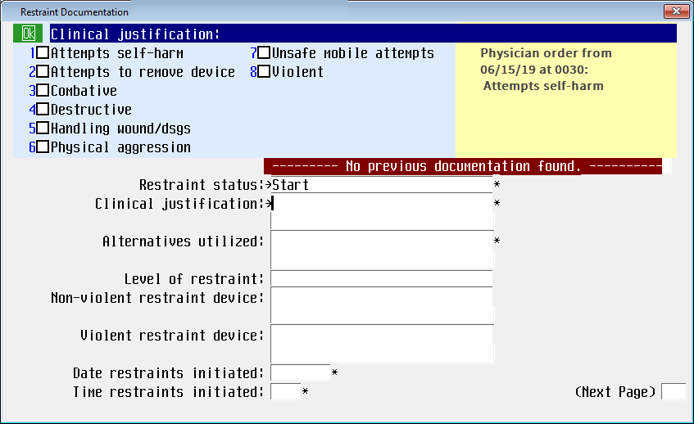

*Observed restraints appropriately intact* has an option of **Not applicable**. A pop message will display if not applicable is not an appropriate response for the documented restraint device.

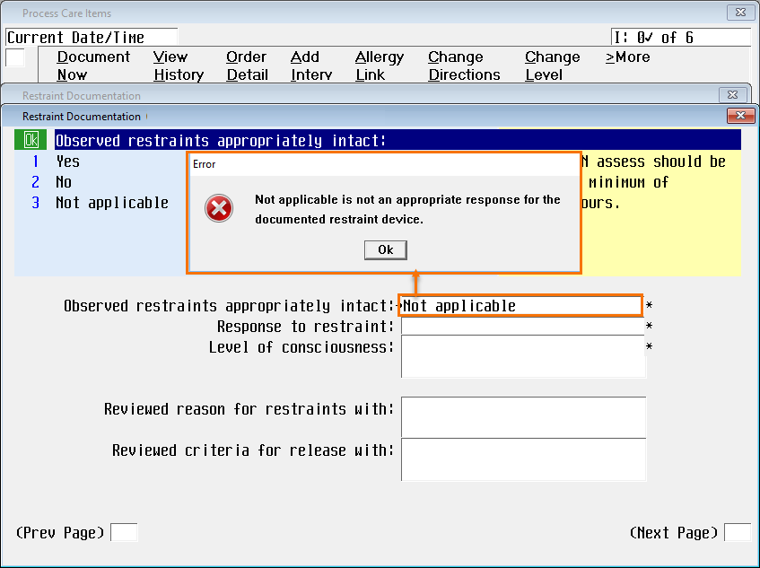

### Monitor Phase:

* Added a **Not applicable** (NA) option for patients in seclusion ONLY.   
  Since you can select multiple restraint devices (on previous page), **NA** is not an option if **Seclusion** is selected in addition to the other restraint choices. For example, if **Seclusion** and **Bedrails** are both selected, **NA** is not be allowed.



* *Alternatives attempted*, is now an option to capture as part of the assessment. It has the same group response options as *Alternative utilized*.

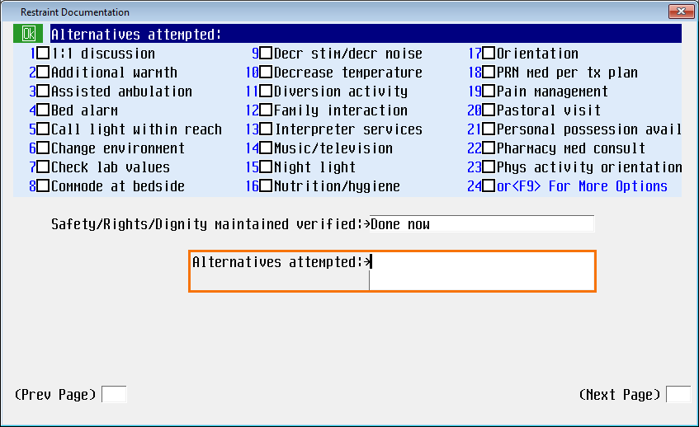

* *Skin under/around restraint verified* and *Circulation distal to restraint verified* queries have **Not applicable** added to the group response option when applicable for the restraint device(s) selected. (For example, if **Seclusion** restraint was chosen as a device type, then *Circulation distal to restraint verified* is not applicable.).

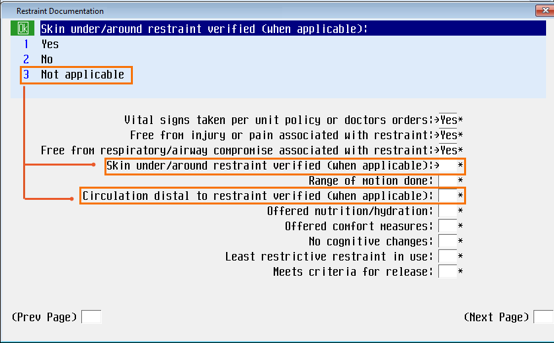

* *Meets criteria for release* has a new yellow information box reminding the nurse that the response here doesn’t discontinue the episode, but s/he must go back in to the intervention and discontinue the episode once the patient meets the criteria for release.

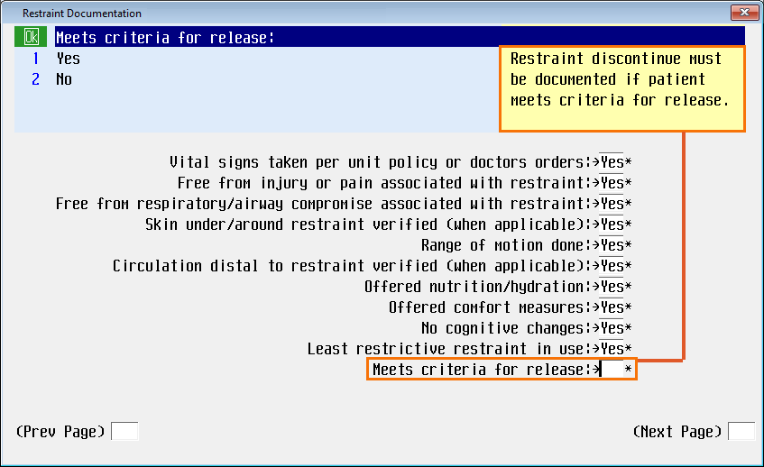

### Safety, Rights, Dignity Phase:

* *Alternatives attempted* was added to this phase as well.
* *Skin under/around restraint verified* and *Circulation distal to restraint verified* queries now have a **NA** group response option, allowing this option when applicable for the restraint device selected (same workflow as *Monitor* phase).



### Discontinue Phase:

* *Criteria for restraint release met* now has an option of **No**. The yellow information box outlines when **No** may be the appropriate selection
* Here the nurse can acknowledge that the patient may **not** meet the criteria for release, but **due to change in device, change in clinical justification, or a new provider order**, the nurse discontinuing this episode would go back in to the patient’s documentation and start a new episode.

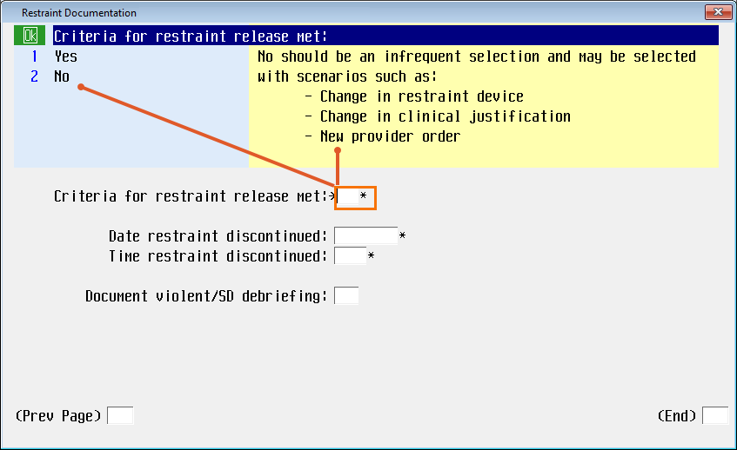

## Suicide Assessment:

#### Detailed Assessment/ Non Urgent Gen Focus/ Health History

The updated suicide assessment programming accommodates both the behavioral health and acute care populations; noting that the assessment criteria which may be applicable to the BH population may not always by applicable in the acute care patient population. These updates align with all patient populations.

In the *Suicidal thoughts* field:

1. If **Current**, **Past six months** OR **Lifetime** is selected as part of the response choices, the user will complete the entire suicide assessment. **The Patient at risk for suicide**: will default a **Yes**.

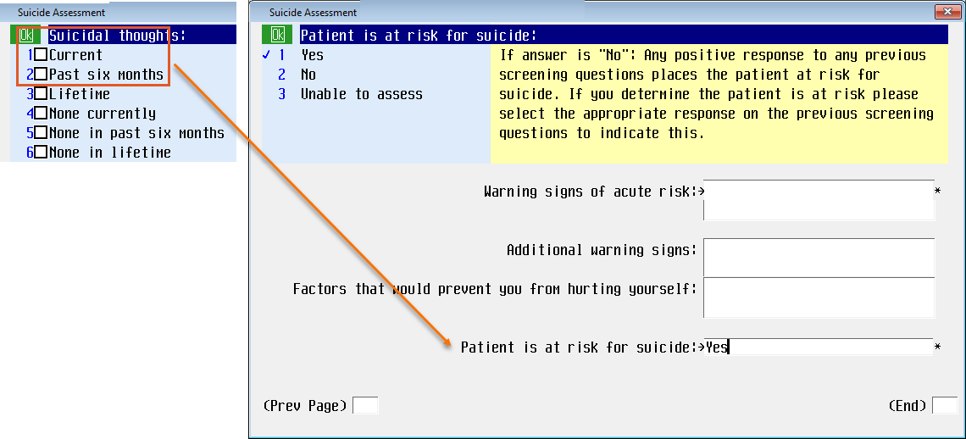

1. If the patient does **not currently have suicidal thoughts, none in the last six months AND none in lifetime**; the programming logic will skip the assessment fields and default a **No** in the *Patient at risk for suicide*.

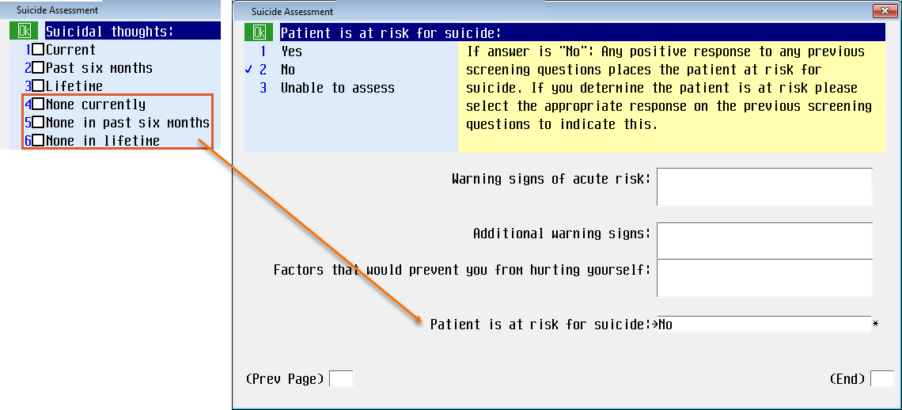

1. If the field has a response of **None in lifetime**, the programming logic will skip the assessment fields and default a response of **No** in the *Patient at risk for suicide* field (as above).

The Yellow information box has been updated to assist with supporting documentation. Address all 3 timeframes with patient and accompanying person to ensure accuracy.

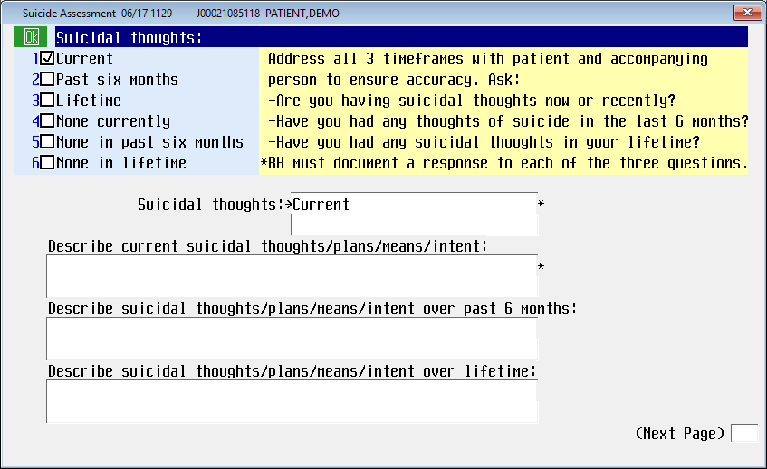

The *Patient is at risk for suicide* will default a **Yes**.

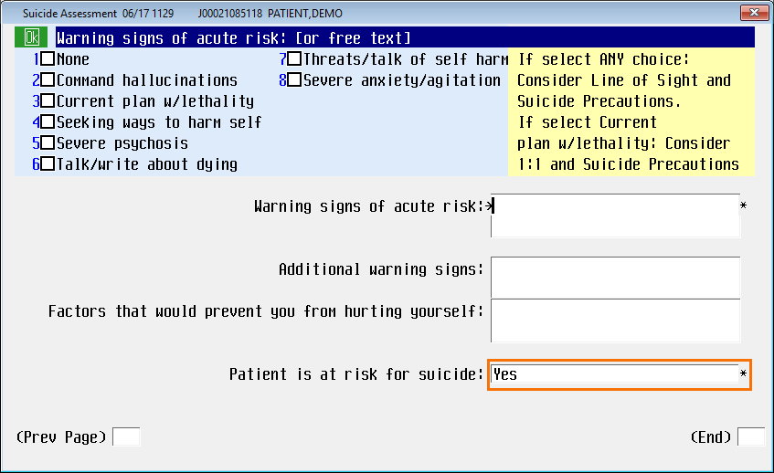

The warning message at the end of the suicide screening has been updated as follows:

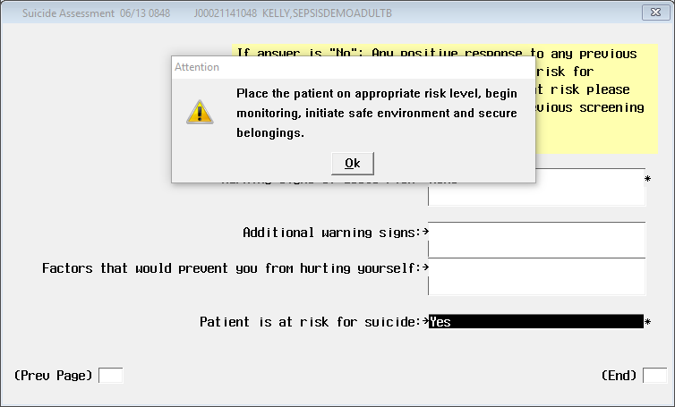

## Urinary Catheter Indications for Chronic Indwelling Catheter

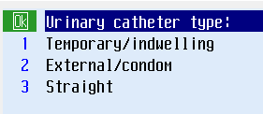*Removed permanent urinary catheter* from Urinary catheter type options. This device type has been added and is now captured as a *surgical urinary device type*.

A programming change prevents the ability to back date the *insertion/applied date* prior to date of patient registration. For patients who’ve had placement prior to admission to the facility, it is the expectation that you document the admission date, NOT the original insertion date.

*Indication of urinary catheter* has new group response of **chronic.**  
The *Indication for urinary catheter* query not required is not required IF the urinary catheter type chosen is **external/condom**.

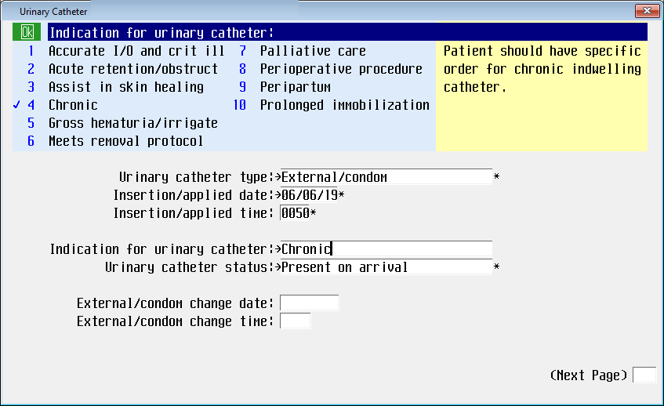

The patient should have a specific order for chronic indwelling catheter, and the catheter should not be documented as “Chronic” unless a physician order for “Chronic Indwelling” has been placed.

The *Indwelling Type* now has option to select a catheter substrate: **Silicone/latex free** has been added.

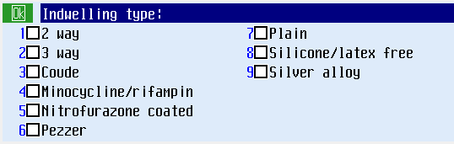

**Patient** was added as an option for *urinary catheter insertions* in documentation.

