EBCD MEDITECH Content Updates – 2019.3  
Nursing Module

Overview

This document is a high-level overview for end user education purposes about significant changes within the Nursing Module. Additional enhancements may be seen in the [EBCD Content Updates section](http://teamrooms.hca.corpad.net/sites/EBCD_Ent_Site/_layouts/15/start.aspx#/Tools%20and%20Templates/Forms/AllItems.aspx?RootFolder=%2Fsites%2FEBCD%5FEnt%5FSite%2FTools%20and%20Templates%2F03%2DEducation%2FContent%20Updates&FolderCTID=0x01200033795B734D296D43995FA9BA1F04246D&View=%7B9B91E0F3%2D6AEB%2D4188%2D9C89%2DD2FDAAAE19B2%7D) of the [EBCD Atlas Connect page](http://connect.medcity.net/web/informatics/ebcd).

How to use this guide

The enhancements are listed by intervention. They include which module(s) affected along with the impact associated with the intervention.

The enhancements are listed in alphabetical order and provide a rationale behind the change and screenshot example(s). This document focuses on end user enhancements designated as high and medium impact.

Impact Legend:

|  |  |  |  |
| --- | --- | --- | --- |
| Safety/Regulatory |  | Clinical Initiative |  |
| Reimbursement/Billing |  | Enhancements/Wins |  |

Be aware the enhancements may not be in your test environment at the time this document is published. Your facility/IT Division support team will notify you when the updates will be available in your software.

Please read the MEDITECH selected prompts and follow the yellow information boxes onscreen as you become aware of changes in the documentation.

*Click the topic name to be taken to the specific documentation within this update:*

Summary of Revisions 2

Health History Update – CAGE Screening 3

Hygiene Care 4

Legal Hold Status: Health History 5

Patient Email verification 7

Plan of Care 10

Restraints 14

Suicide Assessment 20

Urinary Catheter Indications for Chronic Indwelling Catheter 23

# Summary of Revisions

| **Date** | **Revision** |
| --- | --- |
| 8/9/19 | Published for Enterprise |

## Health History Update – CAGE Screening

*Assess trauma alcohol screening (CAGE)* was added to the **Health History Update**

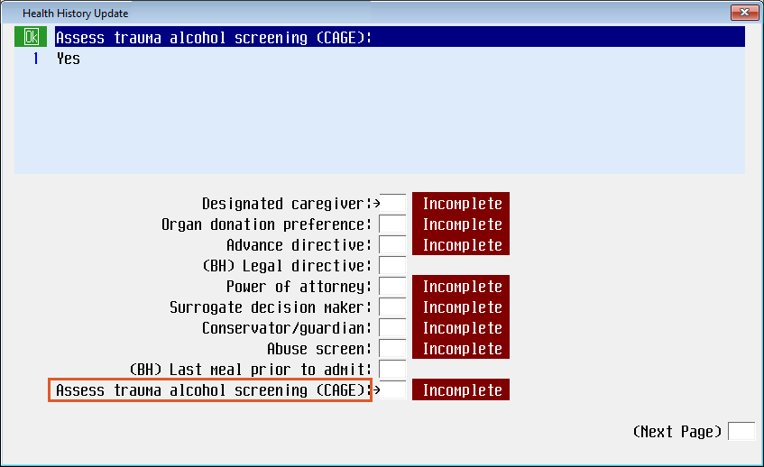

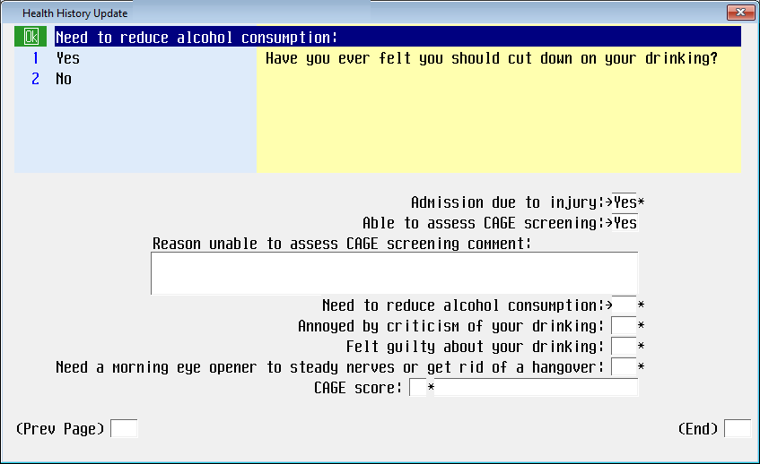

## Hygiene Care

**Hygiene Care** is a new standalone intervention optimizes the documentation process for capturing hygiene and CHG bathing information.   
This intervention also includes Oral CHG care and perineal care.

With this update, Routine Daily Care intervention was updated, removing a page and moving it to this new **Hygiene Care** intervention.

Documentation should be done on admission and every shift. Add this to the patient’s plan of care, if it is not pulled in via the Quick Start Routine.

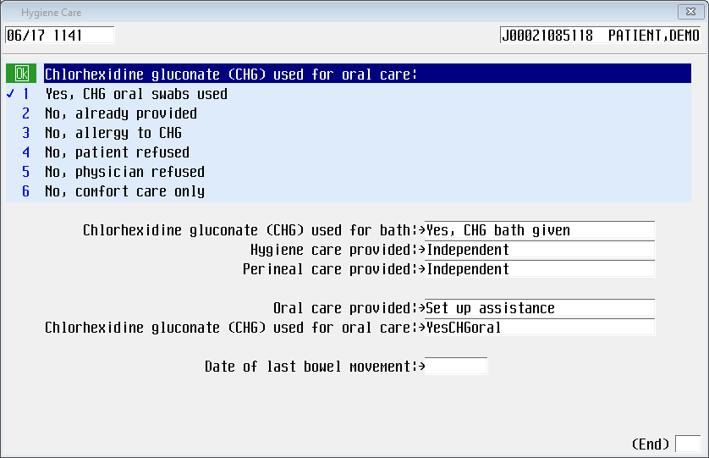

Additional CHG information may be found here in the CSG: Nursing Corner

<https://connect.medcity.net/web/nursingcorner/c-diff-user-guide>

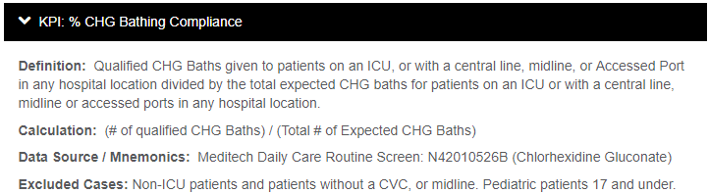

## Legal Hold Status: Health History

A newly standardized method captures the legal hold status throughout the patient encounter. This aligns with current process used to populate the facesheet (regulatory requirement) and on patient handoff/SBAR.

On the **Inpatient: Health History Assessment** and the **Behavioral Health: Health History Assessmen**t, **Legal Hold** was removed as an option from *Barriers in living situation relevant for discharge planning*.

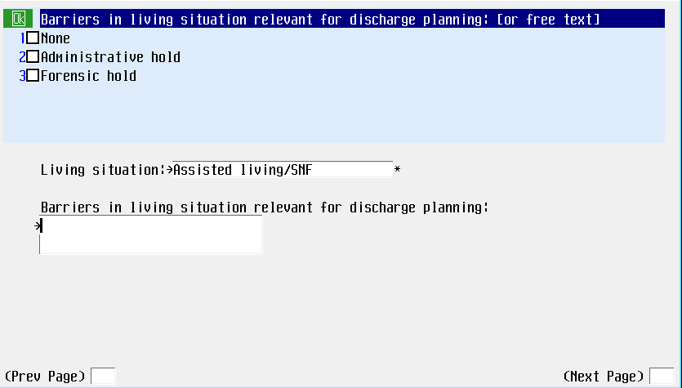

**Health History Assessment**: The programming has been updated to reflect 'Incomplete' when more documentation is needed and complete when the regulatory requirement has been met:  
If *Copy of advance directive on chart* is answered **No**, it will populate the *Advance Directives* entry on **Health History Update** main page as Incomplete.

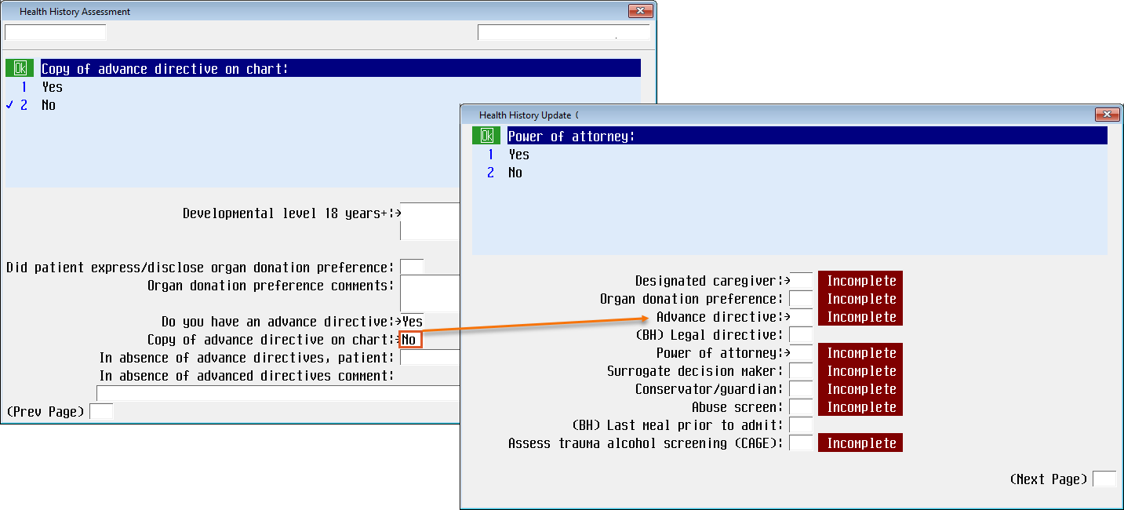

If answered **Yes**, it will populate *Done* on the **Health History Update** main page.

**Health History Update:** if *Copy of advance directive on chart* is answered **No**, it will populate the *Advance Directives* entry on **Health History Update** main page as Incomplete.

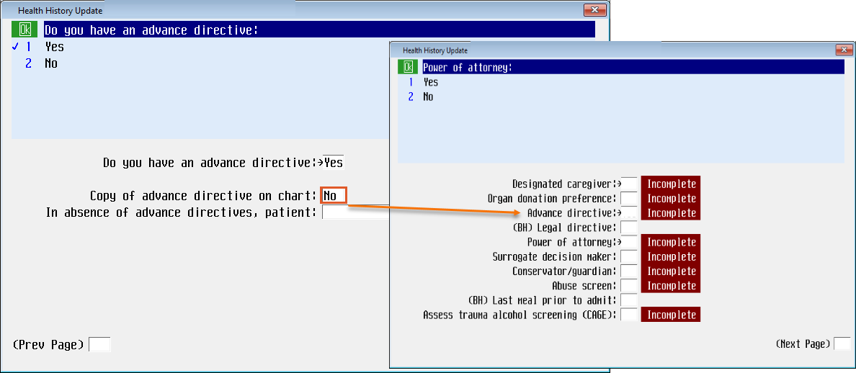

The warning message at the end of the suicide screening has been updated as follows:

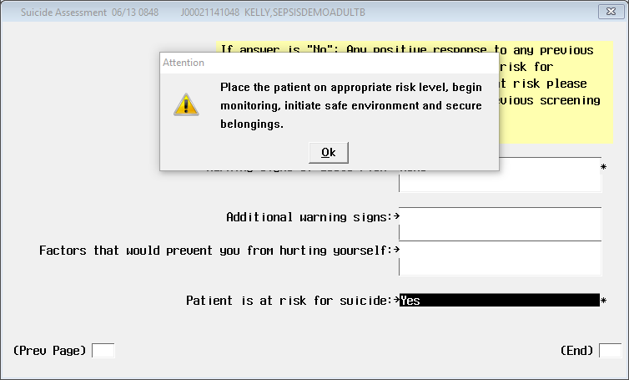

**Inpatient and OR SBAR reports**: The legal hold status section will displays the legal hold status from:

* Initial legal hold status – from the provider order
* Involuntary Detention – from the ED Module’s Rapid initial Assessment

## Patient Email verification

The patient’s email address is captured in the MEDITECH Admissions module. This email will now be verified in the Inpatient Nursing, ED and OR Modules.

There is considerable evidence in the published literature on survey research that the patient’s pre-notification will increase response rates. There are numerous opportunities to let patients know they will receive a questionnaire. Data shows that when the patient’s nurse makes a “meaningful, personal ask” of the patient to please complete the survey, the patient is more likely to take the survey. Any pre-notification method must be neutral. It must not ask the patient for a specific response (e.g. don't say or post sayings like, Give us a "5"). Note that CMS has specific guidelines for communicating to patients regarding CAHPS surveys; please see below for examples that CMS considers appropriate regarding promotion of the survey:

* Explain to the patient and their family members what improvements resulted from recent feedback.
* Tell the patient you personally value their feedback about their stay
* Mention an example of an improvement project the organization is currently addressing.

Note: This email address field is editable but not required in EDM, NUR and OR.

The email address flows from Inpatient, ED and OR Modules but will not be bi-directional at this time. Follow your facility process to communicate changes to the patient’s information.

The following Screens now include a new Patient email address field:

* Health History Assessment
* Inpatient Discharge Instructions
* SURG: Admission Health History
* ED Disposition

The *Patient Email Address* field is available to verify the patient’s current email address. If an email address was entered via the Admission module, the last response will default in the field and in the red highlighted area:

* Last recorded by Reg – no edits found – displays when only the original Registration entry has been found.

Example, the Registration form had “None” entered in the Patient email address field: 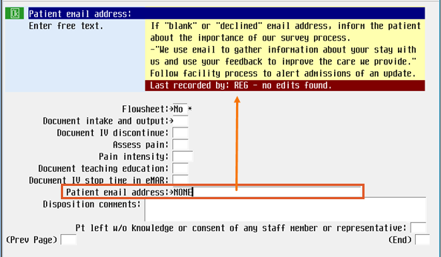

* Last recorded by: Reg on [date/time] - displays when the registration entry has been updated since the original registration.

Example of updated information from Registration: 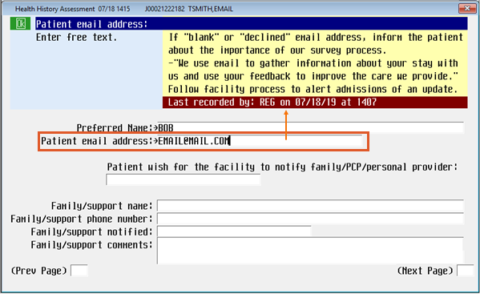

* Last recorded by: Nursing on [date/time] - displays when *Patient Email Address* field in the nursing documentation screens has updated since the Registration has been entered (either original or edited).

Example of updated information from Nursing documentation (OR,ED, Nursing):

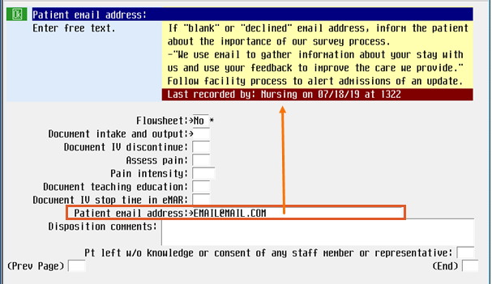

* Last recorded by: No email found. - displays when no email address has been documented. If no response entered in the Inpatient Admission questionnaire then nurse can free text enter the email address (up to 40 characters).

EDM Example: Disposition DX/TX/ADM/LPT

Inpatient Nursing Example: Health History Assessment

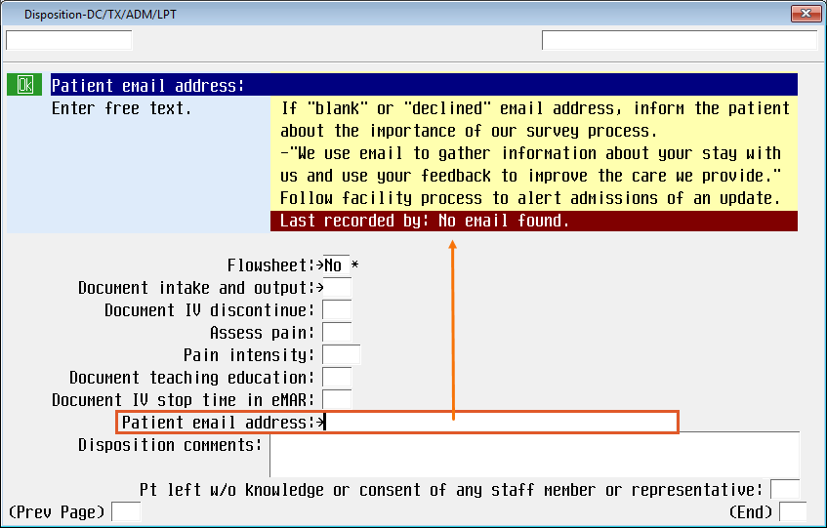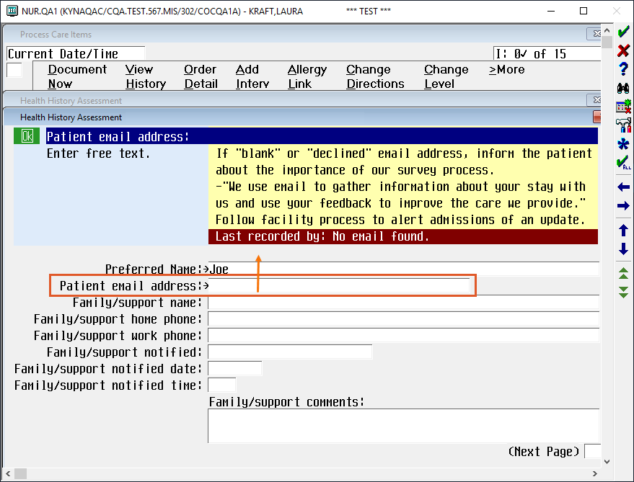

## Plan of Care

The restraint episode is to be reflected in the plan of care. This includes the problem (on the plan of care screen) as well as the interventions and assessments provided (on the process interventions screen). The *perioperative* and *inpatient nursing* ***Plans of Care*** have been updated to document once a restraint episode begins.

*Click on these links to access MediaConnect recording for restraints and Plan of Care:*

[*Video of 2019.3 Nursing Module Enhancements*](https://mediaconnect.medcity.net/media/2019.3+EBCD-Plan+of+Care+and+Restraints+%28NUR+Module%29/1_f9m8xa7a)

[*Video of 2019.3 OR Module Enhancements*](https://mediaconnect.medcity.net/media/2019.3+EBCD-Plan+of+Care+and+Restraints+%28OR+Module%29/1_77pgfhtz)

2019.3: **Violence/restraint risk** will no longer be an option for the nurse.

The **Plan of Care** now includes two new problems under the *Health behavior problem/risk*:

* **Restraint safety precautions** problem
* **Violence risk** problem**.**

The **Restraint Safety Precautions** is intended to be used for both violent and nonviolent restraint episodes.

***Violence risk*** is associated only with violence risk/behavior and may be unrelated to restraints.

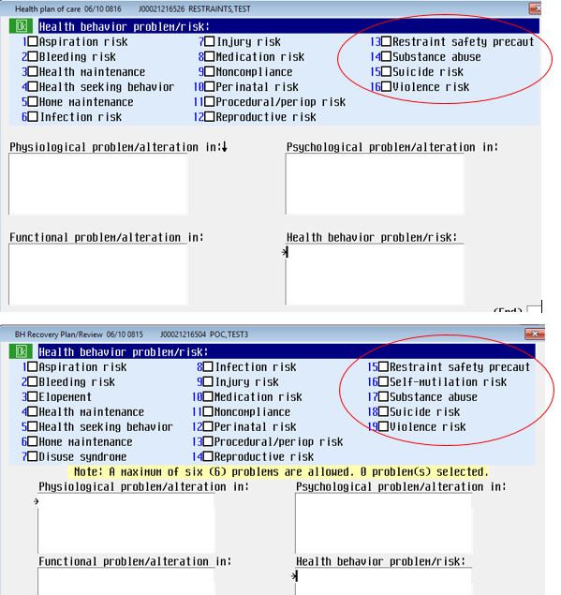

The expectation is for there to be a query link so that when the restraint documentation occurs for inpatient there will be a link to automatically add the problem to the plan of care screen. *This only occurs for the original episode and must be manually added for subsequent restraint episodes.

How to document during the cutover/transition period from the old screens to the new 2019.3 documentation if the patient already has the Violence/restraints risk problem on their care plan:

When going live with the new *Plan of Care* screens, the **Violence/restraints Risk** Diagnosis/problem will be inactivated and the nurse will have the option for:

* **Restraint safety precautions** (for both Violence/Non-violence Restraint types)
* **Violence** **risk**.

When documenting on the patient for the first time with the new Plan of Care screens, the nurse will be presented with alerts stating that the old problem has been inactivated and is provided with options of the two new problems to select. S/he will be asked in the alert if BOTH new problems are needed and given the opportunity to answer Yes or No and choose the new problems(s) accordingly. S/he will then be asked to document an outcome for old Violence/restraints Risk problem in order for it to be set to Complete in the Plan of Care.

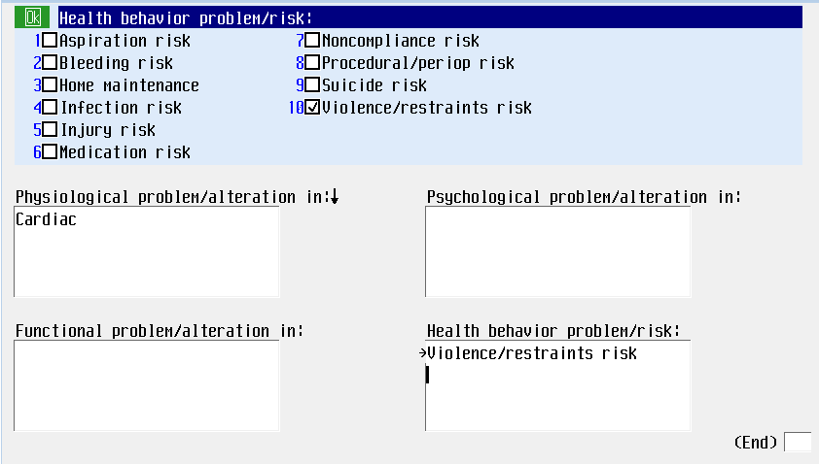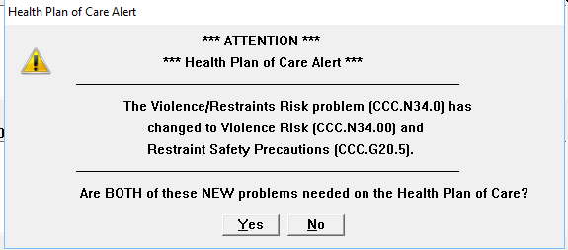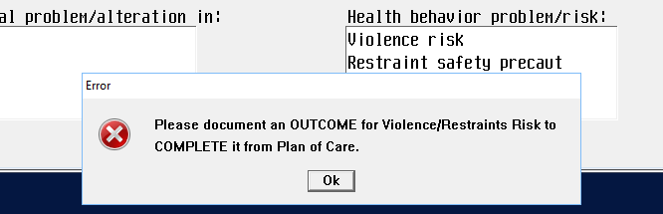

All of the information below, including a T date, will default in for the nurse but this response is editable.

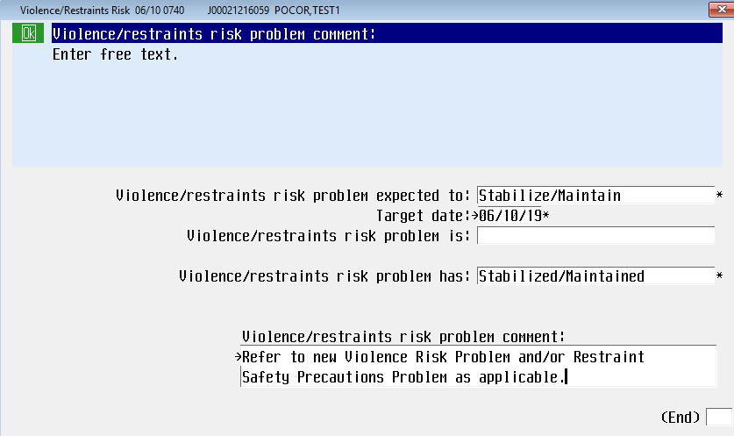

One or both of the new problems (as chosen via the prompts) will now appear in the care plan documentation and be added to the plan of care.

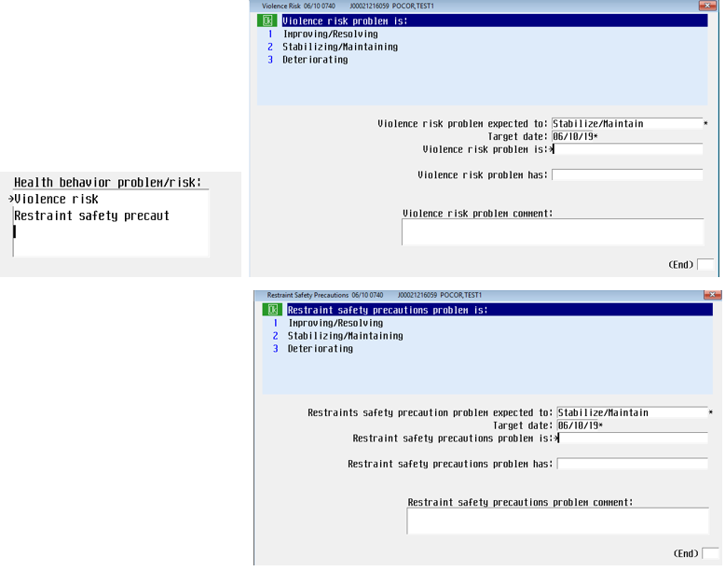

**Plan of Care beyond the problem identification:**

When speaking to the process of the plan of care for patients in restraints it is important to note the multiple interventions and assessments provided to the patient during the restraint episode. Examples include:

• Restraint documentation and associated assessments and alternatives   
 attempted

• Pain assessment

• Vital signs

• Manage/refer/contact/notify

• Orders

• Education

• System assessment

• Hygiene care intervention

• I/O – oral intake and output

• eMAR

## Restraints

The EBCD restraint documentation provides a streamlined linear documentation pathway with content and logic that aligns with the corporate policy. The nursing documentation and associated provider order is standardized for adults and pediatrics in the Nursing (including Behavioral Health), Emergency, and the OR/PACU settings.

The **Safety, Risk, Regulatory** assessment no longer includes the *Assess Restraints* option. Use the standalone **Restraint Documentation +** intervention to document Restraints.

Skip-logic programming guides the user through the proper documentation pathway for violent and non-violent type episodes.

*The restraint problem in the plan of care is now an independent problem. Programming has been put in place to guide the end-user through the cutover process if they have patients with the old Violence/restraints risk problem already existing on their care plans. This programming will walk the nurse through the conversion/completion of the old problem into one or both of the new problems as applicable.

The corporate Patient Restraints Policy can be found on the CSG Quality Standards Atlas site. Link: <http://connect.medcity.net/web/clinical-services/clinical-policies>

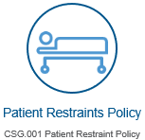This policy/procedure applies to healthcare professional operating within HCA facilities that have responsibility for ordering, assessing, care planning, restraining, or monitoring the restrained patient. This policy is applicable to all age groups of patients, including neonates.

### Start Phase:

The yellow information box displays the clinical justification from the most recent *active* provider order.

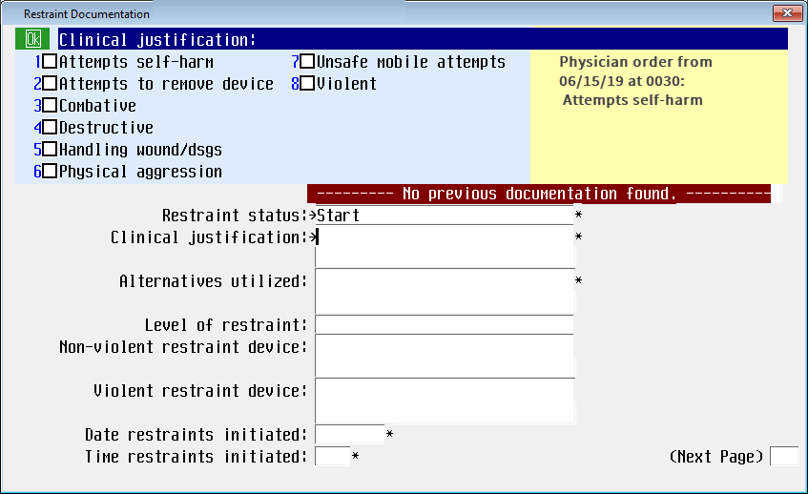

*Observed restraints appropriately intact* has an option of **Not applicable**. A pop message will display if not applicable is not an appropriate response for the documented restraint device.

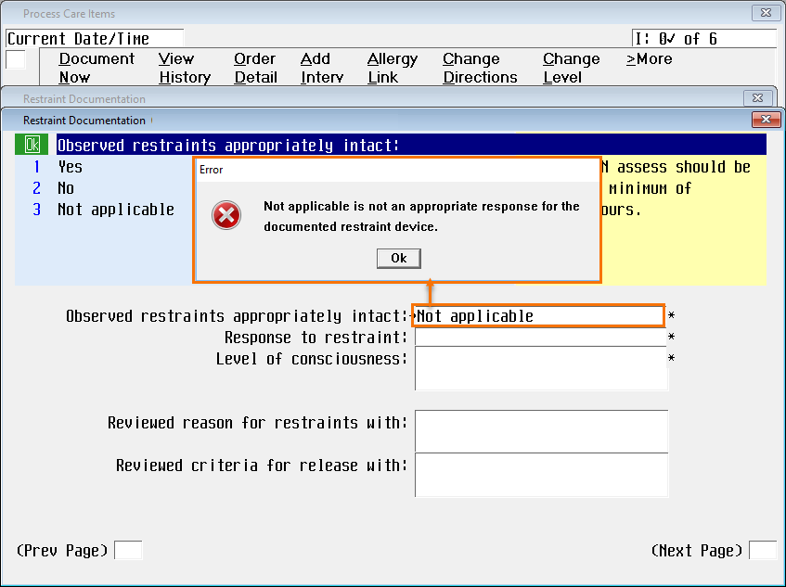

The suggested problem for *Restraint Safety Precautions* will display in the popup and should be added to the patient’s plan of care the first time you receive the popup message.

For multiple restraint episodes, if the problem is closed out on the plan of care and a second episode is started, then nurse will have to add the problem to the plan of care.

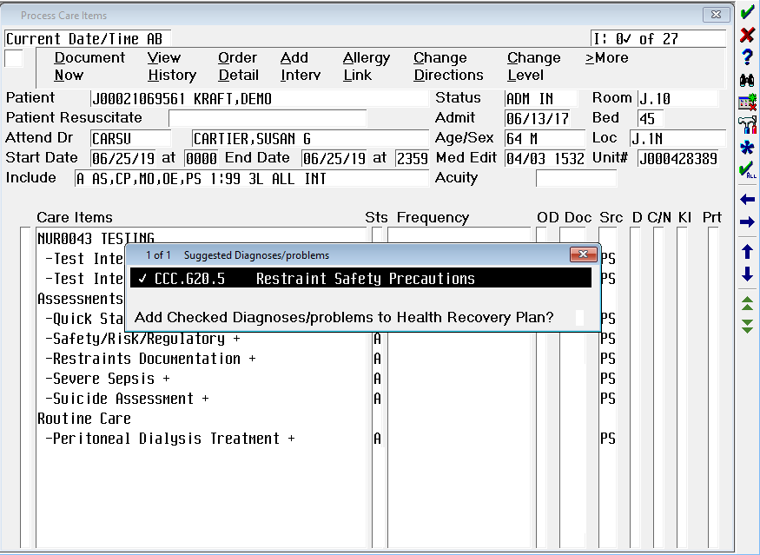

### Monitor Phase:

* Added a **Not applicable** (NA) option for patients in seclusion or chemical restraints ONLY.   
  Since you can select multiple restraint devices (on previous page), **NA** is not an option if either **Chemical** or **Seclusion** is selected in addition to the other restraint choices. For example, if **Chemical** and **Bedrails** are both selected, **NA** is not be allowed.



* *Alternatives attempted*, is now an option to capture as part of the assessment. It has the same group response options as *Alternative utilized*.

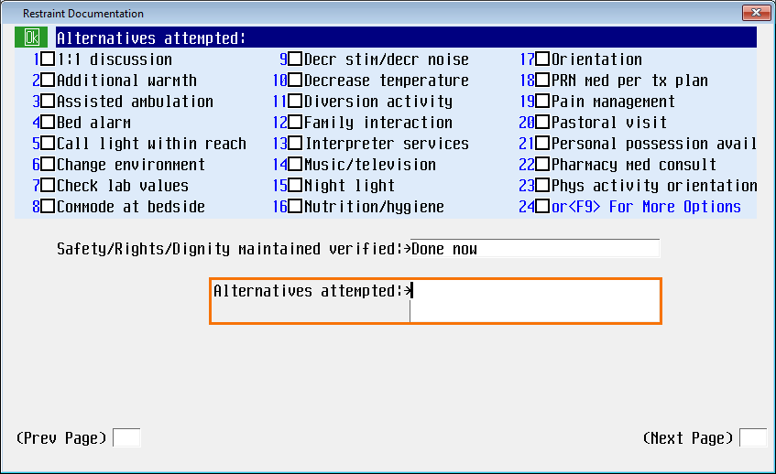

* *Skin under/around restraint verified* and *Circulation distal to restraint verified* queries have **Not applicable** added to the group response option when applicable for the restraint device(s) selected. (For example, if **Chemical** restraint was chosen as a device type, then *Circulation distal to restraint verified* is not applicable.).

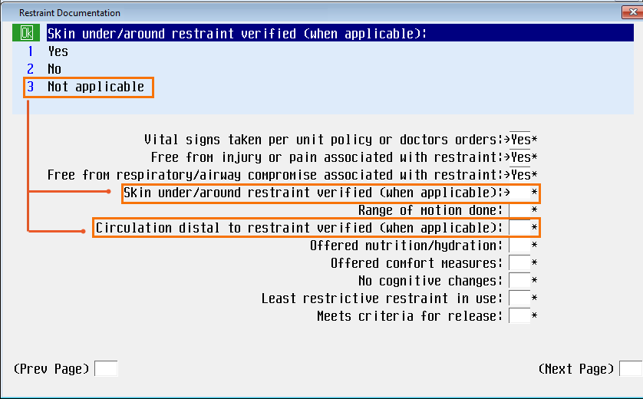

* *Meets criteria for release* has a new yellow information box reminds the nurse that the response here doesn’t discontinue the episode, but s/he must go back in to the intervention and discontinue the episode once the patient meets the criteria for release.

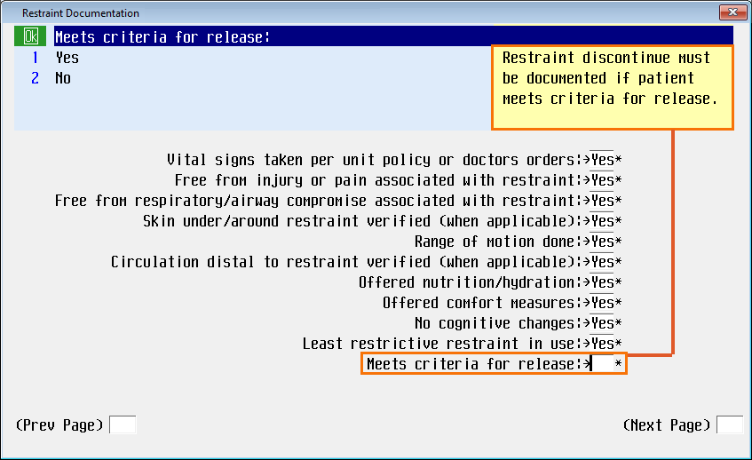

### Safety, Rights, Dignity Phase:

* *Alternatives attempted* was added to this phase as well.
* *Skin under/around restraint verified* and *Circulation distal to restraint verified* queries now have a **NA** group response option, allowing this option when applicable for the restraint device selected (same workflow as *Monitor* phase).



### Discontinue Phase:

* *Criteria for restraint release met* now has an option of **No**. The yellow information box outlines when **No** may be the appropriate selection;, for example in the event that the restraint device has to change, or a new provider order is placed, where the nurse may need to change the restraint device but the patient hasn’t met the criteria for release (for example, if the patient’s device needs to escalate from two-point to four-point restraints). Here the nurse can acknowledge that the patient may not meet the criteria for release, but due to change in device, change in clinical justification, a new provider order, the nurse is discontinuing this episode would go back in to the patient’s documentation and start a new episode.
* 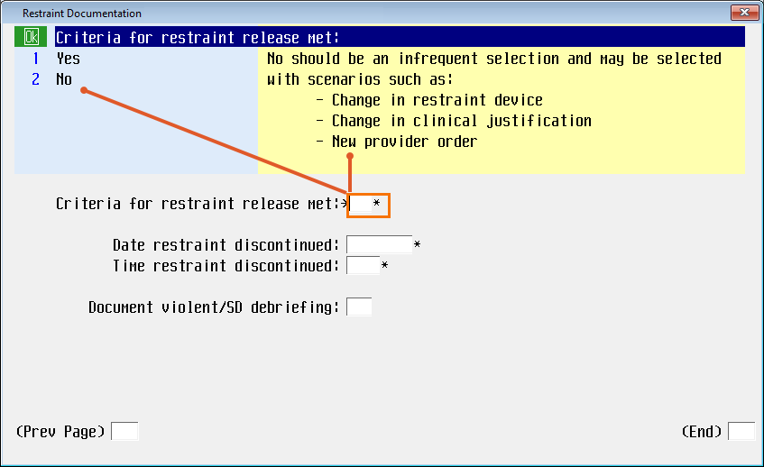

## Suicide Assessment

The updated suicide assessment programming accommodates both the behavioral health and acute care populations, noting that the assessment criteria which may be applicable to the BH population may not always be applicable in the acute care patient population. These updates align with all patient populations.

In the *Suicidal thoughts* field:

1. If **Current**, **Past six months** OR **Lifetime** is selected as part of the response choices, the user will complete the entire suicide assessment. **The Patient at risk for suicide**: will default **Yes,**

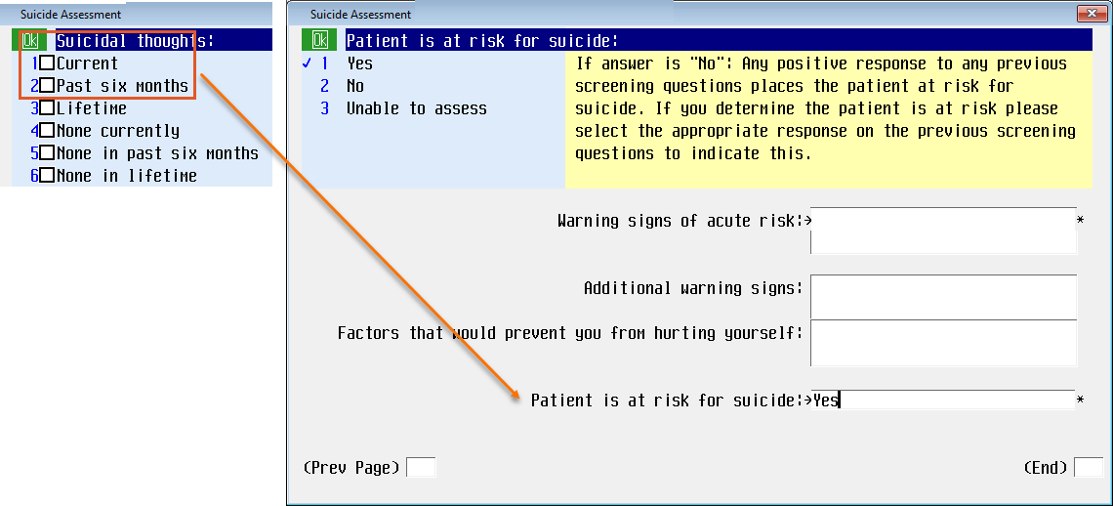

and the updated customized report Suicide Precautions - Appropriate Patient Monitoring Level Definitions will print for the clinician.

The report will now autoprint but is also available for on-demand printing.

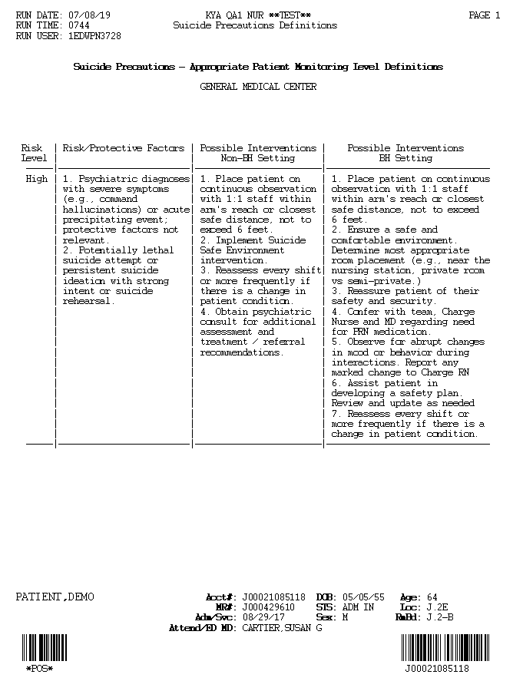The Provider order information no longer displays at the end of the report. Follow your facility guidelines for the Provider Order Workflow.

Here is an example of page 1, “Suicide Precautions - Appropriate Patient Monitoring Level Definitions” Report:

1. If the patient does not currently have suicidal thoughts, none in the last six months AND none in lifetime; the programming logic will skip the assessment fields and default a **No** in the *Patient at risk for suicide*.

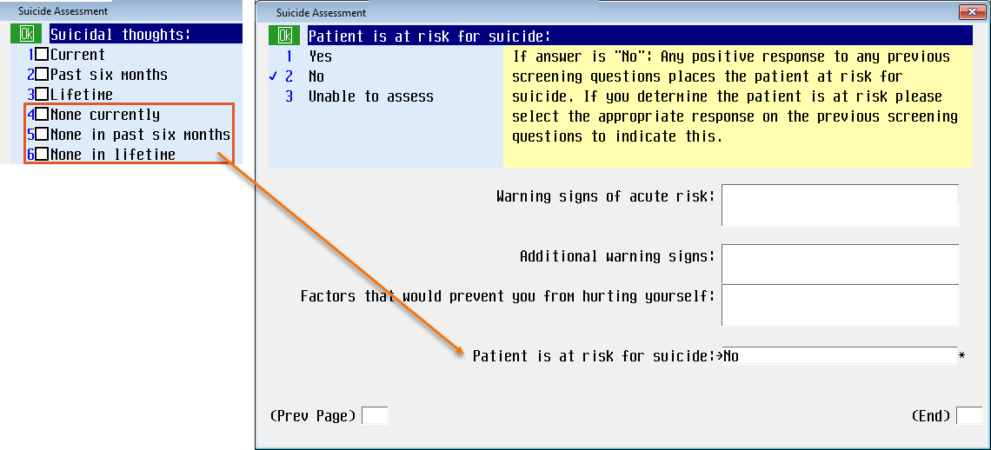

1. If the field has a response of **None in lifetime**, the programming logic will skip the assessment fields and default a response of **No** in the *Patient at risk for suicide* field.

*Pediatrics population*: Follow the yellow information box for all documentation.

The Yellow information box has been updated to assist with supporting documentation. Address all 3 timeframes with patient and accompanying person to ensure accuracy.

*Behavioral Health must document a response to each of the three questions.

The *Patient is at risk for suicide* will default a **Yes** and the updated customized report   
“Suicide Precautions - Appropriate Patient Monitoring Level Definitions" will print for the clinician.

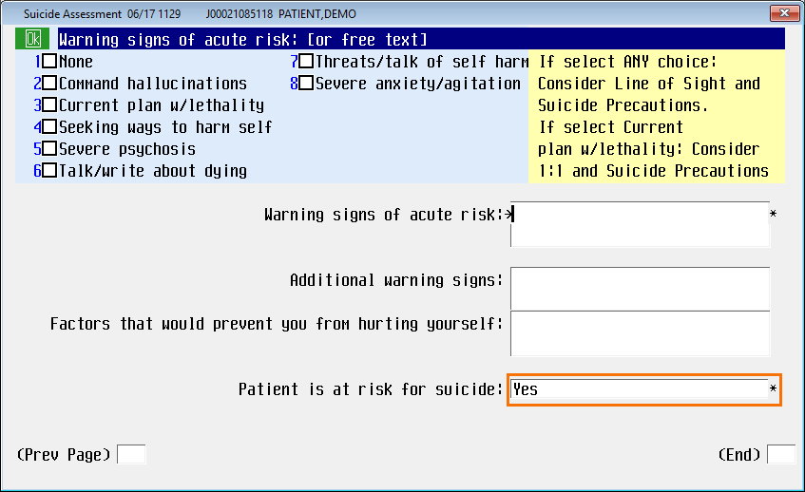

Example of “Suicide Precautions - Appropriate Patient Monitoring Level Definitions” Report, Page 1:



## Urinary Catheter Indications for Chronic Indwelling Catheter

Documentation enhancements have been made to capture indications for chronic indwelling urinary catheter maintenance, capture maintenance care of chronic indwelling urinary catheter as well as accurately capture Catheter insertion days.

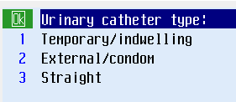*Removed permanent urinary catheter* from Urinary catheter type options. This device type has been added and is now captured as a *surgical urinary device type*.

A programming change prevents the ability to back date the *insertion/applied date* prior to date of patient registration. For patients who’ve had placement prior to admission to the facility, it is the expectation that you document the admission date, NOT the original insertion date.

*Indication of urinary catheter* has new group response of **chronic.**  
The *Indication for urinary catheter* query not required is not required IF the urinary catheter type chosen is **external/condom**.

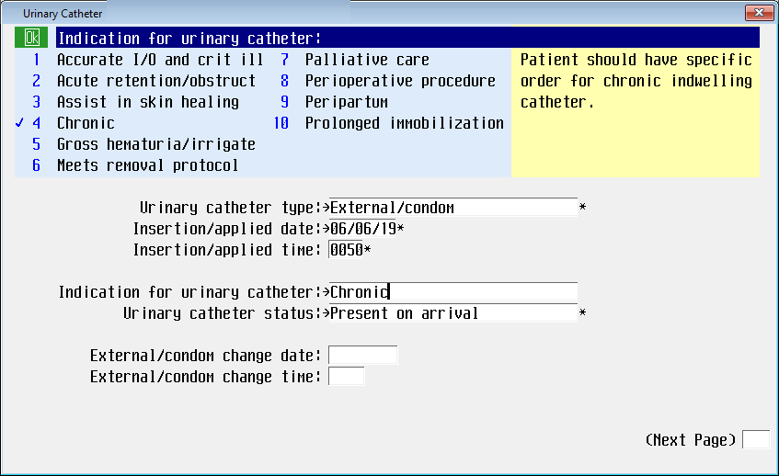

The patient should have a specific order for chronic indwelling catheter, and the catheter should not be documented as “Chronic” unless a physician order for “Chronic Indwelling” has been placed.

The *Indwelling Type* now has option to select a catheter substrate: **Silicone/latex free** has been added.

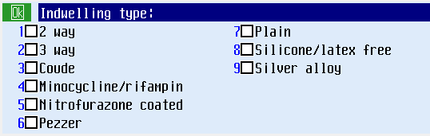

**Patient** was added as an option for *urinary catheter insertions* in **Lines/Drains/Airway** documentation.

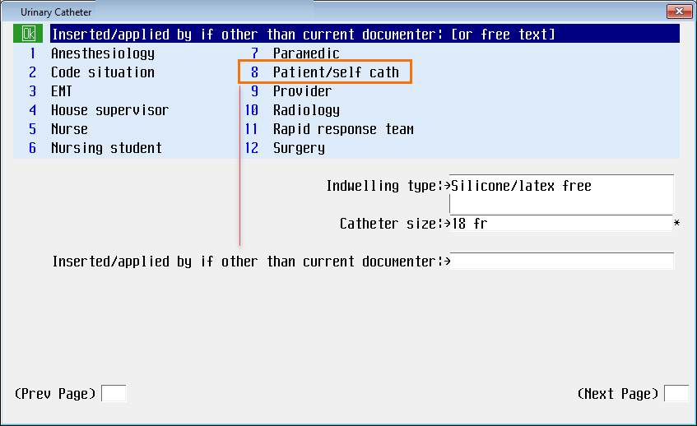

*This page intentionally left blank.*