USING the Cactus SMART SINK®

for disposal of controlled substances

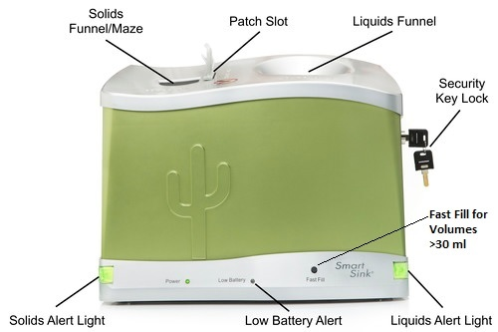

The battery powered Cactus Smart Sink system, an innovative pharmaceutical waste system accepts unused raw pharmaceuticals in both liquid and solid forms, including patches. It incorporates two types of cartridges, one for liquid waste and one for solid waste. Both cartridges have the ability to render the remaining portions of controlled substance waste into an "unrecoverable, non-retrievable and unusable" form and securely store them until they can be disposed of per regulatory guidelines.

The Smart Sink system is designed to accept raw liquid pharmaceuticals directly from syringes, vials, or IV bags. It also features a one-way funnel that accepts tablets, capsules, and patches. The Smart Sink includes audible alarms and alert lights to notify staff when the cartridges are full, have expired, or when the unit has been accessed. The system cannot be removed from the security bracket without the key, and **does not accept sharps, vials, ampules, and/or IV bags. Placing sharps and broken ampules into the Cactus Smart Sink presents a risk of injury to staff when changing cartridges.**

Instructions: Place capsules and pills into the solids funnel. Place liquids into the liquid funnel. For liquid volumes over 30 ml, press and hold Fast Fill button. Fentanyl patches: fold in half, adhesive-to-adhesive, do not cut or tear. Insert folded patch into Patch Slot; use plunger to fully push patch into slot. **All Controlled Substance waste must be witnessed, and documented per HCA and facility policy.**

\***Pyxis Transactions and Controlled Substance Wastes Recorded on Security Cameras for Your Protection**\*