To: Members of the Nursing Staff

Re: Medication Safety Functionality – Co-Sign ability being turned ON

**Below is a description of the changes you will see:**

* Based on Drug selected within the “IV Drip Titration” Intervention, you may get a prompt for Co-Signer at:
  + Start/Restart
  + Titration

**Rationale for this change:**

* *A nursing double check is required for certain medication when Starting, restarting or at the time of titration. This new feature will allow them to document a Nurse Double check of the action being performed.*

**Where will you see these changes?**

1. In the “IV Drip Titration” Intervention

**Screenshots:**

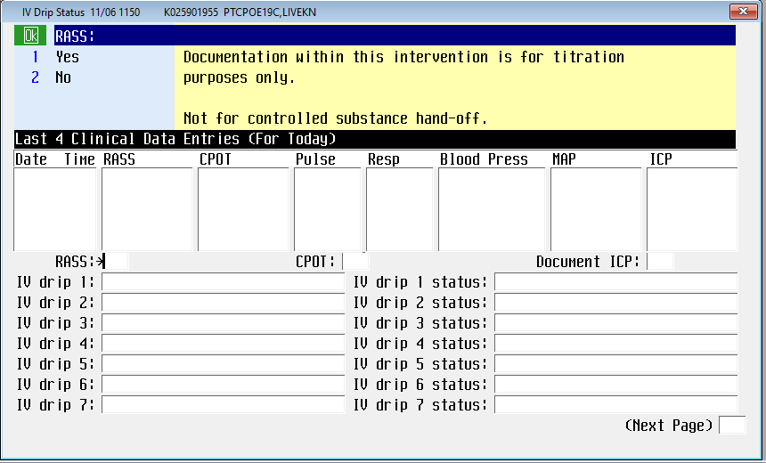

The nurse may select the specific Drip which will then allow them to give more specific documentation

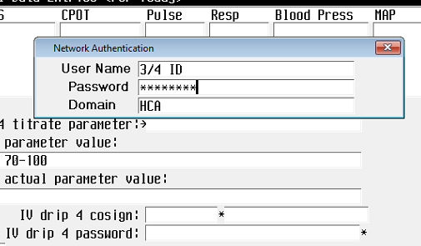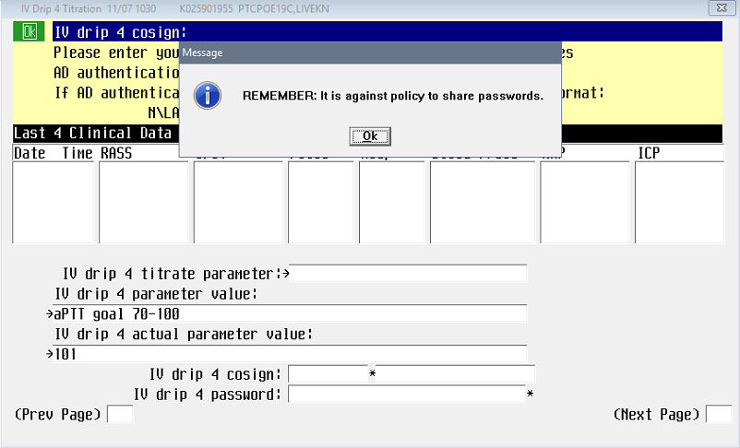

Once information is documented, the Nurse will be prompted to obtain a Co-Signer.