New PRN Reason vs Pain Assessment Functionality

Live Wednesday, August 22nd

* A pop up has been built in Meditech to warn Nursing they are administering a PRN pain medication outside of its intended Pain Scale.
* The below example is a physician ordered Fentanyl for Pain Scale 7-10.
* The RN will document his/her assessment as usual. If the Pain is correctly documented according to the scale, no warning.

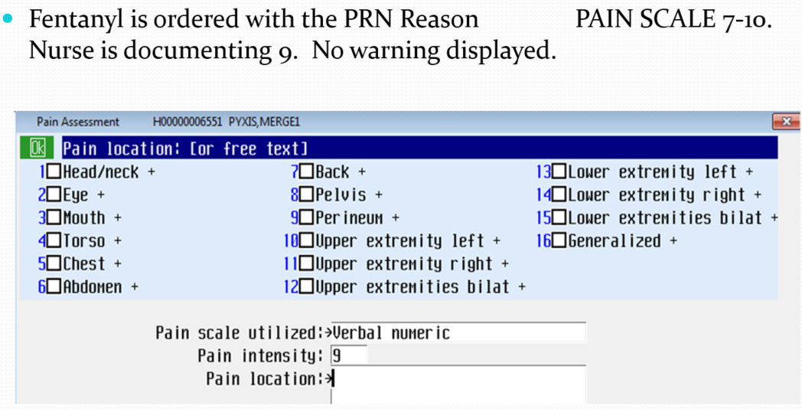

However, if the Pain is incorrectly documented according to the scale as below, a pop up warning will then display.

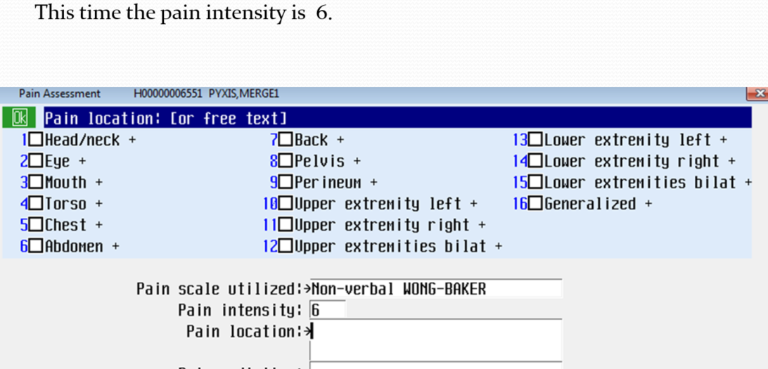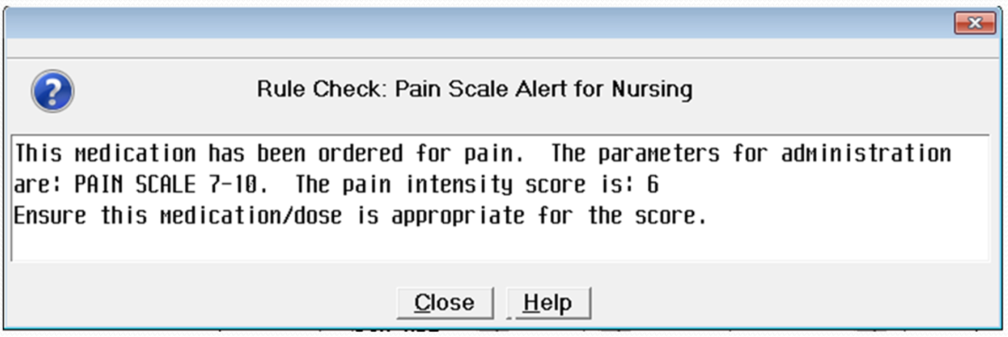

If you give less than ordered amount you can document in comment section:

