eMAR Desktop Quick Reference Card
Getting Started
eMAR Workflow  - Acknowledge Orders  - Remove medications and take to patient’s bedside  - Access eMAR Desktop using Status Board and perform functions  Button Types/Functions  - Integrated Desktop Buttons  Located on right side of screen  - Similar functions as Status Board  - eMAR button “grayed out” while using eMAR Desktop  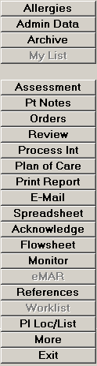  Constant Navigation Buttons  Located on bottom of screen  Button Description  Document Full Document  ACK Acknowledge Orders  Preferences Set for this session or permanently  Drug Data Displays drug monographs, interactions  eMAR Reports eMAR reports  Change Order Hold or DC Medication  Other Quick Charge & Manual Barcode  Submit Submits medication data after barcode scan | Medication Profile Color Indicators  Currently Selected Order Medication order on BLUE background  Discontinued Order Medication order on YELLOW background  Scheduled Time BLACK text on GREEN background  Not Administered Time WHITE text on GRAY background – time documented as not given  Administered Time GREY text on WHITE background – actual administration time  Overdue Time BLACK text on RED background  Future Scheduled Time BLACK text on WHITE background  Hold Medication HOLD text on YELLOW background
Using eMAR Desktop
Scan Med Process  - Scan patient armband  - Scan bar code on each medication package  - Complete any screen presented  - Click Submit button  - Click Save and Recompile or Save and Exit button | Edit/Undo Administration  - Click the administration time of medication to edit  - Change information and data in pop-up box  - Click the Edit or Undo buttons  - Click Submit button  - Click Save and Recompile or Save and Exit button
Full Document - Med Given and Armband Not Scanned  1. Click Other button and click Manual Barcode  2. Manually enter patient’s account number  3. Click to select medication  4. Click the schedule time; be sure cursor is on correct date  5. Document any information in pop-up box  6. Click Document button  7. Click Submit button  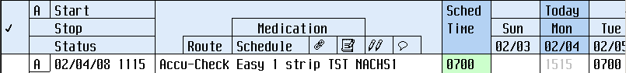  8. Click Save and Recompile or Save and Exit button  Co-Signature  Linked  History medications  Queries  Instructions  Icons  In order to see the history of the medication, select the A link and choose the History button.  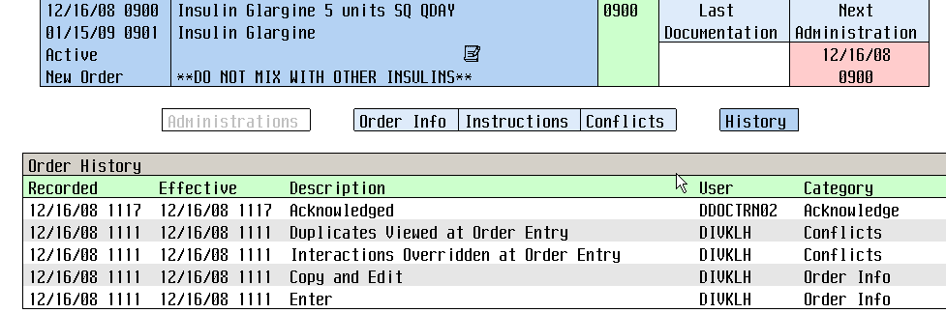 | Full Document - Med Not Given  - Click Other button and click Manual Barcode  - Enter patient’s account number  - Click to select medication  - Click the Sched time; be sure cursor is on correct date  - Review information on pop-up box  - Click “Not given”  - Enter Reason Code (required)  - Click Document button  - Click Submit button  - Click Save and Recompile or Save and Exit button  Quick Charge/Document – if applicable  - Scan patient’s armband  2. Click Other button, then select Quick Charge/Doc  3. Click Other button  4. Select Quick Charge/Doc  5. Complete any screen presented  6. Click Submit button  6. 7. Click Save and Recompile or Save and Exit button  Tips  - Constant navigation buttons replace Verb Strip options  - Mouse clicks expand fields for more details  - Document button is low lit until scan patient’s armband; afterwards barcode displays by patient name in header

