**Let’s talk about restraints Babay..**

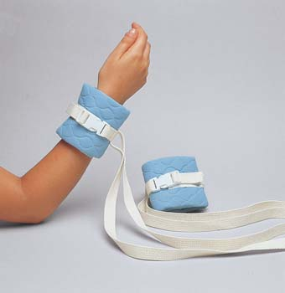

The **Do’s** on restraints:

* Add “injury risk” to care plan
* Add “self-injurious behavior” to education
* Put “three times an hour” for your hourly check
* Back time your checks for top of the hour
* Make sure your patient has an order every calendar day
* Ask your charge nurse to put in the 2nd tier
* Remove your restraints before patient death (if you think your patient is circling the drain)
* Shift handoff of restraint documentation

If all of these things are not done, you **cannot** restrain your patient!

The **Definitely** Don’ts on restraints:

* Put “done now” on your hourly assessments
* Forget to retime your hourly checks-Epic does not automatically do this anymore
* Continue to document without a new/existing order
* Continue to restrain your patient without an existing order
* Let your patient die in restraints….like ever