**New update to Nova Statstrip Glucose Meters**

**Glucose Meter Sample Type Comment Feature**

**Go-live Tuesday Sept. 11, 2018**

**Nova StatStrip glucose meter now has FDA approval for use of capillary samples in intensive care and emergency care settings. A new Sample Type Comment prompt for capillary draws has been added to the ICU meter screen display. Selection of sample type will continue to be required before patient testing in all test areas. Use of the Patient Type Selection in the emergency setting will no longer be required.**

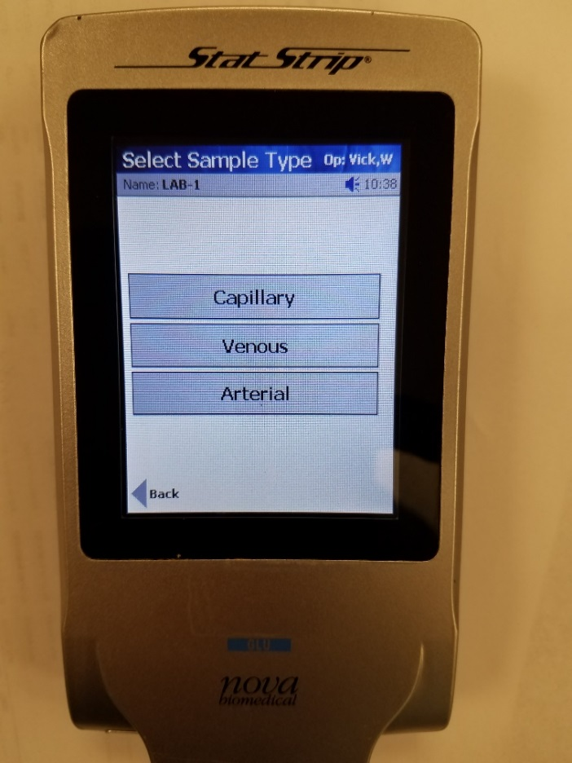

**After the patient armband is scanned, the Sample Type screen will appear**

**Select the sample type – Capillary (finger-stick), Venous or Arterial**

**- used for glucose testing.**

**The screen will not advance** **until a sample type is selected.**

**Press Accept to continue with patient glucose testing**