In case you have a complaint about our products, services or otherwise, please fill out this form and e-mail it to CustomerServices@spgprints.com. Please do not return any materials without our confirmation of receipt and a RMA number.

Customer information
Company name:
End user name:
When different from company name
Contact person:
Email-address:
Telephone number:

Complaint Information
Date of complaint:
SPGPrints B.V. order or delivery number:
Box number:
Your reference number:
Complaint Number:
To be filled by SPGPrints B.V.

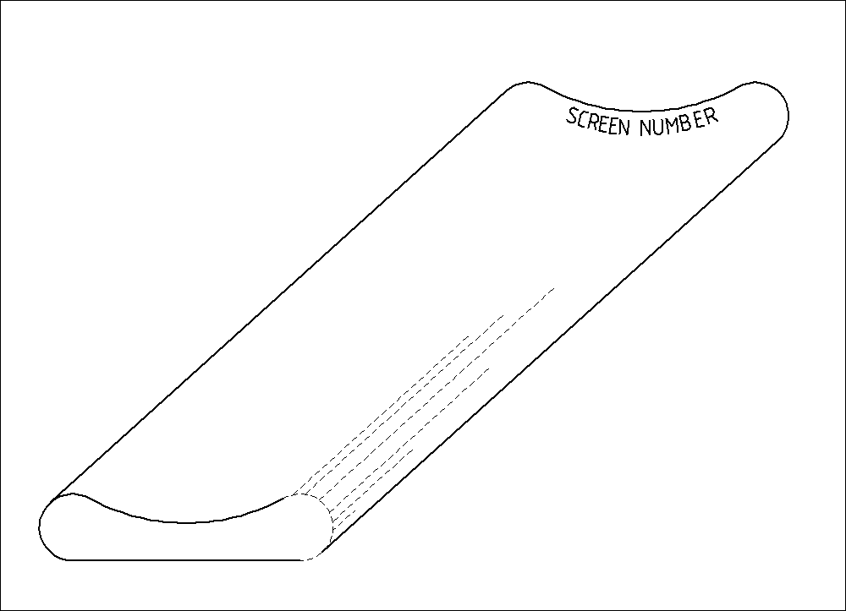
Fold crease

- Creases to the outside
- Box fallen on the side
- Handling/transport

Screen number: _________________

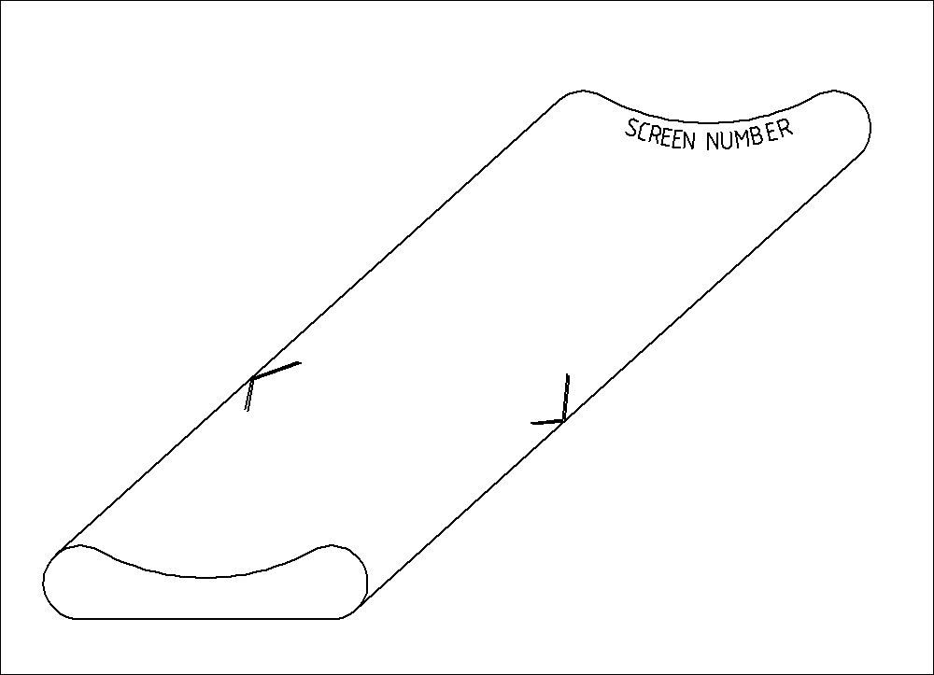
Handling crease

- Creases to the outside
- Mostly on two spots

Screen number: _________________

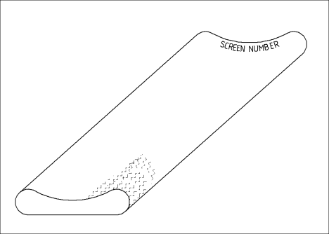
Shock crease

- Creases to the inside and outside
- End are shocked
- Handling/transport

Screen number: _________________

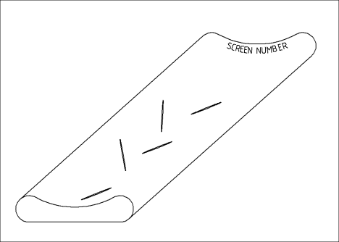
Transport crease

- Creases to the inside
- Box has fallen
- Most inside screen heaviest crease

Screen number: _________________

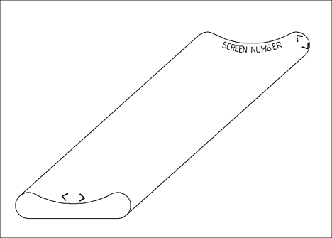
Swing crease

- Crease at the ends
- Out of packing table or light bar
- Handling crease

Screen number: _________________

Remarks: __________________________________________________________________________
___________________________________________________________________________________

___________________________________________________________________________________

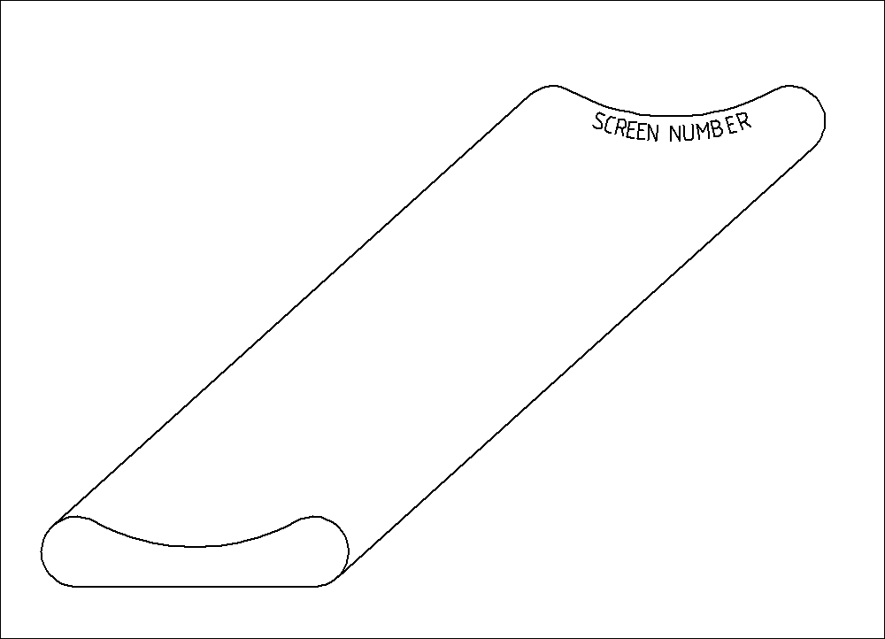

Screen number: _________________ Screen number: _________________

Screen number: _________________ Screen number: _________________

Screen number: _________________ Screen number: _________________

Screen number: _________________ Screen number: _________________

