  Inside Sales Support: 425-827-7279 Office  June Vellat: june@pro-pacific.com  Mary Cowles: mary@pro-pacific.com  Carmen Chamberlin: carmen@pro-pacific.com  Website: www.pro-pacific.com |  | WASHINGTON AND OREGON OFFICES:  Robin Oury Keith Hicks  425-827-7279 phone 541-848-7607 cell phone  robin@pro-pacific.com keith@pro-pacific.com  Ryan Chamberlin Bill Rummerfield  360-305-2418 cell phone 503-351-4048 cell phone  ryan@pro-pacific.com bill@pro-pacific.com  Wade Harris / Executive Chef  206-450-2417 cell phone  wade@pro-pacific.com
  COOK-N-HOLDS, COMBI OVENS, HEATED DISPLAY |   DISPLAY CASES, DELI, MEAT, BAKERY CONFECTIONER |  | 
  Eco Arch Ventilation, Utility Distribution &  Conveyor Systems |   Steamers, Kettles, Braising Pans, & Combination Ovens |  |   Commercial Microwave Ovens, Rice Cookers & Steamers
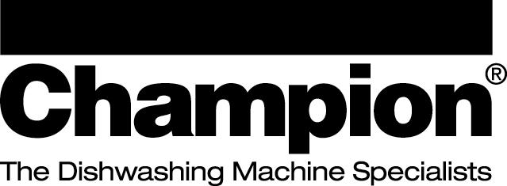  DISHWASHERS, GLASSWASHERS, WAREWASHING |   COMMERCIAL COOKING EQUIPMENT |  |   CONTINUOUS MOTION WARE WASHING SYSTEMS
 | 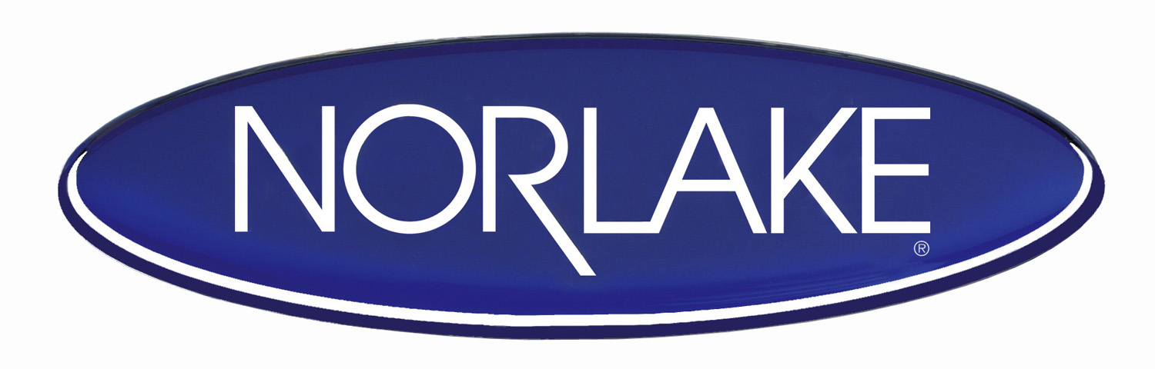  REFRIGERATION, WALK-INS, REACH-INS |  | PIZZA, TORTILLA, GRILLS, PRESSES
  Refrigeration equipment—evaporators, condensing units, chillers, fluid coolers, and defrost controls. |   BREAD SLICERS & BREAD BAKING OVENS |  |   Prep Tables, Chef Counters, Eqt. Stands, Serving Lines & FX precise Holding Refrigeration
  TEMPERATURE MONITORING |   FOODSERVICE FILTRATION SYSTEMS |  |   Pre-Rinse, Pot/Kettle & Glass fillers, Faucets,  Appliance Connectors.Components
  Sinks, Dish tables, worktables hot food tables, underbar, shelving, transport racks and carts. Custom fab.    Aerobic Food Digesters |  |  |   DRINK BLENDERS, FOOD PROCESSING    Slicers, Ovens, Dough Process, and Prep Eqt.

