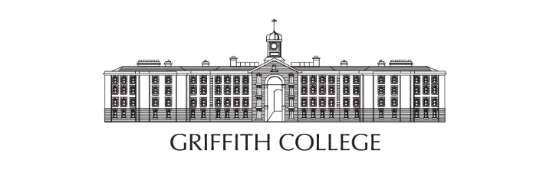

CREATIVE BREAK BURSARY - APPLICATION FORM
SCHOOL NAME:
SCHOOL ADDRESS:
SCHOOL PHONE:
TEACHER NAME:
TEACHER EMAIL:

1 - How would your school use the award to improve learning in creative subjects the classroom?

2 - How would the Creative Bursary benefit your students?

3 - How would you monitor the Creative bursary’s effectiveness and success?

4 - Why is your school deserving of this bursary?

Rebrand Guidelines

We want you to design a new logo for your school and provide an accompanying tagline to become your school’s new motto. The logo design can be created using a computer, or simply drawn up using good old-fashioned pen and paper, whichever you prefer. The proposed rebrand can be as close to or as far away from your existing school branding as you like but remember - this is your chance to get creative!!

In the video, we would like you to explain the thinking behind the proposed rebrand, maybe briefly touching on the school’s existing branding so we can see the difference. What’s the story behind the new logo? Why have you chosen that tagline? How do you see it helping the school, the students and even the wider community?

We won’t be judging your film skills but we do want to see your ideas and see that your school has a flare for all things creative so don’t hold back!

Please send everything, including your 60” video to roisin.roberts@griffith.ie no later than Friday 31st January 2020. If the file is large, you can send to the same email using WeTransfer (www.wetransfer.com).

Good luck and we can’t wait to see your ideas!!

