Name: __________________________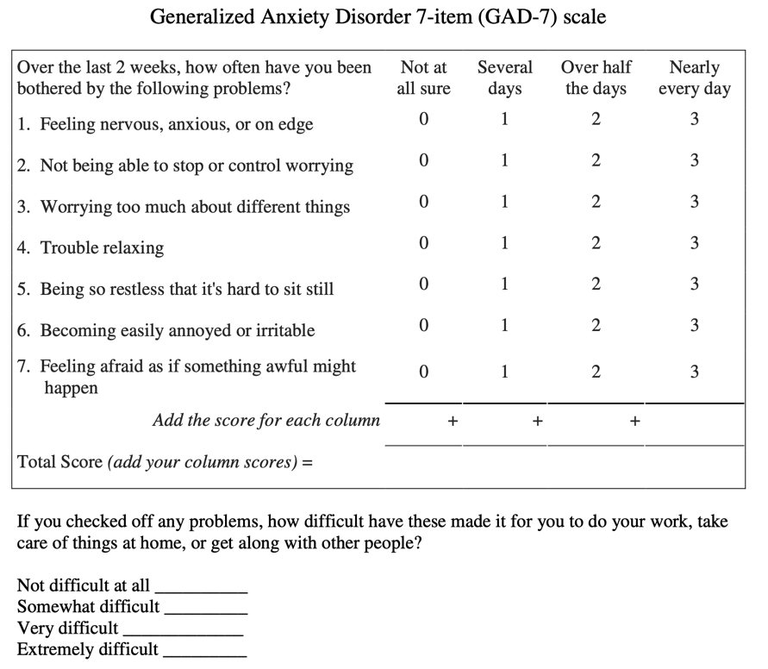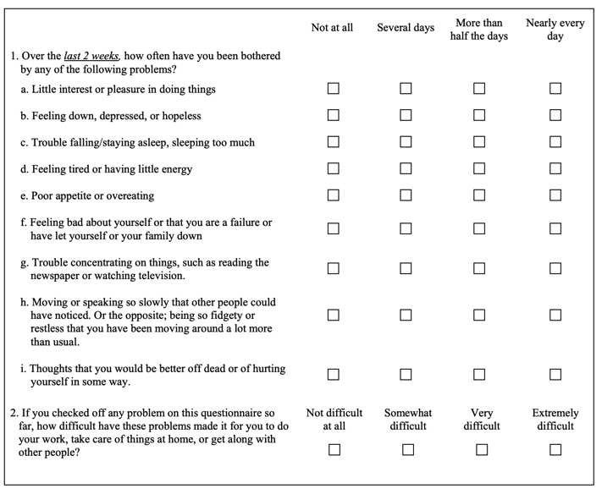 Date: ___/____/______