Student Information
Student Name:
Student email:
Student number: | Student number
Enrolment date: | Enrolment date
Date of Assessment: | Date of assessment

Summary Level (ACSF) – to be filled by the assessor
 |  |  |  |  | 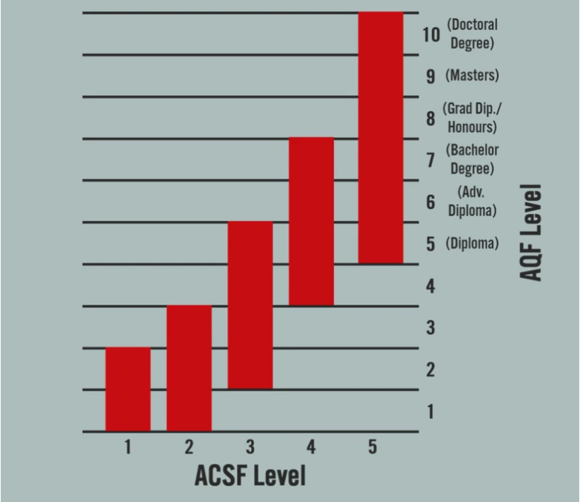
 | Course Level |  | Student Level
Learning | 5
Reading | 5
Writing | 5
Oral Communication: Listening* | 5
Oral Communication: Speaking* | 5
Numeracy | 5
*This is assessed during enrolment interview. Please see enrolment interview form for more guidance.

The LLN Entry Assessment
The Language, Literacy and Numeracy Evaluation is a short series of questions followed by a conversation which enables your trainer to determine if you already have the required language, literacy and numeracy skill level to successfully complete your training in this course. Australian Polytechnic Institute will assist where possible throughout this course when you encounter difficulties.
INSTRUCTIONS:
- If you have completed year 12 English in Australia or equivalent/higher studies
You may submit a copy of your year 12 Certificate, report card or certificate for a Qualification of an equivalent or higher level AQF as evidence, instead of completing the LLN Assessment
- If you have not completed year 12 English in Australia
  - Proceed to complete this LLN Entry Assessment – Please submit the completed assessment via the student portal or email it to info@aupi.edu.au.
  - The assessment of your oral communication skills is done via phone on face-to-face interview. If this has not been completed yet, our student support team will contact you to arrange this.

Candidate Declaration
Please read the Candidate Declaration below. If you agree to the terms of the declaration, sign and date in the space provided.
By submitting this work, I declare that:
- I have been advised of the assessment requirements, have been made aware of my rights and responsibilities as an assessment candidate, and choose to be assessed at this time.
- This work is my own and contains no material written by another person except where due reference is made. I am aware that a false declaration may lead to the rejection of my application
- I am aware that Australian Polytechnic Institute will be checking the validity of any supporting evidence I supply as part of this LLN assessment. I give my consent for Australian Polytechnic Institute to contact relevant parties for verification purposes.
Name |  | Name
Signature |  | Signature
Date |  | Date

LLN Assessment
LANGUAGE and LITERACY
Writing  Write a paragraph explaining why you want to do this course, and what you hope to gain from this training in the space provided.  Score:  /20 | Click or tap here to enter text.
 | ☐ |  | guidence |  |  | ☐ |  |  | guidance |  |  | ☐ |  | guiddance
 | ☐ |  | occurrence |  |  | ☐ |  |  | occurrance |  |  | ☐ |  | occurence
 | ☐ |  | accommodate |  |  | ☐ |  |  | accomodate |  |  | ☐ |  | acommodate
Spelling | ☐ |  | seperate |  |  | ☐ |  |  | separate |  |  | ☐ |  | sepearate
Tick the box next to the | ☐ |  | neccessary |  |  | ☐ |  |  | neccesary |  |  | ☐ |  | necessary
correct spelling of the | ☐ |  | cematery |  |  | ☐ |  |  | cemetary |  |  | ☐ |  | cemetery
following words: | ☐ |  | absence |  |  | ☐ |  |  | absentse |  |  | ☐ |  | absance
Score: | ☐ |  | accross |  |  | ☐ |  |  | across |  |  | ☐ |  | acroos
/10 | ☐ |  | apparently |  |  | ☐ |  |  | aparently |  |  | ☐ |  | apperently
 | ☐ |  | copywrite |  |  | ☐ |  |  | copywright |  |  | ☐ |  | copyright
Comprehension  Score:  /4 | Read the passage below and answer the following questions.  Are you scared of heights? Fifteen-year-old Merrick Johnston is not. In 1995, she climbed Mount McKinley - a 20,320-foot mountain in Alaska. She became the youngest person ever to reach the mountain's peak! Merrick climbed with her mom and a guide. They each carried a backpack full of supplies. The team faced icy slopes and rough weather. It took 26 days to reach the top.
What is the main idea of this story? | ☐ | Merrick reached a tough goal at a young age. |  | ☐ |  |  | Fear of heights is a serious problem. |  |  | ☐ | Merrick carried a backpack. |  |  |  | ☐ | Weather can be a problem for mountain climbers.
In this story, the word peak means | ☐ | Bottom |  | ☐ |  |  | Rocky |  |  | ☐ | Top |  |  |  | ☐ | Snow
Mount McKinley is | ☐ | Less than 20,000 ft tall |  | ☐ |  |  | 26 days old |  |  | ☐ | A mountain in Alabama |  |  |  | ☐ | More than 20,000 ft tall
You can guess from the story that | ☐ | Mount McKinley is the world's tallest mountain. |  | ☐ |  |  | The weather is usually mild on Mount McKinley. |  |  | ☐ | Merrick's guide was older than she was. |  |  |  | ☐ | Merrick's guide was 13 years old.
 | Every country _____ good people and bad people.
 | ☐ |  | has |  |  | ☐ |  |  | have |  |  | ☐ |  | haven’t
Grammar – Part One | They _____ as fast as they could, but they missed the bus.
Choose the word that | ☐ |  | ran |  |  | ☐ |  |  | run |  |  | ☐ |  | runs
could be placed in the | Both my sister and I _____ how to bake bread.
gap to create a | ☐ |  | are knowing |  |  | ☐ |  |  | knows |  |  | ☐ |  | know
grammatically correct | He stood up and _____ the room.
sentence. | ☐ |  | left |  |  | ☐ |  |  | leaves |  |  | ☐ |  | leave
Score: | Bring a grocery bag _____ you when we collect the garbage.
/5 | ☐ |  | to |  |  | ☐ |  |  | with |  |  | ☐ |  | on

 | He didn't recognize me,
 | ☐ |  |  | didn’t he? |  | ☐ |  | did he? |  | ☐ |  | doesn’t he?
Grammar – Part Two | Mr Isobel is from Greece,
Select the correct | ☐ |  |  | isn’t he? |  | ☐ |  | is he? |  | ☐ |  | aren’t he?
response/tag question | We won’t be late,
to create a | ☐ |  |  | won’t we? |  | ☐ |  | will we? |  | ☐ |  | are we?
grammatically correct | I’m right,
sentence. | ☐ |  |  | amn’t I? |  | ☐ |  | am not I? |  | ☐ |  | aren’t I?
Score: | We must lock the doors,
/5 | ☐ |  |  | mustn’t they? |  | ☐ |  | shouldn’t we? |  | ☐ |  | mustn’t we?
NUMERACY
A box holds 15 zucchinis. At the end of the day, the farm crew had filled 86 boxes. How many zucchinis is that in total? |  | Click or tap here to enter text.
Diesel costs $1.86 per litre. The tractor’s fuel tank is half full. When full it holds 1200 litres. How much money would it cost to fill up the tractor with fuel? |  | Click or tap here to enter text.
Fill in the gaps in the following table. Simplify the fraction in column one.  The first one has been done for you. | FRACTION |  |  |  |  | DECIMAL |  |  |  | PERCENTAGE
 | 1/10 |  |  |  |  | 0.1 |  |  |  | 10%
 | 1/5 |  |  |  |  | Click here to enter text. |  |  |  | Click here to enter text.
 | Click here to enter text. |  |  |  |  | 0.7 |  |  |  | Click here to enter text.
 | Click here to enter text. |  |  |  |  | Click here to enter text. |  |  |  | 65%
 | 16/25 |  |  |  |  | Click here to enter text. |  |  |  | Click here to enter text.
The table below shows the average price of petrol per litre for the period July 2020 to June 2021.
Read the information and then answer the questions that follow.

Month | Average price/litre
July 2020 | $1.14
August 2020 | $1.15
September 2020 | $1.13
October 2020 | $1.18
November 2020 | $1.20
December 2020 | $1.22
January 2021 | $1.26
February 2021 | $1.23
March 2021 | $1.24
April 2021 | $1.23
May 2021 | $1.27
June 2021 | $1.30

In which month was the petrol price the lowest? |  |  |  |  | Click or tap here to enter text.
In which two months was the price of petrol the same? |  |  |  |  | Click or tap here to enter text.
In which month was the price of petrol the highest? |  |  |  |  | Click or tap here to enter text.
In which month did the price of petrol increase the most? |  |  |  |  | Click or tap here to enter text.
What was the general trend in the price of petrol over this 12-month period? |  |  |  |  | Click or tap here to enter text.
Handy Dandy Store is having a sale. All items have been reduced by 35%. Complete the table to show the sale price of the items. | Item |  |  |  |  | Normal price |  |  |  | Sale price – 35% off
 | Men’s woollen socks |  |  |  |  | 2 pair pack for $20.00 |  |  |  | Click here to enter text.
 | Children’s pyjamas |  |  |  |  | $18.00 |  |  |  | Click here to enter text.
 | Women’s jumpers |  |  |  |  | $35.00 |  |  |  | Click here to enter text.
 | Sports shoes |  |  |  |  | $50.00 |  |  |  | Click here to enter text.
 | Football scarves |  |  |  |  | $22.00 |  |  |  | Click here to enter text.

Oral Communication Assessment
Assessment of Oral Communication may be done in the initial phone conversation you have with our admissions staff. If this had not been completed, this formal oral communication assessment may be administered. If found necessary by your enrolment coordinator, we will organise a time for you to undertake the assessment outlined below.
STEPS FOR THE VERBAL ASSESSMENT
Marks: | /5 Fluency Overall Score: /25  /5 Pronunciation/accent  /5 Vocabulary  /5 Grammar  /5 Details
1. Introduction to Interview | The assessor wants to get to know who you are and what you are doing. They will also try to relax you so that you don’t feel too stressed.  Relax and answer the questions in full (about 4-5 minutes)
2. Topic | The assessor will give you a topic (offer you a choice of 2-3). They will also give you some main points to consider. They will give you one minute to prepare for your turn to speak. You will then be given 2 minutes to talk (uninterrupted on this topic) no guidance or hints will be given to assist you.  Take your time and speak clearly and sensibly (About 3 to 4 minutes including preparation time).
3. Discussion | This is a two-way discussion between you and the assessor. The assessor will ask you a range of questions that will facilitate free conversation. Answer the questions as best you can, elaborate on your answers, and encourage back and forth discourse. Treat this as two friends having a nice chat. Please feel free to use a casual conversation style of speech (informal language).
Do’s and Don’ts | Do Don’t  Speak clearly and answer in full sentences Don’t speak too softly  If face to face: Look at the assessor and maintain eye contact when possible Don’t limit responses to yes or no  Take the full minute to plan for the Topic Don’t worry about speaking too much – the assessor will control the timing of your responses  Vary the words and phrases you use Don’t try to give rehearsed speech  Be well-mannered and respectful throughout the interview Don’t stop trying throughout the interview
Be prepared to: | - Give information (personal and non-personal)  - Give your opinion and justify it  - Explain/ or suggest something  - Express your preference for something  - Compare/ or contrast something  - Summarise  - Repair, maintain and expand on a conversation.

