Levels A1J- A2.2J
Send a photo or draw a picture of you dressed up in your scariest Halloween costume! Write sentences saying what clothes you are wearing (up to 20 words).

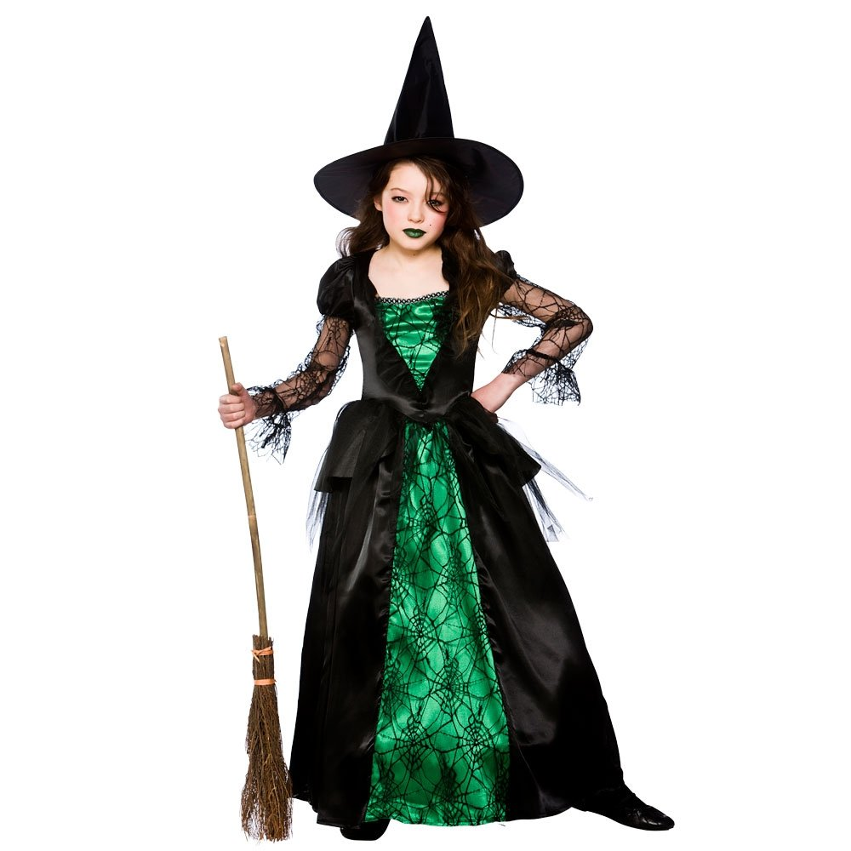

A1J – A2.2J
I am wearing a witch costume! The dress is green and black. I’ve got scary green lips and a witch’s hat.

Write your name, your class and your school!

